Spring Security Course

Course Agenda - https://github.com/eazybytes/spring-security

Basic Concepts
- Welcome to the world of Spring Security
- Securing a web app using Spring Security
- Important interfaces, Classes, Annotations of Spring Security
- Configuring Authentication & Authorization for web app

Advanced Concepts
- Implementing role-based access using ROLES, AUTHORITIES
- Different Strategies that Spring Security provides when coming to passwords
- Method level security using Spring Security
- How to handle most common attacks like CORS, CSRF with Spring Security
- Deep dive on JWT & its role in Authentication & Authorization
- Deep dive on OAUTH2, OpenID & Securing a web app using the same
- Exploring Authorization servers like Keycloak, Spring Authorization server
- Important topics of Security like Hashing, Tokens & many more.

MILESTONE 1 – Firstly, will create a simple spring security project & enable basic security in it.
MILESTONE 2 – Authentication using login screen will be implemented along with the URLs security, CSRF & CORs protection.
MILESTONE 3 – Authorization will be implemented using ROLES, AUTHORITIES
MILESTONE 4 – Method level security will be implemented along with custom filters in the authentication & authorization process.
MILESTONE 5 – Finally, the application will be enhanced with OAUTH2/OpenID using JWT which is the most common security approach in the industry.

application.properties
- We can add properties using below expression to have a default value in absence of the environment variable.

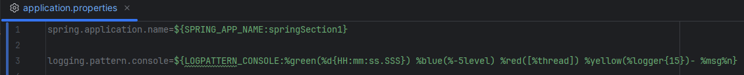

Package declared outside of main package
- Main package is the package where the Spring boot main class is present.
- For some reason, if we’ve created these controller package outside of this main package where the spring boot main class is present, then in such scenarios, by default our spring boot framework is not going to scan the controller classes.
- So, in all such scenarios, we need to make sure we’re mentioning @ComponentScan along with the package detail which we want to scan.

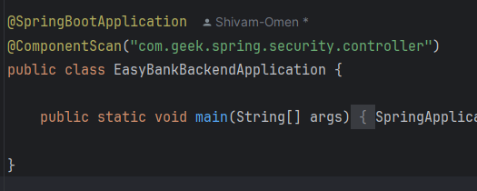

Spring Security
- Once we add the spring-boot-starter-security dependency to pom.xml, by default, Spring Security will assume & protect each & every API & MVC paths available inside our project.
- By default, username is user & default password will be generated on the console.
- Once we logged in, even if we refresh the browser multiple times still Spring security will not ask for relog in. As behind the scene, Spring security does a lot of work in remembering the session within the browser.
- In case we use different browser with no session, Spring security will expect you to login again.

- We can refer SecurityProperties to view the default user & default password configuration

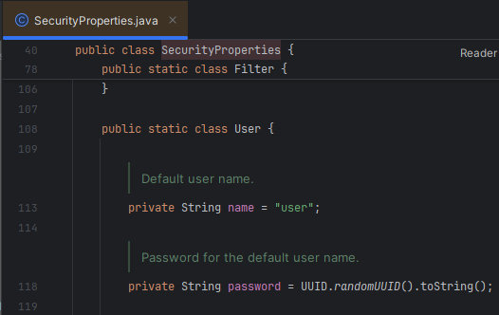

- Default Password is not really applicable for our real time scenarios or even for POCs. We can fix this by defining the properties inside the application.properties file
- For the specific application.properties keys, we can
- Either refer the specific properties class in the Spring boot application
- Or refer the spring boot reference documentation: https://docs.spring.io/spring-boot/appendix/application-properties/index.html. We can utilize right side option to choose security properties.
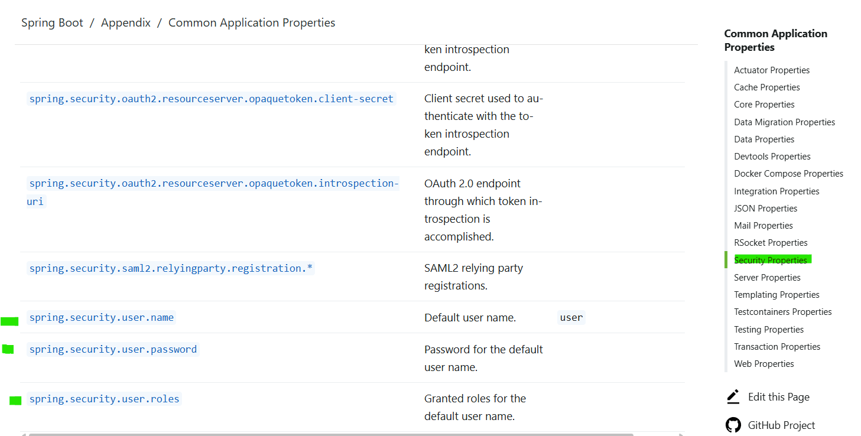

What is Security & Why we need it?
- For e.g., Banks are protected by physical security say & night, strong lockers, sensors & CCTV camera 24X7 & they are protected because Banks hold “Valuable Assets” that includes cash, gold, some important papers. Because of all these reasons, Banks try to protect themselves with various security mechanism.

- Similarly, our web applications can also hold valuable data like Credit Card details, transactions, health records or business logics etc. & they should be protected via proper security mechanism like Authentication, Authorization.

- Security is a non-functional requirement. There can be 2 types of requirements an organization can have:
- Functional Requirements (FR) – Under FR, we have various aspects like business logic, how data to be stored, how UI should be displayed etc.
- Non-Functional Requirements (NFR) – Under NFR, we’ll have topics like Security, Performance, Scalability, Availability etc.

- No client will ask specifically/explicitly to build a proper secure, performing web application. By default, every developer or every team should assume all these NFRs.
- We should implement security right from the development phase. In fact, we should move the security to the left side of the SDLC.

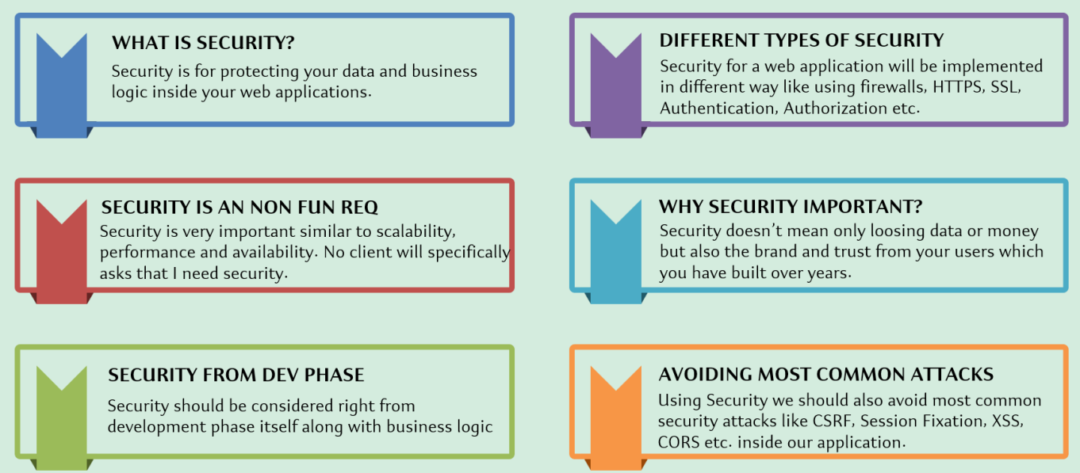

Imp – Spring Security Framework is going to help the developers in securing a web application from all the most common attack.

Typical Security measures for an app

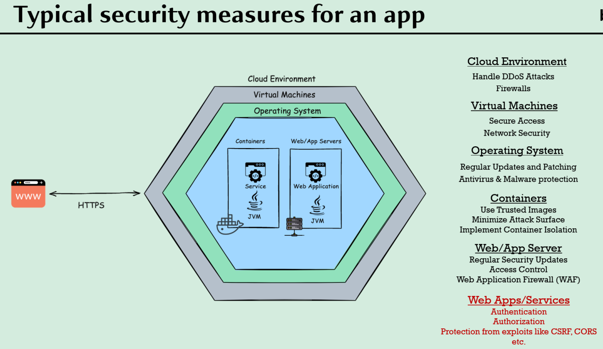

- Inside an organization infrastructure, the very 1st layer will be Cloud Environment -> virtual M/c -> Operation System -> Docker containers or Web/App Servers.
- At each layer, there is a security mechanism, and as a developer, we should be very clear about our responsibilities & Operation/DevOps team’s responsibilities.
- Right from the Client Application, we’re trying to implement the security with the help of HTTPS security protocol.
- For all the layer like Cloud, VM, OS, Containers, Web/App Server -> Operation team uses various mechanism to secure them.
- But coming to the last layer i.e., about securing the web application or the APIs, Developers need to implement various mechanism like Authentication, Authorization & Protection from exploits like CSRF, CORS etc.
- This is where Spring Security framework plays a major role to implement security with ease as it’s super tough to implement security from scratch inside any web application.

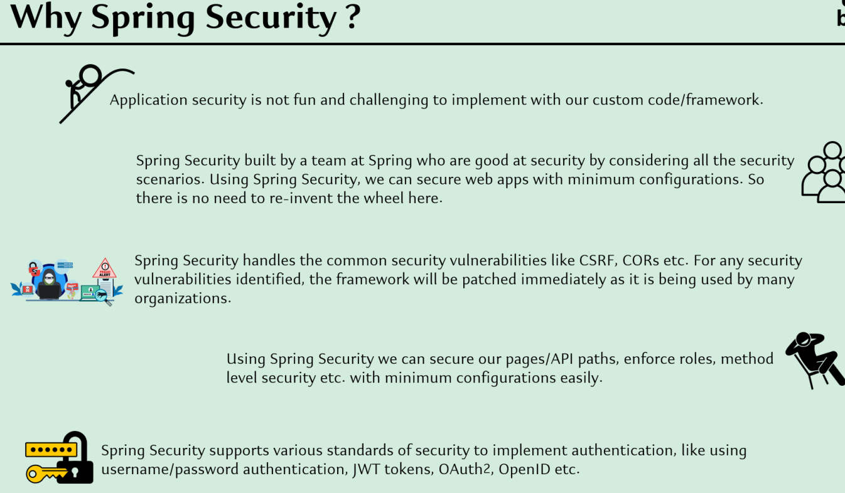

Servlets & Filters
- Before we try to understand the Spring Security internal flow, first we need to understand what’re servlets & filters inside Java ecosystem.
- Inside Spring Security framework, lot of security related functionality is implemented with the help of filters & servlets.

Servlet
- We can easily invoke the REST API or MVC path with the help of the Browser (Client App), the request (message) will be sent via HTTP or HTTPS protocol but the request will not make any sense to the backend server or backend logic.
- Inside Java Programming language, anything we want to process, it has to be converted into java object so, this is where Servlet container comes into the picture.

Servlet Container
- One of the mostly used servlet container is Apache Tomcat.
- In Java web apps, Servlet Container (Web Servers) takes care of translating the HTTP messages for Java code to understand.
- Servlet container converts the HTTP messages into ServletRequest & hand over to Servlet method as a parameter.
- Imp. Point – Once the Servlet request object is prepared, the same will be forwarded to next servlet that can be leveraged by the frameworks like Spring Boot or Spring Security.
- From these servlets, only the actual business logic invocation is going to happen i.e., whatever logic we write inside the controller or service classes will be invoked via these servlets only.
- Similarly, Servlets returns ServletResponse as the output to the Servlet Container & the container will convert the ServletResponse object to the HTTP or HTTS protocol before forwarding the response to the client application.
- So, everything we write inside java web apps are driven by Servlets.

Note – Building a business logic or web application with servlets is very complex, Frameworks like Spring Boot or Spring Security does a lot of heavy lifting for us so that dev can focus on writing business logic.

Role of Filters
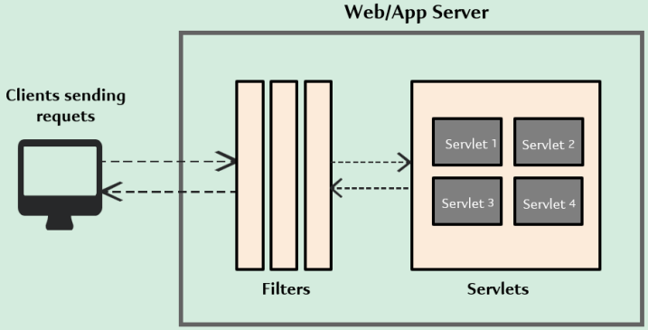
- We can see in the picture that before our request reaches to the actual servlet, there are filters in between.
- Filters inside java web application can be used to intercept each request/response & do some pre work before our business logic.
- Using these filters only, frameworks like Spring Security implement lot of security related logic.
- The purpose of Spring Security framework is whenever we’re trying to access a REST API or a MVC path, it has to intercept the request & identify if the user is authenticated or not. If not, then it has to redirect the user to the login page.
- Since the Spring Security has to intercept each & every request to enforce the security inside a web apps, all the security logic is implemented with the help of filters, only.

Note – Always the filters are going to be executed first, followed by the servlets or the actual business logic execution. Once all the Spring Security related filters are executed, the request will be forwarded to the DispatcherServlet.

Spring Security Internal Flow/Architecture

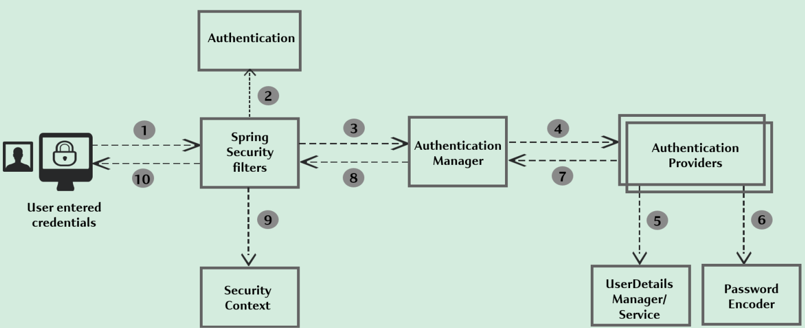

1) Through client applications like Browser, Postman etc.,
- The end users send the request to access REST API or a MVC path & if the API is protected, the end user will have to provide their credential as part of the Request Header or Request Body based on the configuration done behind the scenes.
- If the user is trying to access a protected API without mentioning credentials, the Spring Security framework will intercept the request by using Spring Security filters & will redirect the user to the login page.
- The job of identifying if the user is authenticated or not is handled by Spring Security filters (intercepts each & every request)
- For e.g., A filter can be for authentication, another filter can be CSRF attack etc.
- Based on our security filters configuration – 5 or 10 or 20 filters, the request will go through each filter & at any filter layer, if there is an error then end user will get a 401 or 403 error based upon the exception type.

2)
In case the end user provides the proper credential inside the request while accessing a secured API, the Spring Security filters will populate the Authentication object.

- By default, the credentials received from the end user as part of HTTP Request object can’t be forwarded directly to the framework code or business logic.
- Spring Security filters will first covert the credentials from the HTTP Servlet Request to Authentication object.
- Inside Authentication object, there will be username, password & boolean value to identify whether the user is authenticated or not. Initially when the object is created 1st time, isAuthenticated value will be set to false & username, password will be set to the default or the one we provided in application.properties
- The same Authentication object will be used by all other components inside the Spring Security framework.
- The Authentication object represents a user credentials & information to identify if the user is authenticated or not.
- Once the Authentication object is created & populated, the filters will forward the request to the Authentication Manager.

3) Authentication Manager
- It is responsible for completing the authentication by taking help from other components & conveying the results back to the filters whether the authentication is successful or not.
- Imp Point – Authentication Manager will not be performing actual authentication. So, in order to perform actual authentication, it will forward the request to Authentication Provider available inside the Spring Security framework. (We can use already existing or can define our own Authentication Providers)
- So, a project can have multiple Authentication Providers to identify whether the authentication is successful or failed.

4 – 5) Once the Authentication Providers receive the Authentication object to perform the actual authentication, these Authentication Providers are going to take help from 2 other component i.e.,
- UserDetailsManager or UserDetailsService and Password Encoder component.
- The Authentication Provider uses UserDetailsManager component or UserDetailsService implementation classes to load the user details based upon the username result.
- Once the user details will be sent back to the Authentication provider, it won’t compare the password provided by the user with the stored password (from database or inside the memory) by itself rather it takes help from Password Encoder Component.

6) Password Encoder component
- Is responsible for the password comparison.
- Using these Password Encoder, we can store the password using plain text or using the hashing algorithm.
- Since the Password encoder is a specialist, the Authentication Provider will ask the PE to compare the user provided password with the loaded password from storage system with help of UserDetailsManager.
- Once the PE says the passwords matched accordingly the Authentication Provider conveys back to the Authentication Manager saying “The Authentication is successful”

7) Authentication Provider will convey whether the Authentication was successful or not via setting the boolean value isAuthentication present in the Authentication object.
- Based on the value of isAuthentication attribute, the Authentication manager will know whether the authentication is successful or not.

8) The same Authentication object will be sent back to the Spring Security filters.

9) Regardless of whether the Authentication is successful or not, the Authentication object will be stored in the Security Context against a sessionId (created for a given browser)
- So, if the user is trying to access the same protected page from the same browser then, based upon the given session ID, the Spring Security filters will load the authentication object details from the security context & accordingly they will show either successful or error message.

Imp Conclusion – All the actual authentication execution is only going to happen for the very 1st request as there is no entry for a given session ID in Security Context. Once the 1st request is processed & there is an entry inside the security context for the same session ID, from next time onwards, the security filters will not be invoking the Authentication manager, instead they will leverage the details present inside the security context to send the successful or error response.

10) A response will be sent to the client app based on the authentication result. In case of successful authentication, a response from the REST API will be sent else 401 or 403 error.

Analogy of Spring Security Internal flow with SDLC

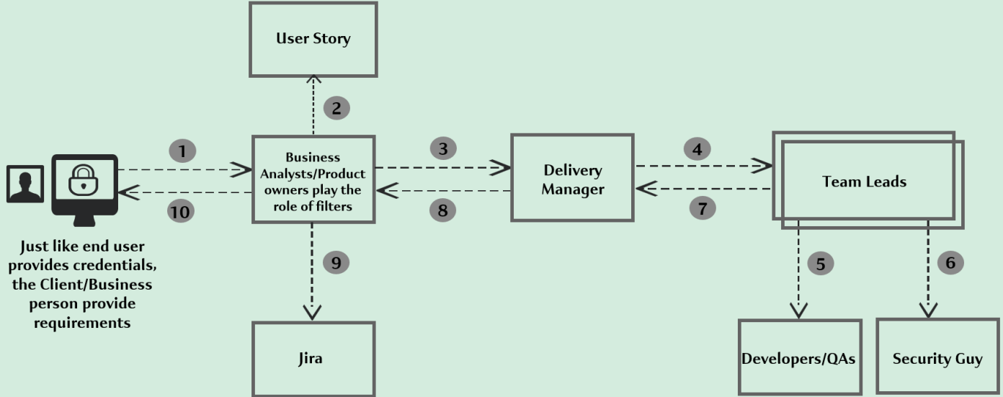

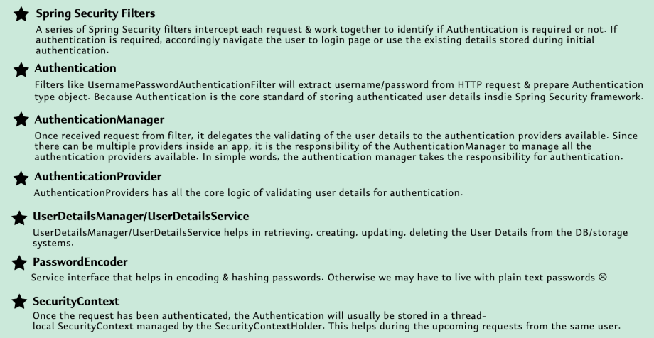

Reference Classes in Spring Security framework to understand the Internal Flow

Suppose End user is trying to access a protected API (e.g., welcome API without providing any credentials), there are few below filters that are going to play a role.

1) org.springframework.security.web.access.intercept.AuthorizationFilter
- Responsible to identify whether a user is trying to access a protected API or path without credentials or without authenticated session.
- AuthorizationFilter class contains business logic to identify whether to deny the request or not.

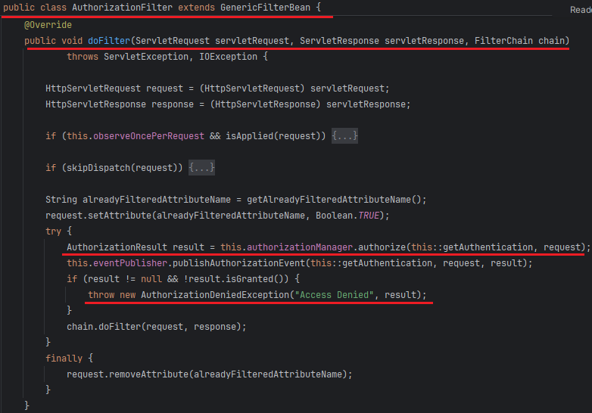

2) org.springframework.security.web.authentication.ui.DefaultLoginPageGeneratingFilter
- The purpose of this filter is to redirect the user to the login page by showing a page with username & password fields.
- DefaultLoginPageGeneratingFilter class contains business logic to build the login page.

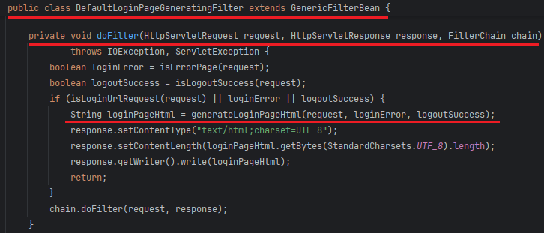

Note: We can add debug point to doFilter methods in DefaultLoginPageGeneratingFilter & AuthorizationFilter class.

3) org.springframework.security.web.authentication.AbstractAuthenticationProcessingFilter
- Implementation class – OneTimeTokenAuthenticationFilter, UsernamePasswordAuthenticationFilter, WebAuthnAuthenticationFilter
- Contains majority of authentication logic.
Note: We can debug from FilterChainProxy to understand the internal flow. Some important classes while debugging
- FilterChainProxy – doFilter () method
- VirtualFilterChain implements FilterChain – doFilter () method: In this method, a doFilter() call will be made to each of the 16 default filters in default order
- Below default Order (1st Parent abstract class doFilter () method will execute then child specific doFilter() method will execute)
- DisableEncodeUrlFilter extends OncePerRequestFilter
- WebAsyncManagerIntegrationFilter extends OncePerRequestFilter
- SecurityContextHolderFilter extends GenericFilterBean
- HeaderWriterFilter extends OncePerRequestFilter
- CsrfFilter extends OncePerRequestFilter
- LogoutFilter extends GenericFilterBean
- UsernamePasswordAuthenticationFilter extends AbstractAuthenticationProcessingFilter
- DefaultResourceFilter extends GenericFilterBean
- DefaultLoginPageGeneratingFilter extends GenericFilterBean
- DefaultLogoutPageGeneratingFilter extends GenericFilterBean
- BasicAuthenticationFilter extends OncePerRequestFilter
- RequestCacheAwareFilter extends GenericFilterBean
- SecurityContextHolderAwareRequestFilter extends GenericFilterBean
- AnonymousAuthenticationFilter extends GenericFilterBean
- ExceptionTranslationFilter extends GenericFilterBean
- AuthorizationFilter extends GenericFilterBean

Authentication Object:
- Authentication is an interface present org.springframewok.security.core &
- Implementation classes – AbstractAuthenticationToken, OneTimeTokenAuthenticationToken, UsernamePasswordAuthenticationToken (used as default), etc.
- AbstractAuthenticationToken acts as base class for Authentication objects.

AuthenticationManager:
- It is a functional interface with authentication (Authentication authObj) method present in org.springframework.security.authentication
- Implementation classes – ProviderManager (used as default) etc.
- ProviderManager – Iterates an authentication request through a list of AuthenticationProviders.

Authentication Provider:
- It is an interface present in org.springframework.security.authentication
- Indicates a class can process a specific Authentication implementation.
- Implementation classes: AbstractUserDetailsAuthenticationProvider, DaoAuthenticationProvider (used as default), etc.
- AbstractUserDetailsAuthenticationProvider – Acts a base class & allows subclasses to override & work with UserDetails objects.

UserDetailsService:
- It is a core interface that loads user-specific data present in org.springframework.security.core.userdetails.
- It is used throughout the framework as a user DAO & is the strategy used by the DaoAuthenticationProvider.
- Implementation classes – UserDetailsManager, InMemoryUserDetailsManager, JdbcUserDetailsManager, CachingUserDetailsService etc.
- UserDetailsManager interface acts as base to InMemoryUserDetailsManager & JdbcUserDetailsManager.

PasswordEncoder:
- Service interface for encoding passwords present in org.springframework.security.crypto.password
- Implementation classes – BcryptPasswordEncoder, DelegatingPasswordEncoder, Pbkdf2PasswordEncoder etc.

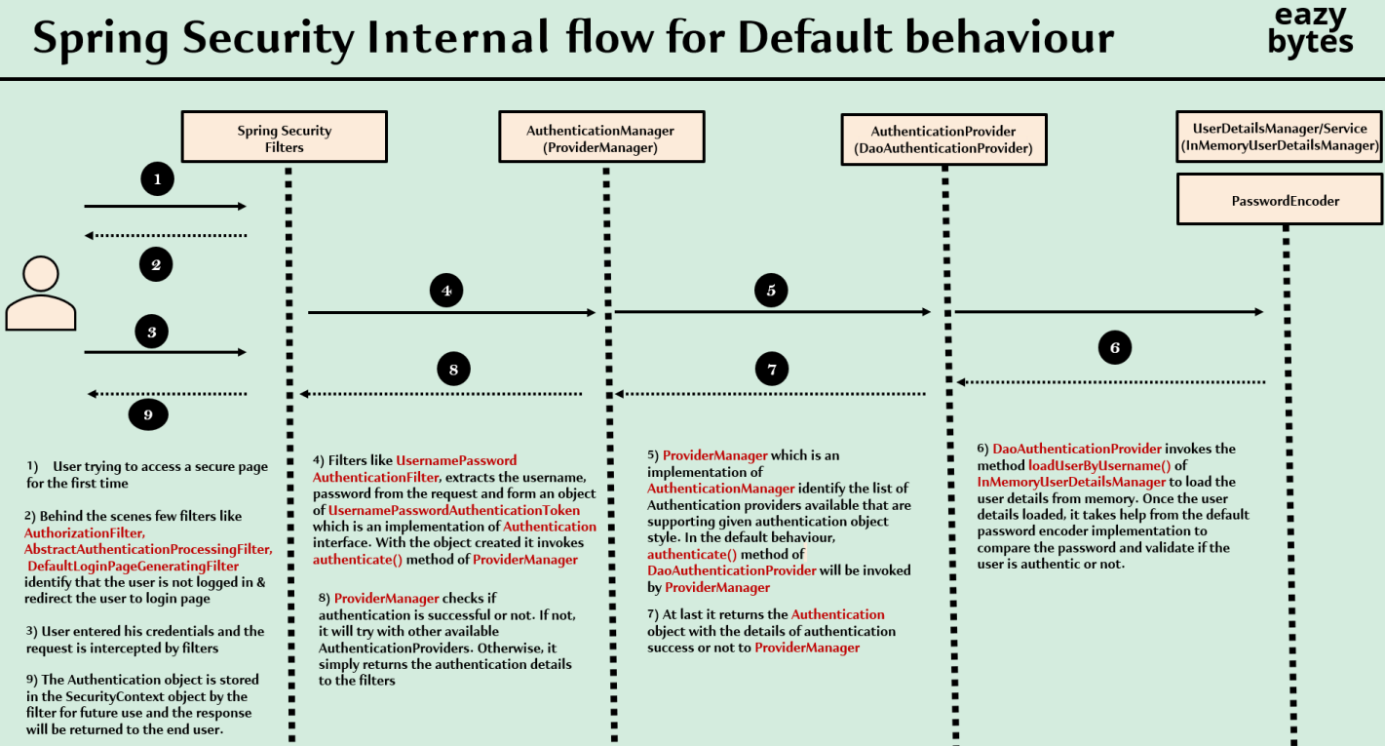

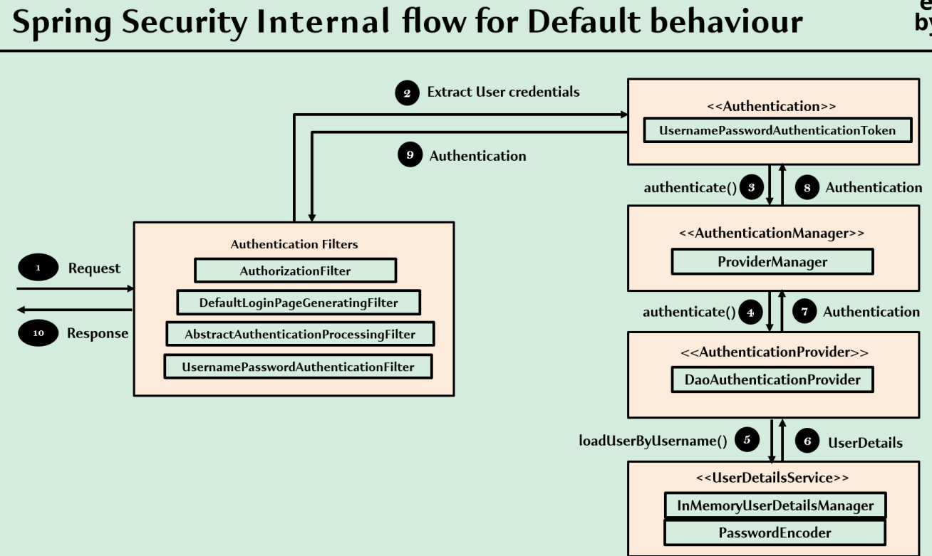

Note:
- Spring Security framework handles all the subsequent requests by creating & publishing the JSESSIONID in the browser.
- As long as a valid JSESSIONID cookie mapped to backend server security context details is present in the browser, we won’t need to login again and we can access any protected API or MVC path without re login.

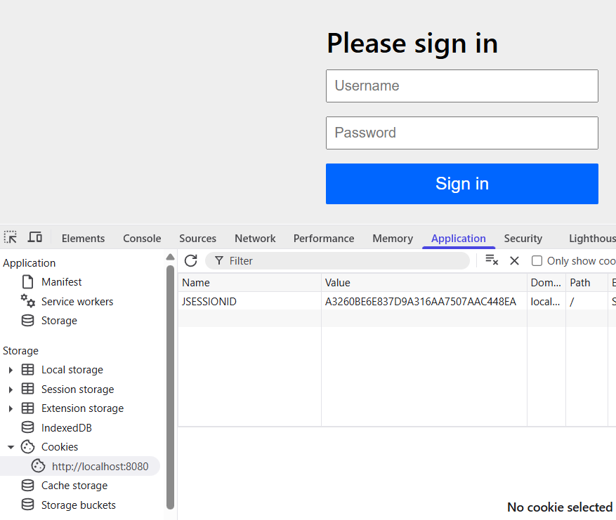

Notes
- This way, Spring Security framework is doing smart job of not invoking the actual authentication every time. If we try to invoke actual authentication for each & every request then definitely it’s going to have some performance impact but by using this JSESSIONID cookie, Spring Security framework is doing a smart job here.
- This is a default behavior of Spring Security framework. There are better & advanced approaches also available like JWT tokens, OAuth2.0 framework, OpenID framework.

Changing the default Security Configuration
- By default, the Spring Security tries to protect all the APIs but we want to customize Spring Security behaviour based upon the business requirement.
- Before we get started with the Customizations, we need to understand the piece of code responsible for default behaviour.
- Refer org.springframework.boot.autoconfigure.security.servlet.SpringBootWebSecurityConfiguration class & method defaultSecurityFilterChain (HttpSecurity http)

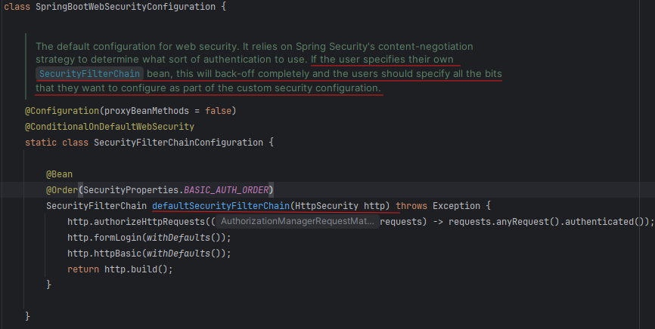

- The code present in defaultSecurityFilterChain () method is trying to create a bean of SecurityFilterChain & is responsible to secure all the APIs in our application.
- By default, formLogin & httpBasic login are enabled.
- Form – Any UI application that can have forms like HTML. The end user can enter the credential inside the forms. So, this style of login we call as Form Login.
- HttpBasic – If someone sends the credentials inside the http Request headers by Base64 encoding them, we call it standard as http basic. HttpBasic style of authentication is used in scenarios where we want to authenticate an API invocation.
- Beside these 2 login styles, we have other advanced style of logins such as OAuth2 login.
- If we want to customize the Spring Security behaviour then we have to declare similar kind of method, which is going to create a bean of SecurityFilterChain.

- Whenever we enable the FormLogin inside our web application, then the extraction of the credentials from the request is going to be taken care by the UsernamePasswordAuthenticationFilter. For more understanding, we can debug same class.
- Whereas, if we’re using the HttpBasic style of login, then the same credential extraction activities will be taken care by BasicAuthenticationFilter. For more understanding, we can debug same class.

Modifying the security config as per our custom requirements

1. permitAll ()
- By using anyRequest ().permitAll(), we can permit all the requests coming towards our web application APIs, Paths using Spring Security framework like shown below:

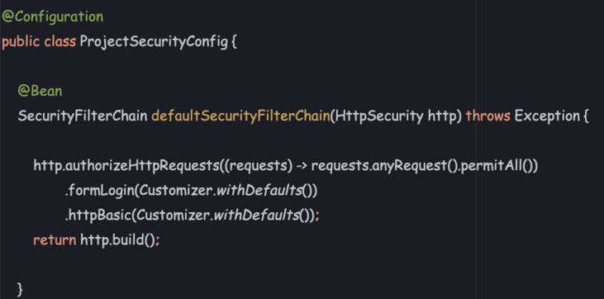

- Not recommended for Production

2. denyAll ()
- By using anyRequest().denyAll(), we can deny all the requests coming towards our web application APIs, Paths using Spring Security framework like below:

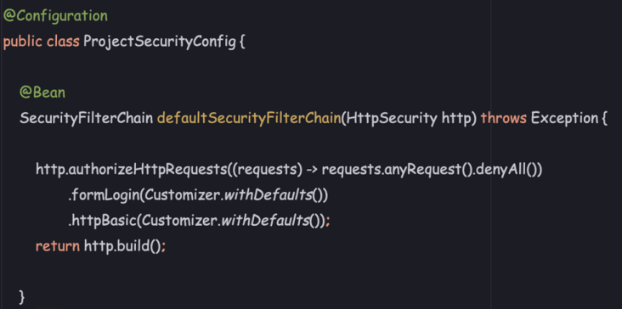

- Not recommended for Production
- denyAll () method is not going to be used very commonly in the real projects, but we can use in case we want to deny the upcoming request towards few APIs for a specific set of time.

Note:
- If we disable both Form Login & Http Basic login, then we will get 403 error

Custom Security Configurations inside Spring Security Framework
- By using requestMatchers().authenticated() & requestMatchers().permitAll(), we can secure the web application APIs, Paths as per our custom requirements using Spring Security framework like shown below:

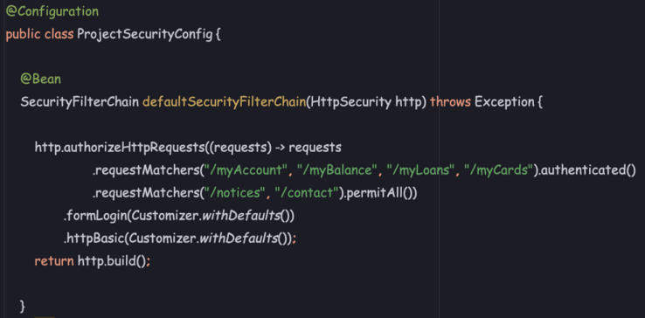

Disable Form Login inside Spring Security Framework
- If your Spring Security-protected endpoints are only accessed programmatically (using APIs) by clients (such as mobile apps or other services) and there’s no need for a web-based login form, disabling form login can be appropriate.
- This can be done in the below way:

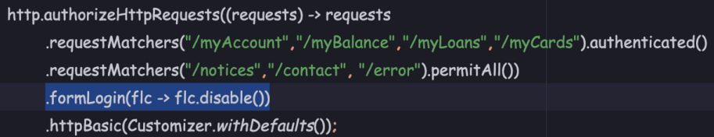

Note:
- By default, Spring Security framework will always redirect to the error page if any runtime exception happens behind the scenes. But this error page is also going to be secured by default.
- We should always permit these error page to everyone so that we can see the runtime exceptions inside our application at any time.

Disable Http Basic Login inside Spring Security Framework
- If your application primarily serves web pages & requires users to interact via a browser, then HTTP Basic authentication may not be required.
- HTTP Basic style logic can be disabled in the following way:

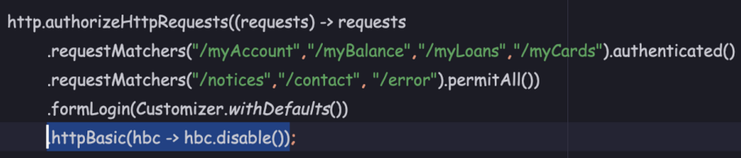

HttpBasic Authentication testing via Postman

- If some API can’t be invoked from the Browser, then we can use Postman for all such scenarios.
- While sending Basic Auth via Request header, a key named “Authorization” & value prefixed with {Basic} string will be sent to backend for authentication.
- In Backend, BasicAuthenticationFilter will be invoked.
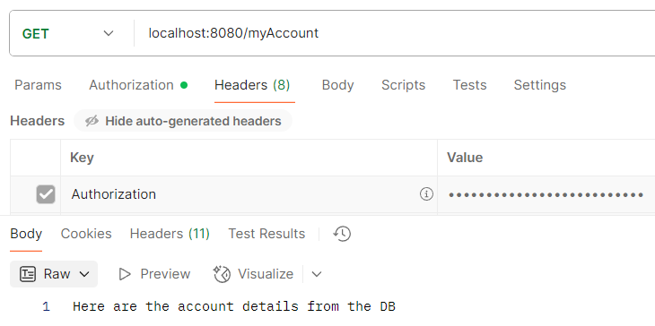

- Trick: We can use different ways to configure base url in postman
- We can set base url as variable with scope as Collection, Environment or global. We can check the set variable name on the collection or selected scope level.
- We can write JS scripts on Collection level -> Pre-request (executed before API invocation) or post-request
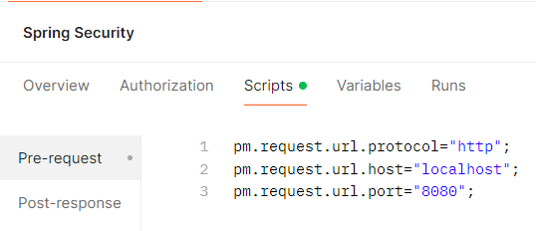

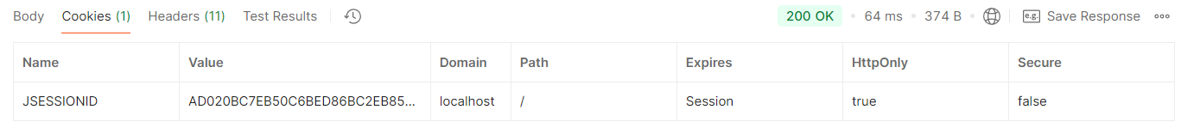

Configure Users using InMemoryUserDetailsManager
- Instead of defining a single user inside application.properties, as next step we can define multiple users along with their authorities with the help of InMemoryUserDetailsManager & UserDetails
- In this section, we will focus on creating multiple users by using the memory of the Spring Boot application. Later, we will be going to enhance this application by creating multiple users inside a storage system like database.

- All user-related operations are supported by UserDetailsService interface & its child i/f UserDetailsManager interface.
- Whenever we want to store the credentials inside the memory of the application, we need to create the object of one of the implementations of UserDetailsService i.e., InMemoryUserDetailsManager.

UserDetailsService interface
- Core interface with loadUserByUsername (String username) method, which loads user-specific data based on username from a storage system.
- The storage system can be in-memory or a database.

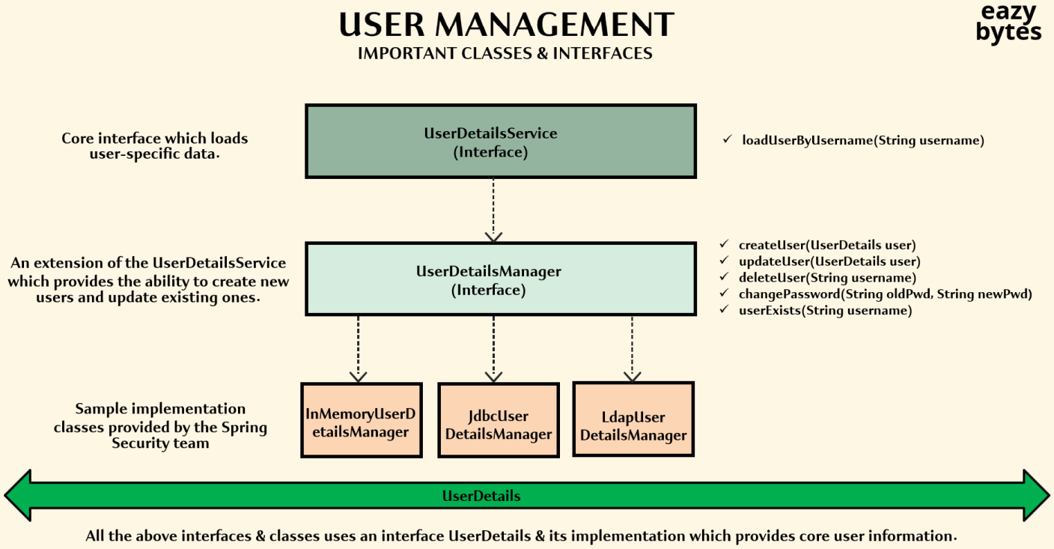

UserDetailsManager interface
- ALL CRUD Operations: It contains the methods to create a new user, to delete end user, to update the user details, to change the password, and to check whether the user exists with the given username.
- It is also going to inherit the fetch related method from the parent interface (UserDetailsService)
- Implementation classes – InMemoryUserDetailsManager, JdbcUserDetailsManager

Q. Why Spring Security team separated user management methods into 2 different interfaces i.e., UserDetailsService i/f & UserDetailsManager i/f
Ans:
- UserDetailsService i/f has only method to load user details by username i.e., Read Operation as there can be use cases where sometimes organizations only want to authenticate the user but never have a scenario where the end user can register or perform any other (create, delete, update) operations directly.
- UserDetailsManager i/f allows all other operations in addition to read i.e., create, delete, update. This can used where organization wants to have complete functionality.
Note: In case we’re not satisfied with already inbuilt UserDetailsManager implementation, we can create custom UserDetailsService as well.

- Inside Spring Security, an end-user is represented by UserDetails interface.
- UserDetails i/f implementation classes: User
- The magic of converting the UserDetails object i.e., User into the Authentication object i.e., UsernamePasswordAuthenticationToken is going to happen inside the AuthenticationProvider implementation classes: DaoAuthenticationProvider
- UserDetails i/f implementation methods are specifically required once the Authentication is successful.

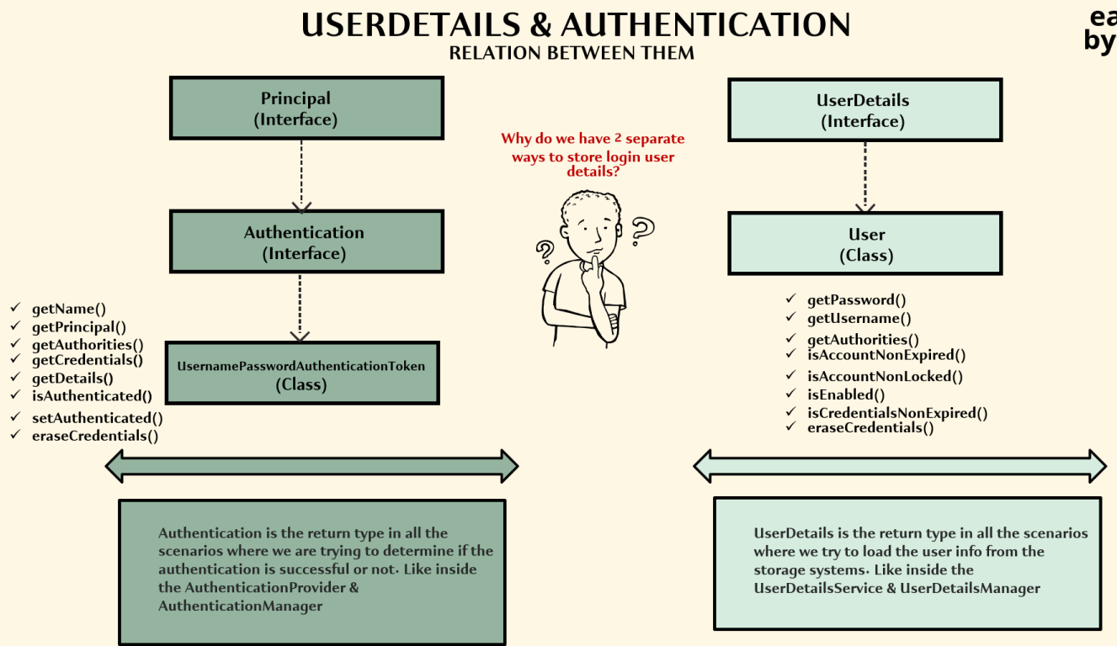

- By default, if we create user like below, we’re not conveying anything to the Spring Security framework, it will store the credential in a plain text format.
- This is not recommended approach for any kind of application because anyone can see your actual password.

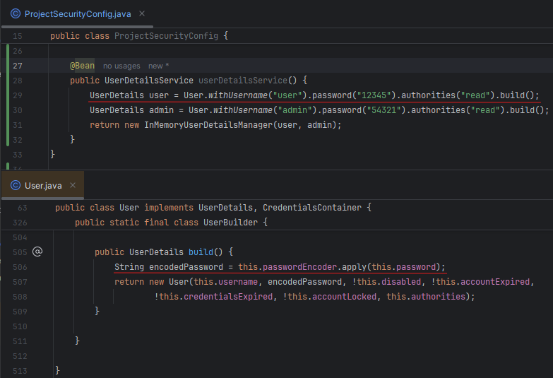

- Without configuring the PasswordEncoder bean, Spring Security will throw an error. Either we configure a PasswordEncoder bean or try to prefix our passwords with the {noop}

Configuring PasswordEncoder using PasswordEncoderFactories
- Problem with above approach:
- Hard coding the credentials inside the source code. Anyone having access to source code can easily see the password.
- Password is being stored as a plain text internally inside the application memory. If some hacker has access to our application head dump, the hacker can easily get what’s the password by analyzing the heap dump.

- In order to solve above 2 problems, we need to tell Spring Security framework to use the PasswordEncoder to store the passwords in an encrypted or in a hashing format.

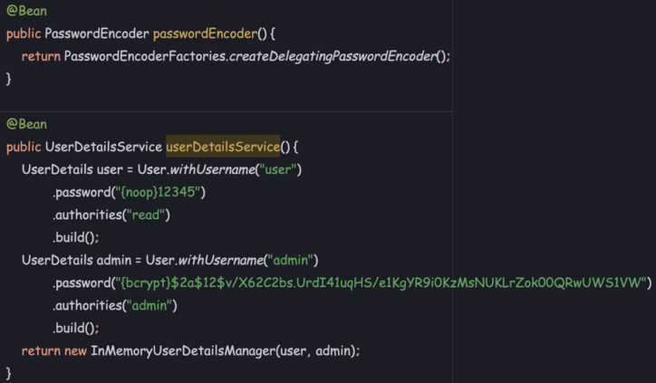

- PasswordEncoderFactories.createDelegatingPasswordEncoder() gives the flexibility to store the password in either Spring Security recommended default format or any specific format by adding the specific prefix to the password.
- We can refer this site to generate bcrypt format password - https://bcrypt-generator.com/

CompromisedPasswordChecker
- Using CompromisedPasswordChecker implementation, we can check if a password has been compromised. This feature is released as part of Spring Security 6.3 version.

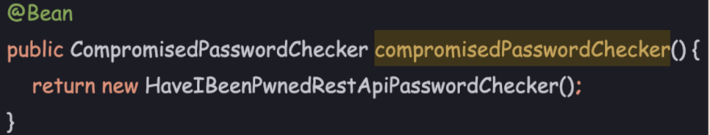

- Implementation classes - HaveIBeenPwnedRestApiPasswordChecker
- Recommended for Production

Tips: We can use warp terminal for better UI experience compared to our traditional terminals that comes along with OS. Using this terminal, we can also ask AI if we’ve any questions around a command.

Docker command to add my SQL:
- docker run -p 3306:3306 --name springsecurity -e MYSQL_ROOT_PASSWORD=root -e MYSQL_DATABASE=eazybank -d mysql

SQL Client - https://github.com/sqlectron/sqlectron-gui/releases/tag/v1.38.0

Understanding JdbcUserDetailsManager & creating Users inside the DB
- JdbcUserDetailsManager is a JDBC implementation of the UserDetailsManager.
- It takes care of all the CRUD operations for managing users in a database.
- It uses a JDBC template to execute the SQL queries.

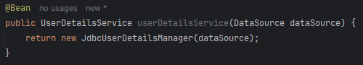

Using JdbcUserDetailsManager to perform authentication
- Add spring-boot-starter-jdbc, mysql-connector-j, spring-boot-starter-data-jpa to pom.xml to resolve JdbcUserDetailsManager class compilation errors.

- JdbcDaoImpl provides default user schema DDL location - org/springframework/security/core/userdetails/jdbc/users.ddl
- We need to add few properties to application.properties to help spring boot application to connect to the MySQL DB.

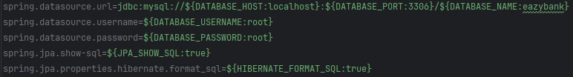

- spring.jpa.show-sql: JPA Framework will print all the SQL statements that are going to be executed against the DB on the console
- spring.jpa.properties.hibernate.format_sql: The queries that are going to be printed on the console, are not in a readable format by default. This property is used to make queries print in readable format.

Authorities Table
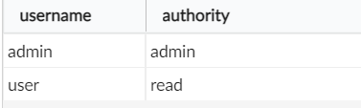

Users Table
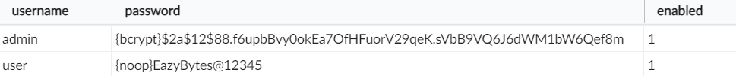

Note: This way is good option for beginners but enterprise applications may not accept to this proposal i.e., using already existing & recommended User table with pre-defined schema by Spring Security. They would require a custom table for Authentication.

Custom Tables for Authentication

Customer Table
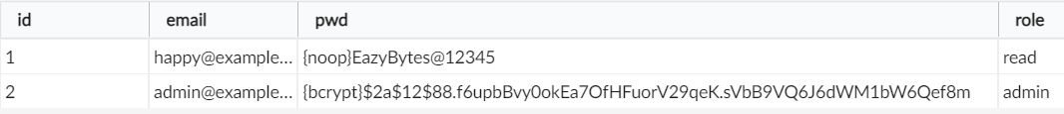

- We will use Spring Data JPA framework to execute DB related logic
- If we’ve created entities like Customer & repositories under the main package only then both annotations are optional.

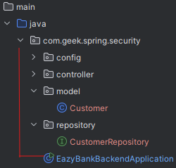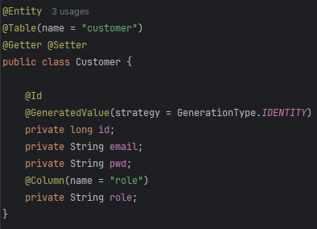

Note:
- @EnableWebSecurity is completely optional in the Spring Boot environment as spring boot is smart enough to enable the security based upon the dependencies that it sees inside the pom.xml
- @EnableWebSecurity is mandatory in case we’re trying to implement the Spring Security in a normal Spring framework application which is not using any Spring boot functionality.

Creating our own custom implementation of UserDetailsService

Authentication Providers depend on the UserDetailsService/Manager implementation to fetch the user details either from Memory using InMemoryUserDetailsManager bean or from database using JdbcUserDetailsManager bean.

The problem with JdbcUserDetailsManager:
- It forces us to use the predefined schema, predefined table structure.

In order to let the DaoAuthenticationProvider to use our own custom tables for the authentication, we should create our own bean by either implementing the UserDetailsManager or UserDetailsService.
Case 1 – Use UserDetailsManager: Then we will have to define all the CRUD method inside UserDetailsManager i/f
Case 2 – Use UserDetailsService: Then we will have to only define the loadUserByUsername () method.

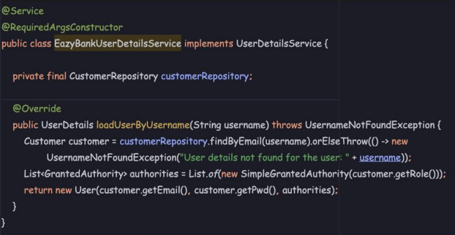

Sequence Flow with our own UserDetailsService implementation:

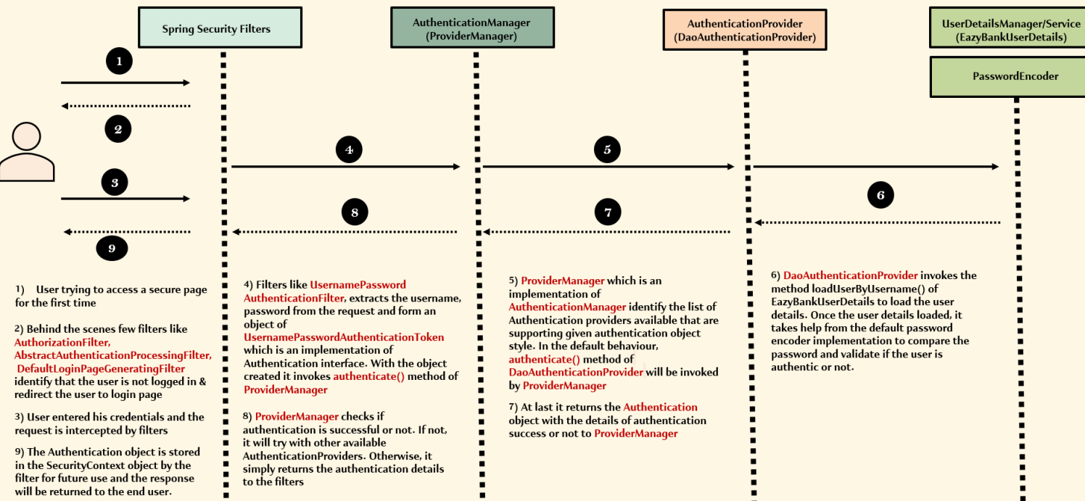

Sequence Flow with our own UserDetailsService Implementation:

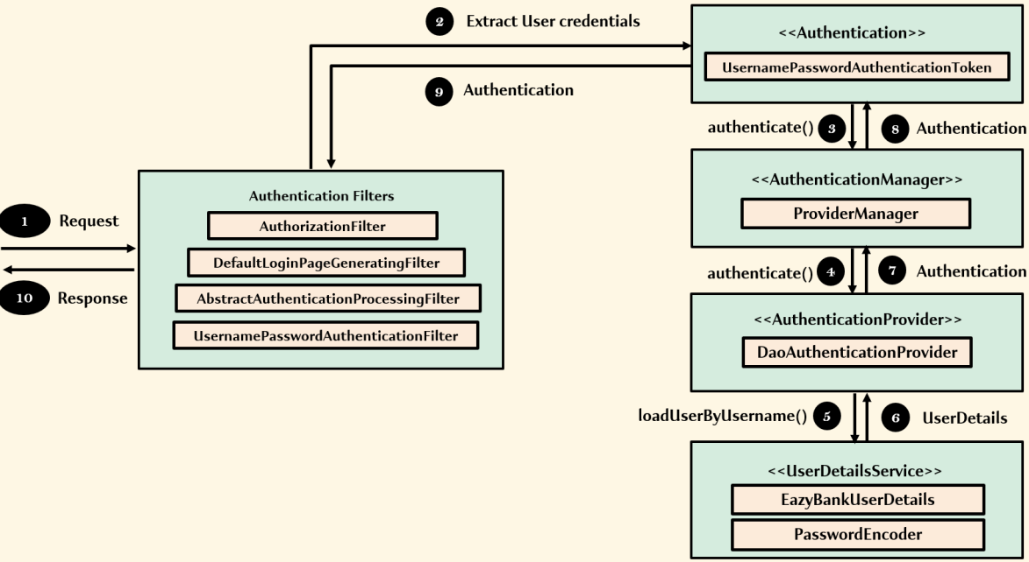

Building a new REST API to allow the registration of a new user
- UserDetailsManager i/f provides a method: createUser (UserDetails user) to create user but we should not involve Spring Security Framework during the registration of a new user due to below reasons:
- If we start involving UserDetailsManager i/f, obviously we need to support lot many other functionalities that may not be needed.
- When we’re using above i/f method, we’re restricted to the input parameter of type UserDetails. If we want to accept any other parameter, then this is not a friendly option.
- Organizations should always leverage the REST APIs or MVC paths that allow the registration of the user, CRUD operations. Recommended to only involve the Spring Security framework during the authentication process. That’s why we’ve created our own UserDetailsService implementation above.

- There are certain modifications that we’ve to do in order to support /register user API
- Permit “/register” API as public API
- Inside Spring Security framework, whenever we’re trying to invoke an API path with Create, Update or delete data functionality, in such scenarios, by default Spring Security framework will stop such request due to the CSRF protection that it’s providing.
- Spring Security for the reading operations (GET), it won’t enforce the CSRF protection whereas for the data-alternating methods (POST, PUT, DELETE), it will enforce the CSRF protection.

To Resolve CSRF issue, either we need to properly implement the CSRF protection inside our application or we need to disable the CSRF protection provided by the Spring Security framework.

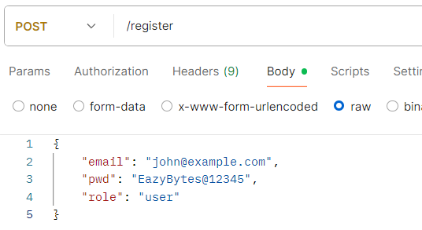

Note: There is no need customize AuthenticationManager or ProviderManager
Password Management with Password Encoders

How our passwords validated without PasswordEncoders – NoOpPasswordEncoder

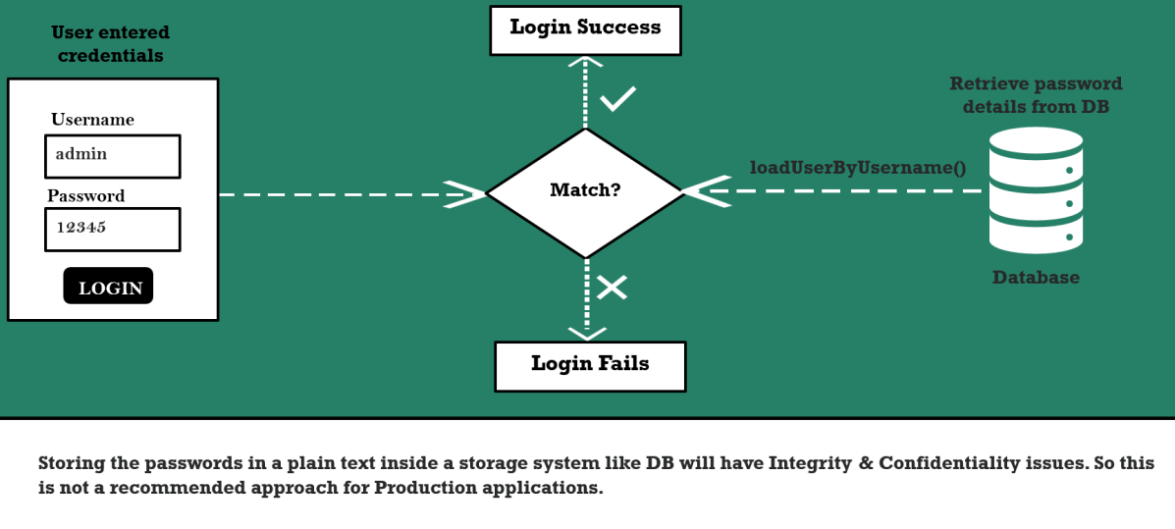

Encoding Vs Encryption Vs Hashing

Different ways for Data Privacy

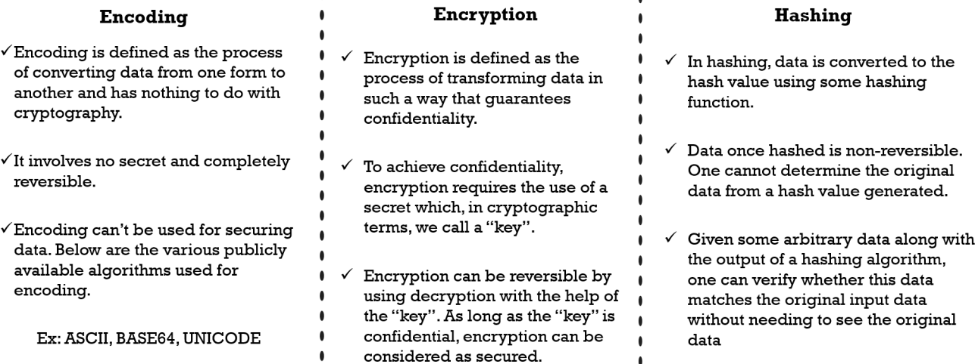

Encoding & Decoding Process
- Not recommended approach for password management.

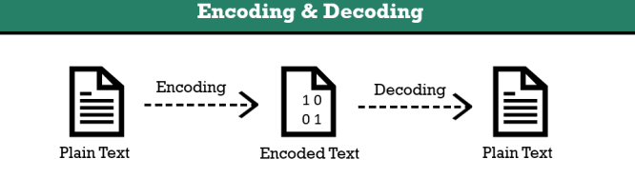

One of the most common use cases of Encoding & Decoding
- Whenever a system is not capable of dealing with the binary data like images etc. then for all such scenarios Encoding & Decoding will be used.
- For e.g., Outlook application. Since mail applications are not capable of storing, processing or dealing with binary data like images, videos as attachment, behind the scene, all these binary data is going to be encoded with the help of formats like BASE64 encoding.
- Once the encoding is completed, these files will look like a normal text file. On other side, these normal text files will be decoded to the original binary data.
- Command:
- openssl base64 -in plainText.txt -out encode.txt
- openssl base64 -d -in encode.txt -out decode.txt

Encryption & Decryption Process
- Not recommended approach for password management.
- Encrypted text is also called Cipher text.

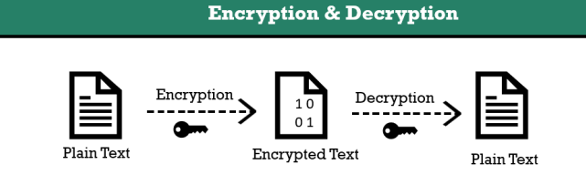
- Encryption is essential in our daily routines,
- whether we’re messaging friends on WhatsApp, ensuring a website’s authenticity through our browser
- Entering our credit card details while shopping online.
- It safeguards our data from potential threats & unauthorized access, ensuring privacy & security.

- Central to any encryption process are the Encryption Algorithm & the key. While numerous encryption algorithm exists, there are generally 2 types of keys: Symmetric & Asymmetric

1. Symmetric Encryption
- In Symmetric key encryption, the same key used to encrypt the data is used to decrypt the data. It is generally used for encrypting data at rest.
- Some famous symmetric encryption algorithms include
- AES – known for its security & used globally.
- Triple DES – an enhancement of DES providing better security
- Blowfish – Notable for its speed & variable key length.

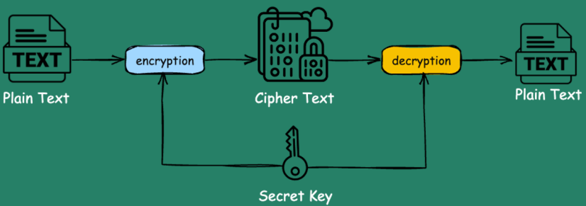

- Each offers distinct advantages for protecting data.

Drawback with Symmetric Encryption
- Though it’s trying to provide the confidentiality, if someone lose the secret key to unauthorized persons, then they should be able to do both encryption & decryption.
- That’s why the strength of our encryption depends on how strongly we’re protecting our secret key.

Problem Scenario:
There is an application “A” & it wants to communicate with various 3rd party applications like P1, P2, P3 etc. using Symmetric encryption. A will share the secret key to P1, P2, & P3. Application “A” can ensure that this key is well secured but can’t guarantee if the other third-party applications can ensure the safety.
In this case, entire encryption process may get compromised.

What is data at rest?
Ans: Data at rest refers to the data stored on a device, such as hard drive, smartphone or cloud storage & is not actively being transmitted or processed.
For e.g., AWS S3 buckets
Inside S3 bucket, we can store any amount of data. AWS gives the option to the customers if they want to encrypt the data at rest. If opted, then AWS is going to encrypt the new data with the secret key known only to AWS.
- With that even if someone gets handhold onto the data present inside the s3 bucket, it is going to be useless for them becoz the data is encrypted & they can’t get the secret key either from the AWS or from the organization.
- In case the organization is trying to read the data from these S3 buckets, AWS behind the scenes is going to decrypt the data using the secret key & send the data in a plain format to the organization who owns the data.

Use case Recommendation:
- Use the Symmetric encryption only in the scenarios of data at rest & to an extent where there is only a single application use involved.
- Don’t use Symmetric encryption if there are multiple parties involved during the encryption & decryption process.

2. Asymmetric Encryption
- In Asymmetric key encryption, a unique lock with 2 distinct keys is used. One for locking (encryption) & one for unlocking (decryption).
- We can keep the private key (decryption) secure with us while freely distributing the public key (encryption) to anyone who want to send us an encrypted message.
- Public key is used to encrypt the messages on sender side & only the private key will be used to decrypt the message on receiver side.

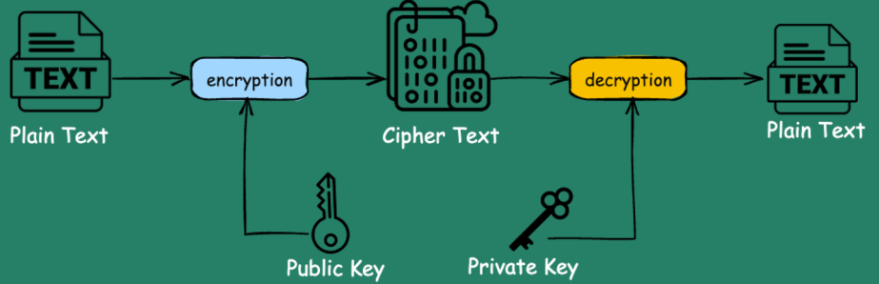

- Asymmetric key encryption is ideal for encrypting data in transit, where we need to share the key with another system.
- The most commonly used asymmetrical algorithms include:
- RSA – Rivest-Shamir-Adleman
- Diffie-Hellman
- ECC - Elliptic Curve Cryptography
- PGP – Pretty Good Privacy

- Still, we can’t use encryption for password management – We may have people inside the organization only to steal the secret key.
- Though, this encryption option is providing confidentiality option, it’s not providing integrity option.

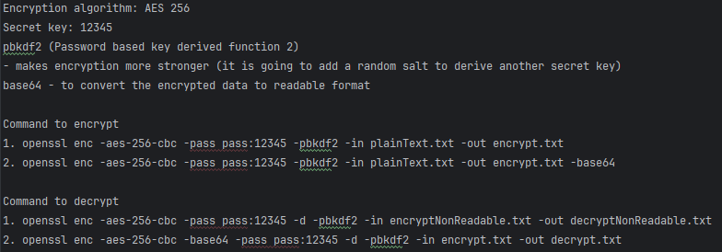

Hashing
- In hashing, data is converted to the hash value/digest value using some hash function.
- A hash function transforms input of any length (such as a file, message, or video) into a consistent, fixed-length output (e.g., 256 bits for SHA-256).
- When the same input is hashed, it always generated the same resulting digest or hash.

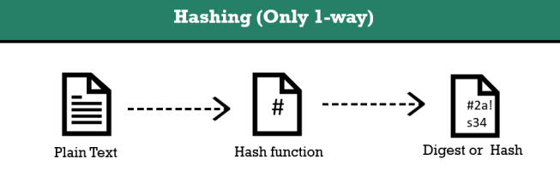

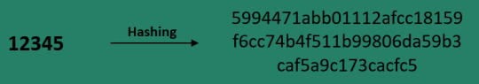

- A fundamental characteristic of a hash function is its irreversibility, meaning it is not possible to deduce the input from its output alone. This property is often referred as “one-way”.

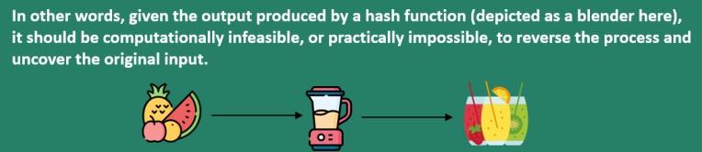

- Suitable for password management as integrity of data is maintained using hashing.

- We can also validate genuine application by comparing the generated SHA with provided SHA
- Command:
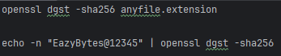

Drawbacks of Hashing
- Based on our discussion about the hashing, it is clear that no one can derive the plain text value based upon a given hash value becoz it’s irreversible. With this, we might be under assumption that hashing is 100% suitable for the password management but don’t come to this conclusion becoz there are certain drawbacks of hashing we need to discuss to making hashing 100% suitable for Password management.

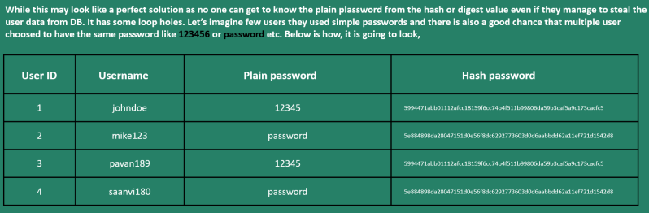

1. Hashing is always going to give same hash value if the input is same
- If an attacker gains access to hashed password in a DB, they could potentially launch a brute force attack or an exhaustive search (on Rainbow table) by trying all possible passwords.
- This method tests each attempt against the entire database of hashed passwords. Ideally, we aim to limit attackers to targeting only 1 hashed password at a time.

2. Hash functions are designed to be fast, which attackers can exploit to try numerous passwords per second during a brute force attack.
- Ideally, we should implement mechanisms to impede such attacks, slowing down the process significantly.

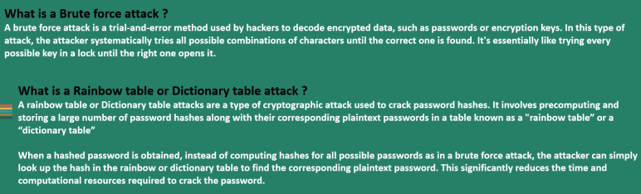

Solutions to overcome the drawbacks of Hashing

1. Using Salt during the password hashing
- To prevent Rainbow table attacks, Salts are commonly used.
- Salts are random values that’re unique for each user & are made public & generated at the time of user registration. The salt value is stored as part of resulting hash itself. Specifically, the salt is included in the hash string along with the actual hashed password.
- This salt can be stored as plain text value or encode it or encrypt it.
- The salt is typically stored/concatenated at the beginning of the hash string & is used during the password verification process to generate the same hash again for comparison.
- Since each user has a unique hash function, attackers can’t precompute large table of passwords (rainbow tables) to test against the entire database of stolen password hashes.

- Salt is not going to protect us from Brute force attack.

How brute force attack will be avoided?
Ans: Let’s understand when the brute force attack is going to happen – 2 such scenarios can be:

Case 1: The hacker doesn’t have original hash value of the end user & he just wants to hack someone’s account. He will keep on trying some random passwords via UI application or whatever mechanism the app has exposed.
- In this scenario, the salt is not going to protect us.
- Becoz during the login operation, the backend API is going to derive the salt value from the value that we’ve stored in DB & append to the value entered by the hacker inside the UI application.
- For e.g., Hacker guessed the password as 12345 for user1 & entered the password on UI then behind the scene, the BE is going to leverage the salt value & append to this user-entered value & it’s going to generate the overall hash value & hash is going to match.
- Here the salt is not protecting from brute force.

To avoid this kind of scenario, the organization is going to use various approaches:
- As soon as app detect someone enter 3 consecutive times wrong password, they will lock the account. With this hacker is going to have just 3 attempts. So, we’re trying to limit the hacker’s option here.
- Website will not accept the simple passwords like 12345 rather they will add criteria like at least 1 uppercase, 1 lowercase, min 8 digits, 1 special character etc. Due to this, the end user will end up picking up some strong password.

Case 2: Suppose hacker steals all the data present inside our organization DB. He has all the hash values of all the users along with salt i.e., salt + total hash value.
- In this scenario, hacker has to guess user original password & append it to salt value & check for the match with total hash value.
- This operation he has to perform for millions of guesses & it’s not going to be problem for him as hash function is super-fast.

To overcome this challenge, we need to make the hash functions intentionally slow.

2. Using Slow hashing algorithms to overcome brute force
- Brute force attacks issue can be solved with password hashes, which are designed to be slow.
- The normal hashing algorithm/process is quite fast, due to which attackers can do the trail & error by trying any number of plain passwords to check against hashed password.
- We can make attackers life tough by using password hashing algorithms like PBKDf2, bcrypt, scrypt & Argon2. These algorithms slow the hashing process & demands lots of CPU cost, memory cost.
- Based on the business requirement, we can slow the algorithm by 2 or 3 .. seconds.

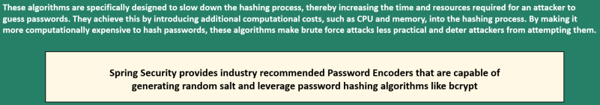

Q. If we slow the hashing algorithm, won’t it affect the organization itself?
- No, it’s not as a user is going to register or login not too many times & he can easily wait for 1 or 2 seconds.

How Password validated with Hashing & PasswordEncoders

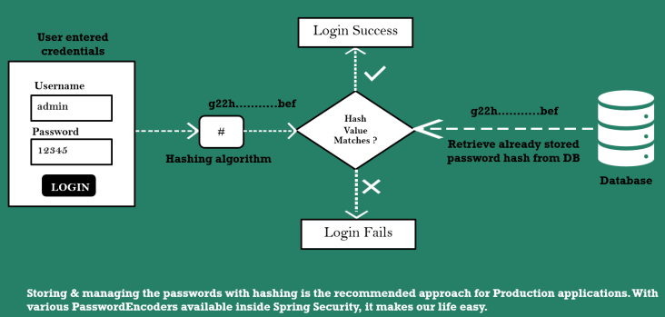

Password Encoders in Spring Security
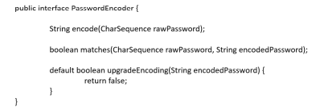

PasswordEncoder Interface implementations (1 – 6 in strength & complexity order)
- NoOpPasswordEncoder (Not recommended for Prod apps)
- StandardPasswordEncoder (Not recommended for Prod apps)
- Pbkdf2PasswordEncoder
- BCryptPasswordEncoder
- SCryptPasswordEncoder
- Argon2PasswordEncoder

Note: We can debug each of these encoders of understand the internal functionality. If we try to use the Scrypt or Argon2 Password Encoders, the configuration is going to be more tough becoz we need to right-tune the CPU cost, Memory cost, Parallelization cost so, we need to find the balance or sweet spot which is going to work for us.

Multiple Encoding Strategies with Delegating Password Encoder (PasswordEncoderFactories)
- When needing to switch password hashing algorithms in an application, such as due to a vulnerability, the DelegatingPasswordEncoder is handy.
- It allows managing multiple hash types simultaneously. For instance, it enables a new algorithm for new users while maintaining the old one for existing credentials.
- The DelegatingPasswordEncoder delegates to the correct implementation of the PasswordEncoder based on the prefix of the password.

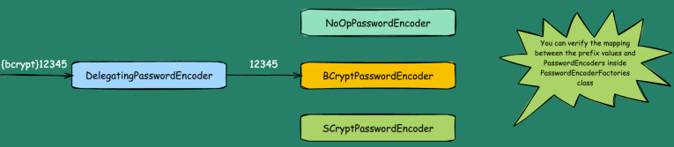

- During the user registration process, the DelegatingPasswordEncoder uses the default password encoder defined in the framework & appends the corresponding prefix to the encoded password.
- During the login operation, when we call the matches () method with a password that has prefix {bcrypt}, the call is delegated to the BcryptPasswordEncoder class.
- Similarly, based on the other prefix values, the corresponding password encoder will be selected.

Conclusion about Encoding, Encryption & Hashing

- For password, always go with the Hashing
- Symmetric encryption we can use in the scenarios where we want to encrypt the data in rest.
- Asymmetric encryption we can use in the scenarios where we want to encrypt the data in transit.
- BASIC 64, we just need to use in the scenarios where we can’t deal with the binary data.

Understanding Authentication Provider & implementing it

- The AuthenticationProvider in Spring Security takes care of the Authentication logic.
- The default implementation of the AuthenticationProvider is to delegate the responsibility of finding the user in the system to a UserDetailsService implementation & PasswordEncoder for password validation.
- But in case of below custom authentication requirement that is not fulfilled by Spring Security framework, then we can build our own authentication logic by implementing the AuthenticationProvider interface.

Imp. Point: It is the responsibility of the ProviderManager (an implementation of AuthenticationManager) to check all the implementation of AuthenticationProvider & try to authenticate the user based on the Authentication object type.

Why should we consider creating our own AuthenticationProvider (inbuilt is DaoAuthenticationProvider)
- With the help of already inbuilt Authentication Provider i.e., DaoAuthenticationProvider, we’re able to perform the authentication of the end user by loading the user details from DB with our own UserDetailsService implementation.
- As of now, we’re building small applications but in real projects/enterprise applications, the security requirement may not look very simple.
Scenario 1: We have a scenario where an enterprise application wants to provide multiple style of Authentication i.e., multiple Authentication Provider to allow the end user to authenticate via:
- Authentication Provider 1 - Username & password authentication for certain application
- Authentication Provider 2 - OAUTH2 authentication
- Authentication Provider 3 - JAAS authentication (Java Authentication & Authorization Service)
This scenario has a lot of complex security requirement.

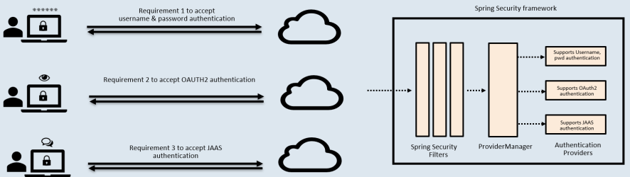

- For all the complex security scenarios, we need to write our own Authentication Provider implementations.

Scenario 2: By default, implementation DaoAuthenticationProvider is taking help from UserDetailsService implementation to the user service details.
Once the user details are loaded from the storage system, the actual authentication of password comparison & the decision of Authentication is going to happen inside the AuthenticationProvider but there will some scenarios where we can have our own custom Authentication requirements like:
- To allow the authentication of a user only if the user’s age is greater than 18.
- To allow the authentication only from certain countries.

- For this kind of custom requirement, DaoAuthenticationProvider is not going to help becoz whatever logic that we’re going to write inside the UserDetailsService implementation will load the user details from storage system but not help us to validate the age details or country details.
- To accommodate such requirements, we have to define own AuthenticationProvider implementation

Understanding AuthenticationProvider methods

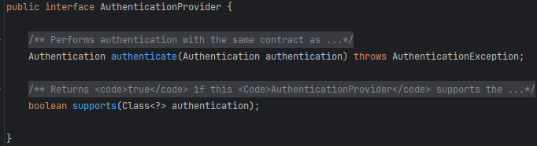

1. authenticate method
- Inside this method, the authentication logic is defined.
- The ProviderManager is going to invoke the authenticate () method with the Authentication object. The Authentication object has username, password, or any other details along with the authenticated boolean set to false.
- So, when we define our own custom AuthenticationProvider, we need to make sure we’re loading the user details from a storage system based on the authentication details that we receive & once we perform the credential matching, we can perform any other extra validation logic & at last, Authentication object will be returned indicating whether the authentication is successful or not.
- We can debug & check the above logic in AbstractUserDetailsAuthenticationProvider, DaoAuthenticationProvider

2. supports method
- Whenever we’re defining our own custom AuthenticationProvider, we need to tell the framework what type of authentication that our AuthenticationProvider is going to support.
- We can check DaoAuthenticationProvider for reference. It is going to support UsernamePasswordAuthenticationToken style of authentication.
- This means when our ProviderManager receives the Authentication object of type UsernamePasswordAuthenticationToken (implementation of Authentication object) then the ProviderManager is going to invoke the DaoAuthenticationProvider for the actual implementation.

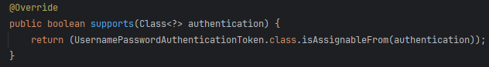

- Above kind of similar logic, we need to define under the supports () method, indicating what style of Authentication (refer this interface & its implementation) that our AuthenticationProvider is going to support.

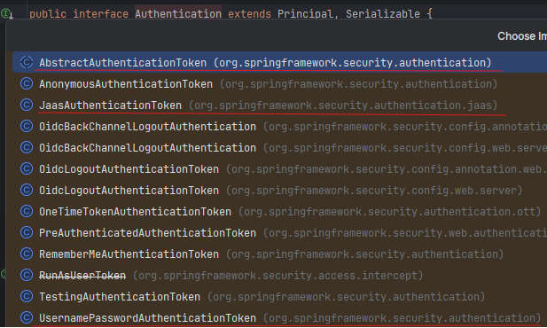

UsernamePasswordAuthenticationToken
- Whenever we’re trying to use login page / HTTP basic style of authentication to send the credentials, Spring Security behind the scene will create the object of UsernamePasswordAuthenticationToken.
- Same token will be forwarded to ProviderManager to DaoAuthenticationProvider.
- DaoAuthenticationProvider is the only AuthenticationProvider supporting Username, Password style of Authentication.

Oidc Token
- Oidc token is the token which is going to be used in the scenario of OAuth2.0 authentication

Jaas Token
- For applications supporting Jaas style.

AnonymousAuthenticationToken
- This token represents an end user who is anonymous i.e., user is trying to access the application without any security.
- For e.g., a public page or a public API

TestingAuthenticationToken
- This token object we can try to create in the scenario of Unit testing.
- If an application has unit testing, we don’t have to actually authenticate the end user every time for each & every scenario. To avoid the actual authentication scenarios, we can mark the entire authentication flow with the help of TestingAuthenticationToken

Sequence Flow with our own AuthenticationProvider implementation

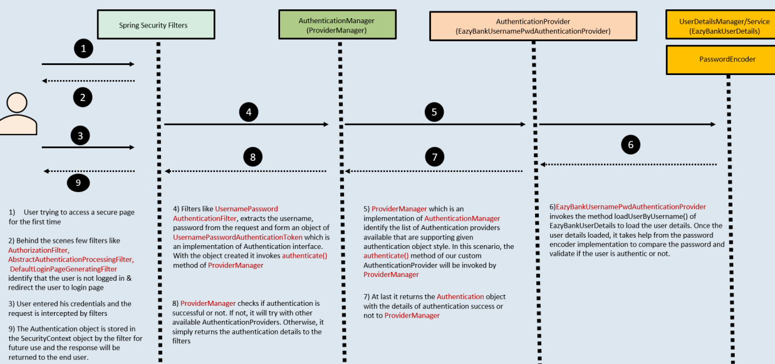

Sequence Flow with our own AuthenticationProvider implementation

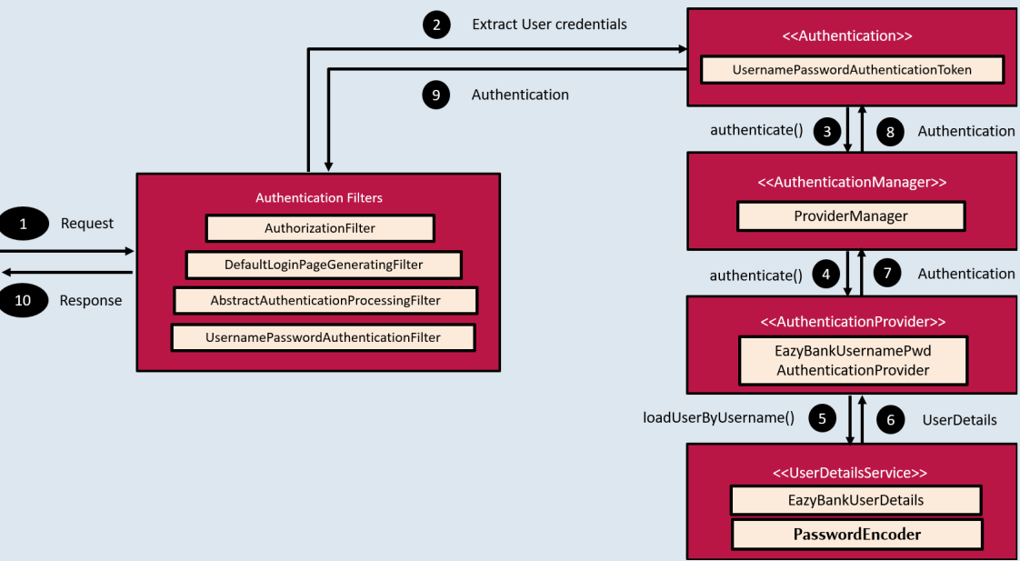

Environment Specific Security Configuration

- We can conditionally authenticate the end user based upon the environment where authentication is happening using the spring boot concept of Profiles.
- Using Profiles concept, we can conditionally load the properties, beans, create the beans.

Way 1: (Not Recommended) Activating specific profile by hardcoding the value inside the application.properties.

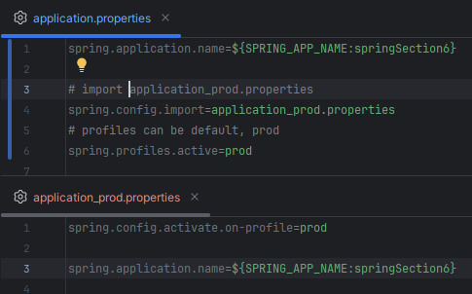

Disadvantage of Way 1
- Every time we need to change the profile, we have to manually update application.properties & build, generate jar & then deploy the same.

Way 2: Spring Boot allows to override properties from outside the application.
- i.e., we can have the same application jar or build file. The behaviour can be changed from outside by activating the profile.
- Using the environment variable, we can change the profile.
- The operation team can always create the environment variables & using the same they can always set specific profile values. Based upon the value present inside the environment variable, the spring boot will give priority to the same & it will not give priority to the values present inside the application.properties file.

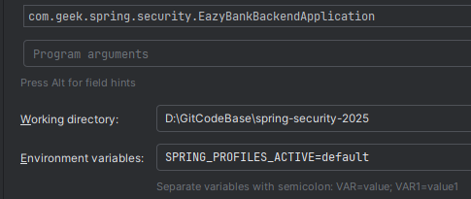

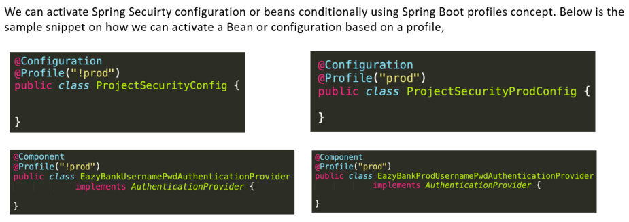

Spring Security Customizations for most common use cases

Accepting only HTTPS Traffic using Spring Security
- Any person who is trying to use a website or mobile application will only be comfortable if app accepts & process the request using the HTTPS protocol.
- With the help of HTTPS, every data that end user sends to the backend application will be properly secured.
- The end user can submit credit card details as well confidently.
- So, if you build a production app which is only accepting plain HTTP requests, then obviously no one is going to use your website.

- That’s why most of the organization will make sure that their Backend application accepts only the HTTPS protocol but not HTTP protocol.
- This can be achieved easily with the help of Spring Security Framework.

Note:
- By default, if we’re not making any HTTPS related configurations, then the Spring Security will accept both kinds of traffic (HTTP & HTTPS)
- We can use below config to allow only HTTPS protocol requests.

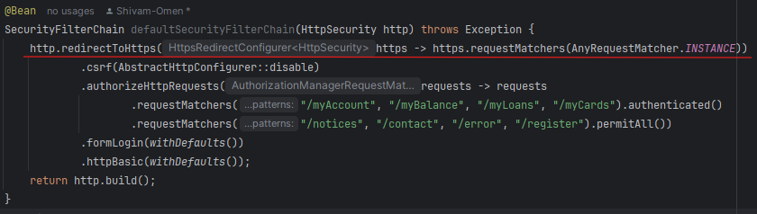

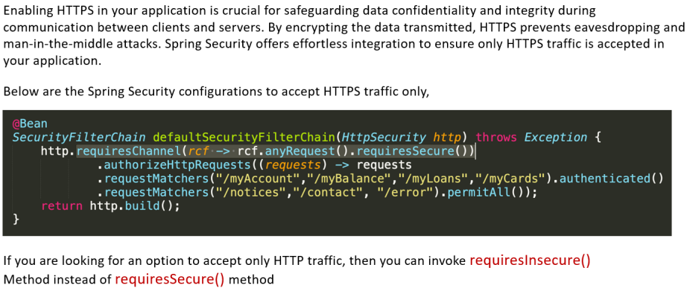

Exception Handling in Spring Security Framework
- If a client attempts to access a protected resource without authentication or proper authorization, they should be prompted to provide credentials to access the resource.
- This can be achieved by either redirecting the client to a login page in the UI or by informing them about the situation through the API Response (Custom Response instead of inbuilt one)
- Inside Spring Security authentication & authorization related exceptions are handled by ExceptionTranslationFilter

In general, Spring Security framework doesn’t worry about all kind of business exceptions or runtime exceptions raised in our application. It is only going to worry & handle Security related exceptions. Inside the Security framework, there are 2 types of exceptions that may happen:

1. AuthenticationException
- Result in status as 401.
- 401 indicates that the person/client application is not authenticated.
- Extended exception classes – BadCredentialsException, UsernameNotFoundException etc.

2. AccessDeniedException
- Result in status as 403 (Forbidden).
- 403 indicates that the person/client application is properly authenticated but they don’t have enough privileges or roles to access a secured API.
- Extended exception classes – AuthorizationDeniedException, CsrfException etc.

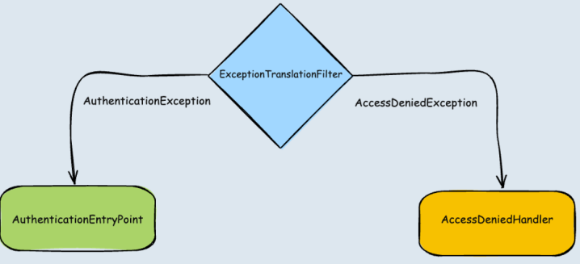
Spring Security is going to worry on how to handle only these 2 types of exceptions. Inside Spring Security we’ve a filter which is going to monitor these 2 exceptions & this filter name is ExceptionTranslationFilter

The responsibility of ExceptionTranslationFilter is to check what is the type of exception raised.
Case 1: If it’s related to the AuthenticationException, it’s going to invoke the AuthenticationEntryPoint related implementation.

Case 2: If it’s related to the AccessDeniedException, it’s going to invoke the AccessDeniedHandler related implementation.

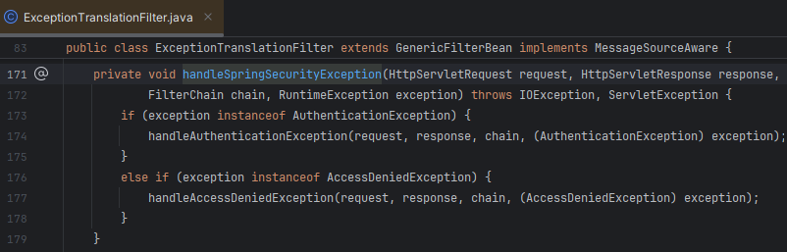

AuthenticationEntryPoint
- AuthenticationEntryPoint is an interface inside the Spring Security framework, which is responsible to handle all Authentication related exceptions.
- AuthenticationEntryPoint serves as a handler for unauthenticated access attempts, determining how to respond when someone tries to access a part of our side or API without the authentication.
- It might redirect users to a login page or return an error message indicating that authentication is necessary.

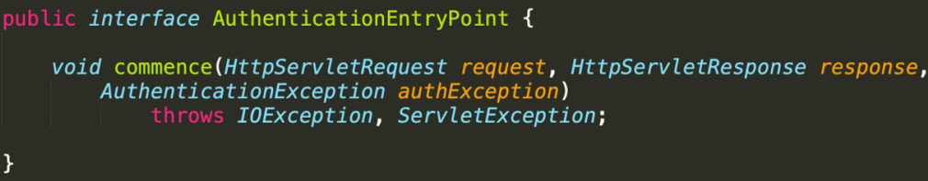

- LoginUrlAuthenticationEntryPoint, BasicAuthenticationEntryPoint are the few of the Spring Security provider implementations of AuthenticationEntryPoint interface that gets executed by default in case of AuthenticationException.

Defining Custom AuthenticationEntryPoint inside Spring Security Framework

Step 1: We need to create an implementation class using AuthenticationEntryPoint interface & by overriding the commence () method. Inside the commence () method, we can build logic on what response to send back to clients based on our requirements,

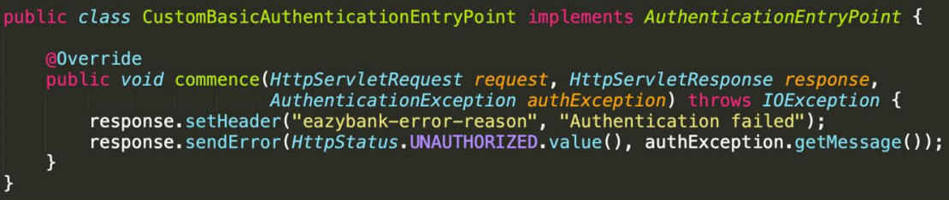

Step 2: The CustomBasicAuthenticationEntryPoint created in the above step can be configured for the httpBasic flow like shown below,

- We can also configure custom AuthenticationEntryPoint globally that is common for all login types using exceptionHandling configurations.

Note:
The authenticationEntryPoint() we’re using for httpBasic configuration is not applicable for formLogin as during the form login, we’re going to deal with UI pages but not with Json response, the UI end user doesn’t bother about Response Header, Response Body, that’s why whenever we’re trying to use the form login, we have other types of config we can use like login page etc.

AccessDeniedHandler

- AccessDeniedHandler interface serves as handler for AccessDeniedExceptions

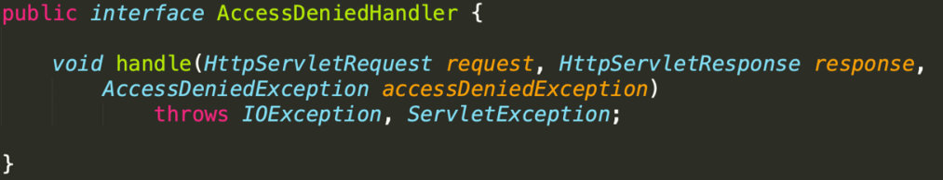

- AccessDeniedHandlerImpl is the most commonly used handler by the Spring Security framework.

Define Custom AccessDeniedHandler inside the Spring Security framework

Step 1: We need to create an implementation class using AccessDeniedHandler i/f & by overriding the handle () method. Inside the handle () method, we can build logic on what response to send back to clients based on our requirements.

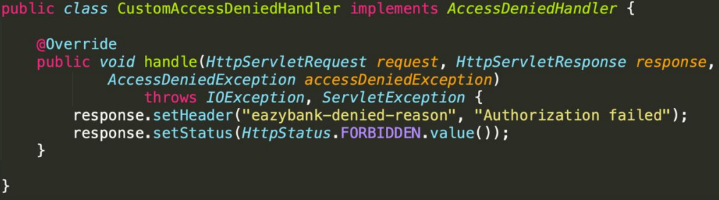

Step 2: The CustomAccessDeniedHandler created in the above step can be configured using exceptionHandling ()

Note:
Getting JSON response may not be an ideal response for an UI application. So, your application is strictly an UI based application, then there is an option available that we can explore.

By using above config, whenever in our application if there is 403 error, the end user will be redirected to the MVC path “/denied”

Session Timeout & Invalid Session configurations

- Session created post login will have default timeout of 30 minutes i.e., the JSESSIONID created by Spring Security framework, by default it’s going to have 30 minutes as a session timeout.
- Post 30 minutes, the end user will be redirected to the login page.
- We can customize this timeout based on our requirement & criticality of the application.

Note: Spring boot never allows a timeout less than 2 minutes.
- Once the session expired, the end user will be redirected to the login page. This behavior may not be user friendly becoz the end user will be clueless on why the login page is being displayed suddenly.
- To handle the invalid sessions/tampered session id properly, we can redirect the end user to a different URL or page with session timeout details.

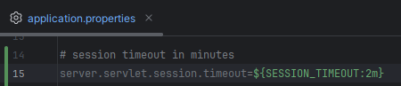

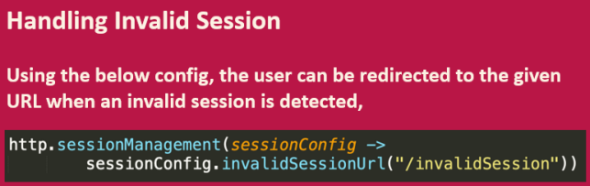

Concurrent Session Control Configuration
- By default, the Spring Security framework is not going to enforce any constraints or any control on how many concurrent sessions an end user can have. The end user can have any no. of sessions by default.
- But in real application, we may want to restrict the end user to have only a single or may be 2 or 3 concurrent sessions depending upon the business requirements.

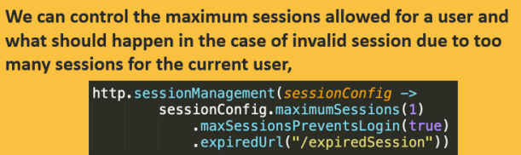

Session Hijacking Attack
- In this attack, the attacker steals the session ids for a web application by eavesdropping on the communication b/w a user & an application or by gaining access to the user’s computer or web browser data.
- Mostly this happens in 2 scenarios
- Session Id mentioned in the URL itself
- Session Id saved as a cookie in the browser
- In above 2 scenarios, if the hacker steals the session Id, then using the same, he can perform some action on the behalf of the user.
- For e.g., we’ve used a public computer in one to login somewhere then the session id associated with the login will be available inside the browser as a cookie or URL or hacker can steal the session id while our request is traveling through the network.
- To avoid session hijacking attack, there are multiple approaches:
- Use HTTPS protocol for communication (hackers can’t steal the session id during the network traffic or while the request is traveling through the internet)
- Limit session id timeout for short time (10 min – 15 min) so that public login session will expire ASAP.
- Add checkbox (if using public computer) for end user during login operation. Accordingly, organization can be cautious while creating cookies.

- Imp. Point – In case of Session Hijacking, Spring Security directly doesn’t play any role. Using above approaches we can secure our application against the same.

Session Fixation Attack
- Session Fixation attacks are a potential risk where it is possible for a malicious attacker to create a session by accessing a site, then persuade another user to log in with the same session (by sending them a link containing the session identifier as a parameter).
- Spring Security protects against this attack automatically by creating a new session or otherwise changing the session ID when a user logs in.
- One such scenario example: (Session Fixation Attack Flow)

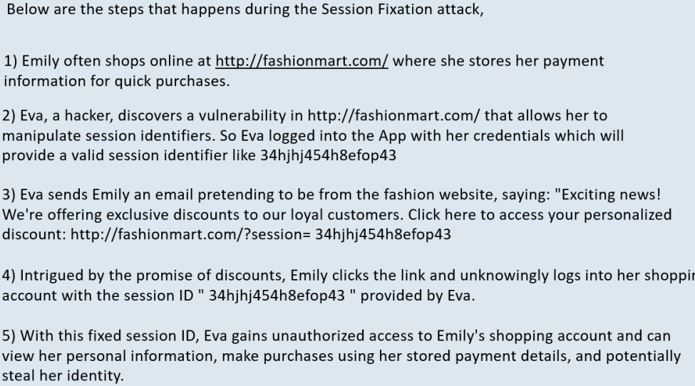

- We have 3 options to control the strategy for Session fixation protection by following the below configuration:

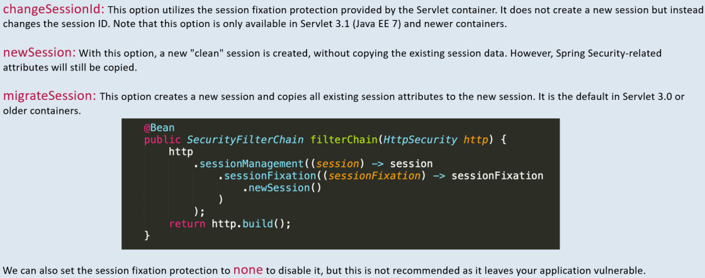

Authentication Events
- For each authentication that succeeds or fails, a AuthenticationSuccessEvent or AbstractAuthenticationFailureEvent respectively is fired by Spring Security framework.
- Spring Security provided DefaultAuthenticationEventPublisher takes care of publishing these events to the listeners.
- We as developers just need to build listeners to listen to these events & execute business logic based on our requirement.

- By using Spring’s @EventListener support, we can listen to the Authentication success event & failure event.

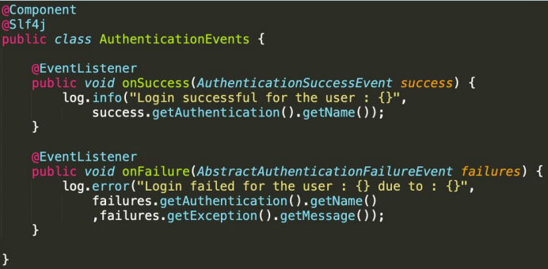
Use cases:
Many time inside real applications, we may have requirements to handle authentication event. For e.g., on successful or failed authentication, we may want to send an email to the end user. This may be required for super critical application.

Form Login Configurations for MVC or Monolithic apps

- For form-based logins, Spring Security already provides a simple login page. But this behavior can be changed with the below configurations:

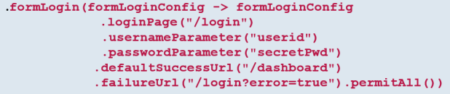

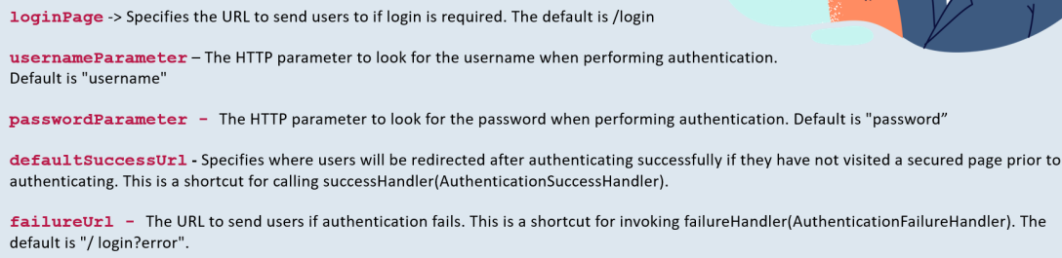

- If we want more control on the successful authentication & failure authentication of form login, we can configure the successHandler & failureHandler like below:

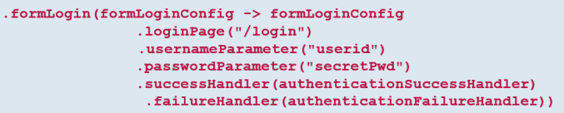

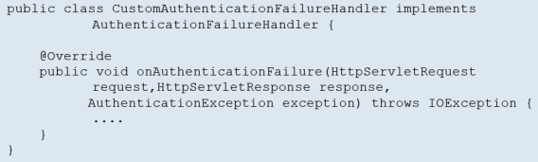

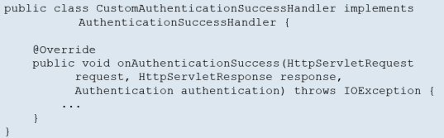

Logout Configuration for MVC or Monolithic apps

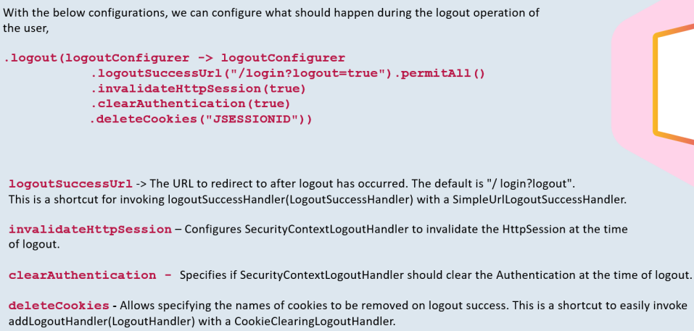

Spring Security Thymeleaf Integration

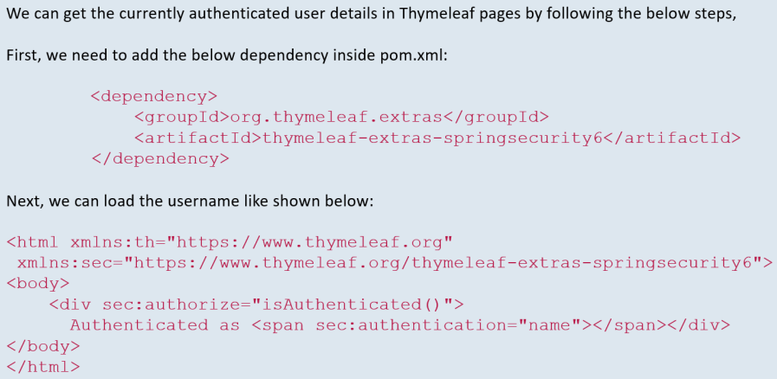

Spring Security JSP Integration

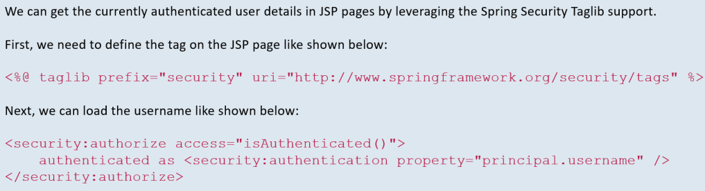

Role of SecurityContext & SecurityContextHolder

- At the heart of Spring Security’s authentication model is the SecurityContextHolder. It contains the SecurityContext.
- The SecurityContextHolder is where Spring Security stores the details of who is authenticated like Principal or username, Credentials like password & Authorities.
- Spring Security doesn’t care how the SecurityContextHolder is populated. If it contains a value, it is used as the currently authenticated user.

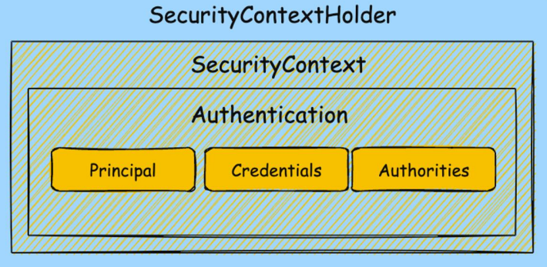

- After the authentication process, we may need details about the authenticated entity, such as username or authorities of the current user. This information remains accessible even after authentication is complete.
- Once the AuthenticationManager successfully completes the authentication process, it stores the Authentication instance for the rest of the request. The component responsible for storing this object is called the SecurityContext.
- The security context is stored in a SecurityContextHolder.

- SecurityContext is an interface defining the minimum-security information associated with the current thread of execution.
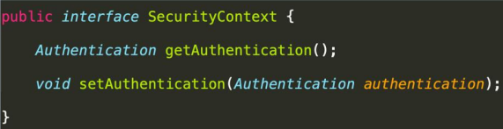

- SecurityContextHolder is a helper class that provides access to the security context. By default, it uses a ThreadLocal object to store the security context, ensuring it always available to methods in the same thread, even if you don’t explicitly pass it around.
- We don’t need to worry about ThreadLocal memory leaks in web applications, as Spring Security handles the cleanup.
- Additionally, SecurityContextHolder can be configured with different strategies for storing the security context.

Note:
- Once the authentication action is completed, the Spring Security framework is going to store the authentication details inside the object of SecurityContext. (SecurityContext is an interface with SecurityContextImp as its implementation).
- This SecurityContext is going to be managed by a class “SecurityContextHolder”. This holder class is responsible to manage the details inside the SecurityContext. It exposes various methods to clear the SecurityContext, add new details to the SecurityContext, update i.e., all the CRUD operation related to the SecurityContext along with other utility methods.
- Spring Security framework is going to leverage this holder class to a great extent whenever it’s trying to store or deal with the SecurityContext object.
- We don’t have to implement our own SecurityContext or SecurityContextHolder.

Holding Strategies for the Security Context

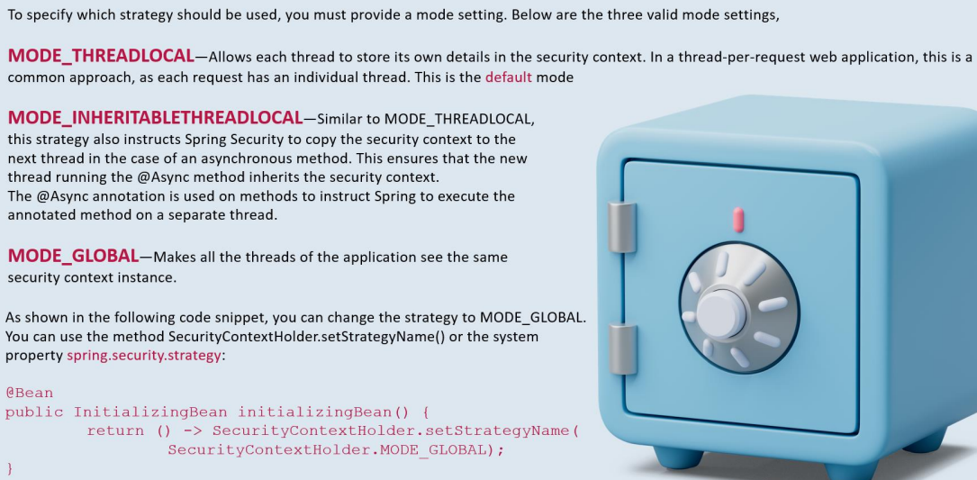

Load login user details in Spring Security

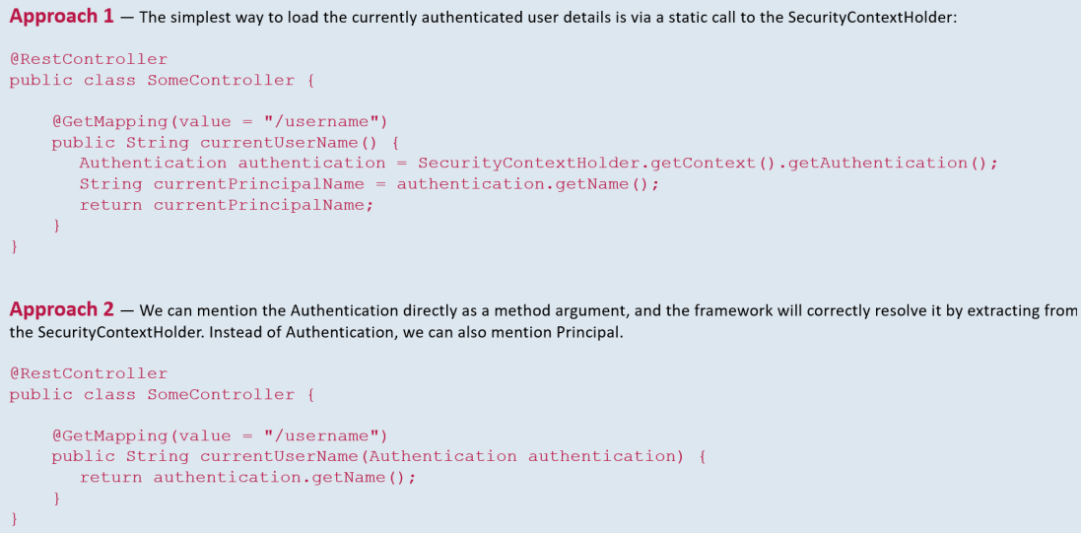

Section 8: Understanding CORs & CSRF

Setting up the EazyBank UI Project

- Download & install node.js from https://nodejs.org/en/download/ as per your OS & check if the installation is successful using the command ‘node -v’ which will print the current installed version.
- Run the command ‘npm install -g @angular/cli’ to install Angular CLI
- Download the visual code using the link https://code.visualstudio.com/ and import the angular provided.
- Navigate to the folder inside the project where package.json is present and run the command ‘npm install’ by opening a terminal. This will install all the dependencies inside the new folder created with the name ‘node_modules’
- Run the command ‘ng serve’ & it will start the application at http://localhost:4200/ by default.

Now we can run the UI & BE application.

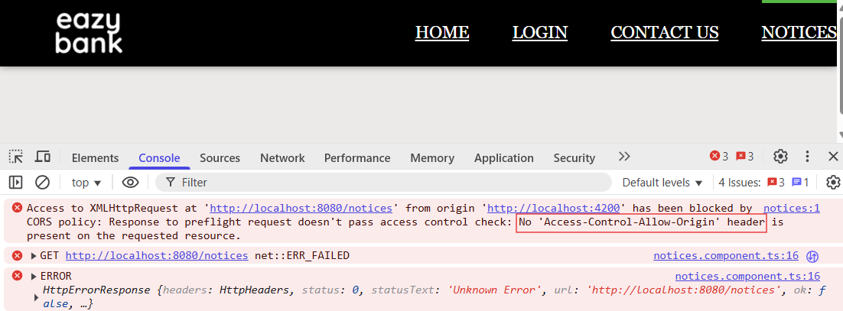

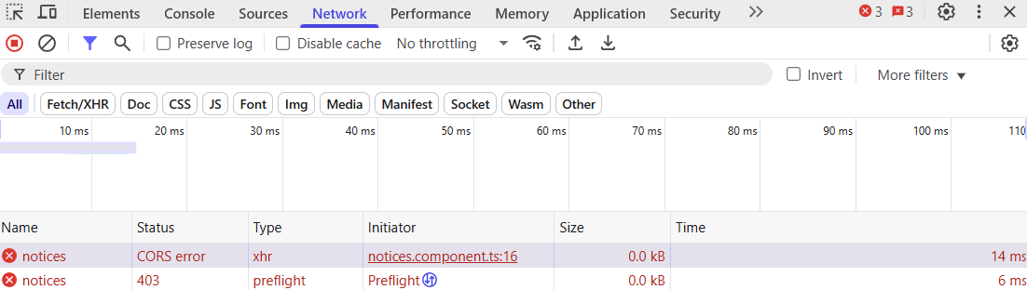

Why our UI resource is not able to access the Backend resource?
Ans: CORS policy (A Specification from W3C implemented by most browsers)

Browser default behavior
- Firstly, browser will send a preflight request to the BE resource and in response the BE server will send the proper response header indicating all the accepted origin details
- Post Preflight success request, the actual request with the Request headers will be sent to the BE resource.
- In case Preflight Request fails, the actual request will fail with CORS error.

Cross – Origin Resource Sharing (CORS)
- CORS is a protocol that enables scrips running on a browser client to interact with resources from a different origin.
- For e.g., If a UI app wants to make an API call running on a different domain, it would be blocked from doing so by default due to CORS.
- So, CORS is not a security issue/attack rather the default protection provided by browsers to stop sharing the data/communication b/w different origins.

“Other origins” means the URL being accessed differs from the location that the JavaScript is running from, by having:
- A different scheme (HTTP or HTTPS)
- A different domain
- A different port



Note:
- Understanding Analogy: Indian mobile number receiving call from Indian number & London number.
- CORS policy only comes into pic when UI app & BE app are on different servers (not deployed on the same server/origin)

Solution to handle CORS

Way 1: Using @CrossOrigin annotation on class or method level [Not Recommended]

- If we’ve a valid scenario, where a web app UI deployed on a server is trying to communicate with a REST service deployed on another server, then this kind of communication we can allow with the help of @CrossOrigin annotation.
- @CrossOrigin allows clients from any domain to consume the API.

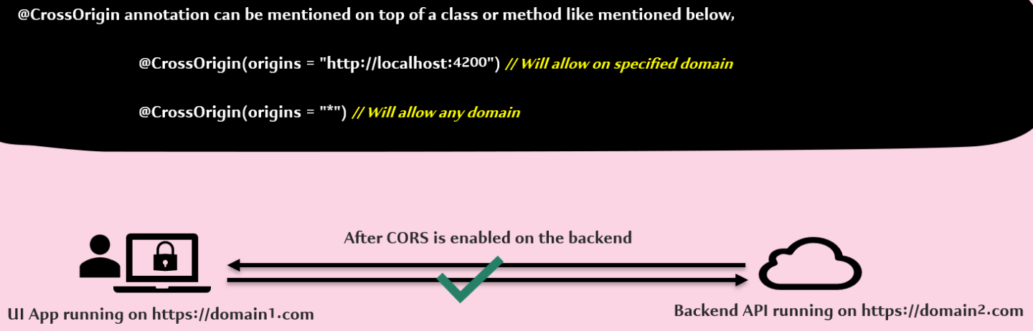

Drawback of Way 1:
- In case we’ve 100 controllers in our project then we’ve to add @CrossOrigin annotation to each controller & in case in future it would be a tedious job to add new origin to each controller.
- This approach is not preferable.

Way 2: Defining CORS related configurations globally using Spring Security [Recommended Approach]

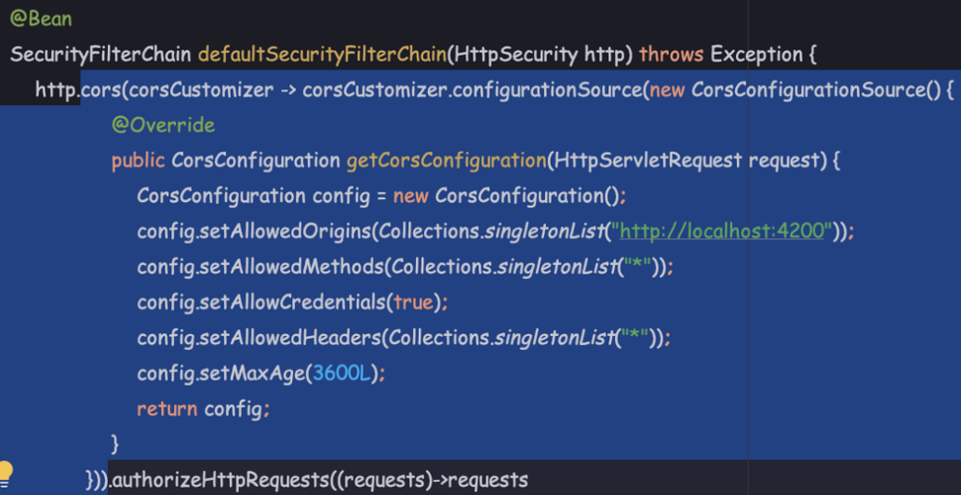

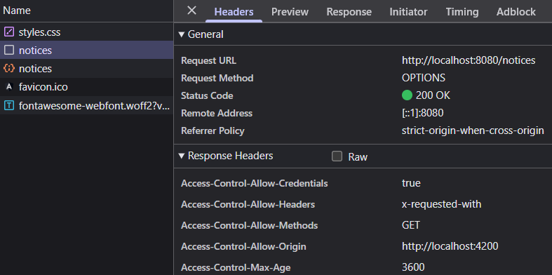

- Based on the configuration we’ve provided, all these CORS related details will be loaded inside the Response Header of Preflight Request with the help of CorsFilter.
- CORS consider localhost:3000 & 127.0.0.1:3000 as different origins.

CSRF Protection

Cross – Site Request Forgery (CSRF)
- Disabling the CSRF protection provided by Spring Security is not recommended for production applications. We need to properly implement a solution to handle the CSRF attacks.
- If you don’t implement CSRF related solution inside your application, then by default Spring security is going to stop all the HTTP methods (altering or creating the data) like POST, PUT, DELETE. Only GET will be allowed.

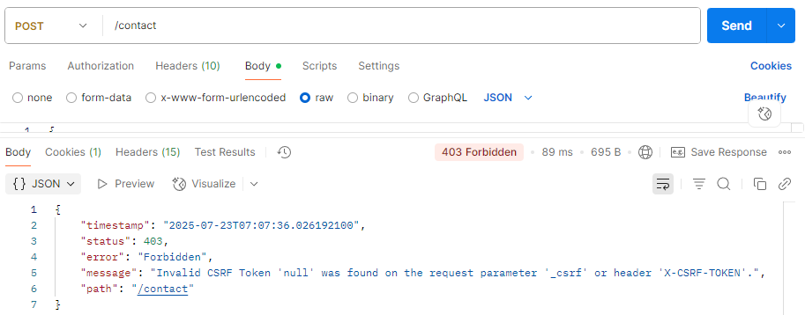

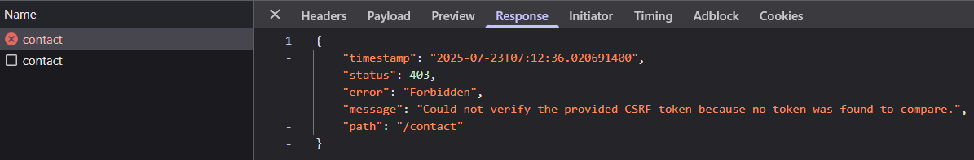

- We’re getting above error from both Postman & UI application becoz we’re trying to create a new data with POST method but we’re not passing any CSRF token as part of the Request.
- Whenever the CSRF token is missing, the Spring Security will assume that someone is trying to attack the application with CSRF attack. That’s why it stops processing the request by throwing 403 statuses.

Introduction
- Forgery – If someone tries to exploit you without your knowledge we call such kind of activity as Forgery. For e.g., Someone got your cheque book & forge your signature.

- A typical Cross-Site Request Forgery (CSRF or XSRF) attack aims to perform an operation in a web application on behalf of a user without their explicit consent.
- In general, it doesn’t directly steal the user’s identity like credentials or JSession Id or Cookie instead it will trick/exploit the end user to carry out an action without their will.

- E.g., We’re using a website netflix.com & the attack’s website is evil.com

Step 1: As soon as the end user enters his credential, the netflix.com backend server is going to authenticate & post Authentication, the Backend server will provide a cookie against the domain name (netflix.com) that is going to be stored inside the browser.

Note: This cookie will be used by netflix.com for further actions (without asking for login again). The beauty of cookies are they’re usually bound to a domain name (i.e., amazon.com will have different cookie than netflix.com). So, it’s Browser’s job to attack the cookie whenever a request is made to netflix.com

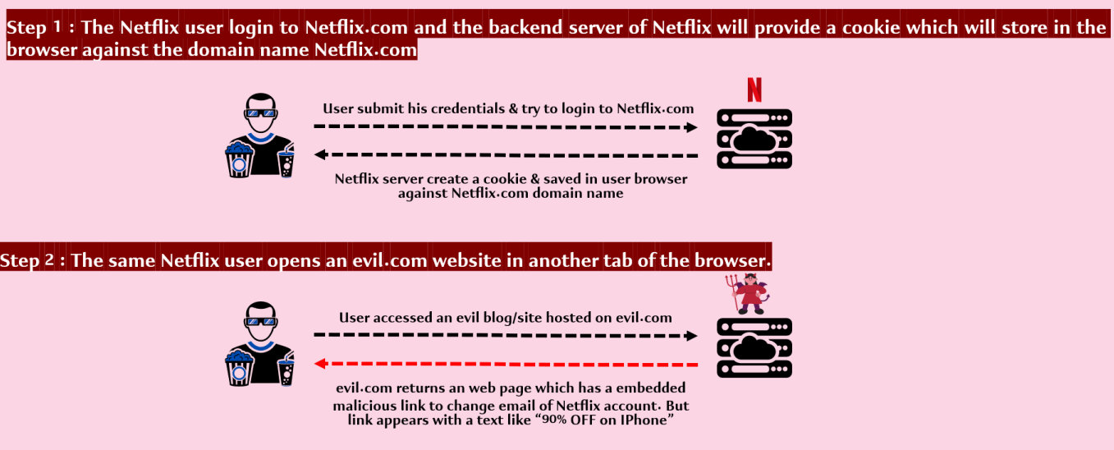

Step 3: The problem here is netflix.com backend server is not able to differentiate whether the request is coming from evil.com or netflix.com becoz even the hacker is trying to send the request to the netflix.com only not to another domain.

Since this malicious form is getting invoked from the same browser (different tab), the browser is going to still attach the cookie of the netflix.com while it is making the request to BE of netflix.com

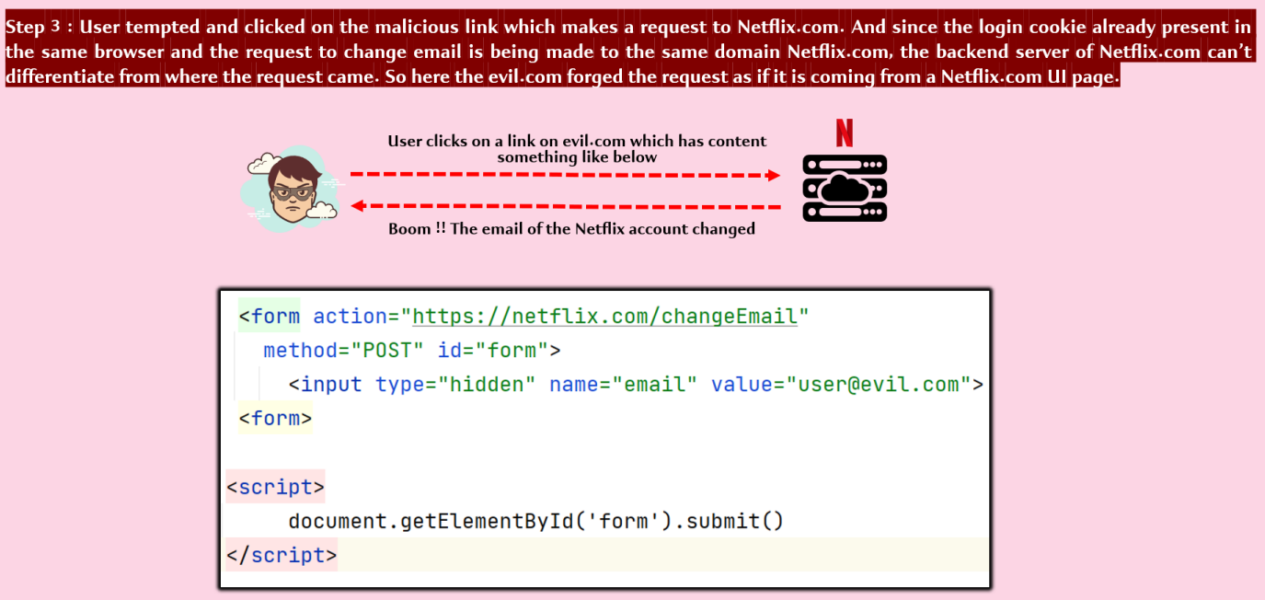

Note:
- Regardless whether the CORS is implemented or not, still the CSRF attack is possible in above scenarios.
- Becoz the malicious embedded form is maintained by the hacker inside evil.com & the advantage with embedded form is whenever someone is making a request to an action using an embedded form, the browser will think the request is originated from their domain (netflix.com) itself.
- netflix.com backend server never know that the embedded form is present inside another domain (i.e., evil.com)
- That’s why CORS is not going to be helpful in this scenario.

Solution to CSRF Attack
- To defeat a CSRF attack, applications need a way to determine if the HTTP request is legitimately generated via the application’s user interface (i.e., netflix.com not from evil.com), the best way to achieve this is through a CSRF/XSRF token.
- CSRF token is a secure random token that is used to prevent CSRF attacks. The token needs to be unique per user session & should be of large random value to make it difficult to guess.

Step 1: Backend will generate CSRF/XSRF token along with JSESSION ID and attach & store them to the cookie inside browser.

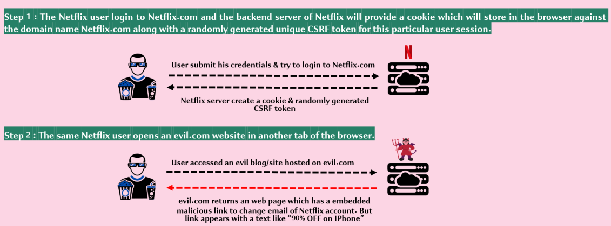

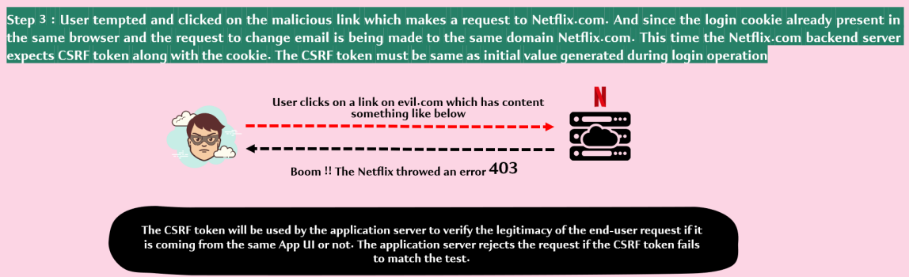

Q. How the backend server is differentiating even though the hacker request has 2 cookies attached?
Ans:
- When the UI application is trying to make a POST/PUT/DELETE request, the Backend server is going to expect the CSRF/XSRF token values at 2 places
- CSRF token as part of Request (Header/Payload depending on UI/Backend server agreement)
- CSRF token as part of Cookie

1. CSRF token as part of the Request (Header/Payload)
- The hacker will not be able to send the CSRF token as the part of Request.
- In order to send the cookie value inside the Request Header/Body, the Client application have to manually read the cookie value using JavaScript. Once the cookie value is read by JS code, the CSRF token value will be populated to Header/Body in the same JS code.
- The Hacker won’t be able to perform above operation from the JavaScript code inside evil.com becoz whenever JavaScript is being executed from a given domain, the JS code can read only the cookies related/belonging to the same domain.
- So though hacker can manage to build client-side code with JS to read cookie value inside the browser of the end user but this JS code will not work becoz the browser will stop evil.com JS code from reading the cookie belonging to netflix.com
- This way hacker would not be able to send cookie value inside the Request. With this, the backend server will easily identify that it got the token only as part of Cookie not as part of Request & with that it will throw 403.

2. CSRF token as part of the Cookie
- Sending the CSRF token as part of Cookie is taken care by the Browser automatically for the specific domain so by leveraging the same, the hacker will be able to send the token value inside the cookie.

Important interfaces/componet that handles CSRF attacks in Spring Security

1. CsrfToken interface
- org.springframework.security.web.csrf.CsrfToken
- Provides the information/contract about an expected CSRF token. Implementation classes:
- DefaultCsrfToken – A CSRF token that is used to protect against CSRF attacks.
2. CsrfTokenRepository interface
- org.springframework.security.web.csrf.CsrfTokenRepository
- Provides the contract to create, store & load CSRF tokens. As a developer, we don’t need to explicitly generate the CSRF token during the login operation. Implementation classes:
- HttpSessionCsrfTokenRepository – Stores the CsrfToken in the HttpSession [Not Recommended]
- CookieCsrfTokenRepository – Persists the CsrfToken in a cookie named “XSRF-TOKEN” & reads from the header “XSRF-TOKEN” following the conventions of Angular

3. CsrfTokenRequestHandler interface
- A callback interface that is used make the CsrfToken created by the CsrfTokenRepository available as a request attribute.
- Implementations of this interface may choose to perform additional tasks or customize how the token is made available to the application through request attributes.
- Implementation classes:
- CsrfTokenRequestAttributeHandler – It is capable of making the CsrfToken available as a request attribute & resolving the token value as either a Header or Parameter value of the request.

4. CsrfFilter class
- Spring Security inbuilt filter responsible to validate the CSRF token received by client & to decide whether to throw an exception or not.
- All the validation logic is present inside CsrfFilter class doFilterInternal () method. We can debug & see.

5. CsrfCookieFilter (Custom Filter)
- Custom Filter written by Developers to send the generated CSRF token back to client side inside the response header.

Note:
- We will create CookieCsrfTokenRepository using CookieCsrfTokenRepository.withHttpOnlyFalse() method. WithHttpOnlyFalse () method will create the CookieCsrfTokenRepository instance & set a variable cookieHttpOnly as false.
- When we’re setting cookieHttpOnly = false, we’re letting the UI framework / JS code to read the cookie value. By default, all the cookies that’re going to be generated will have cookieHttpOnly = true that signifies only browser can read & attach the cookie for each HTTP request but our JS/Angular code will not be able to read the cookie manually.

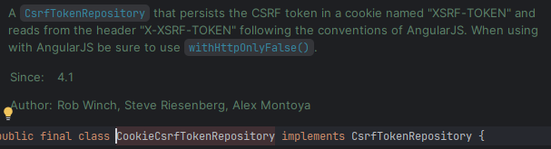

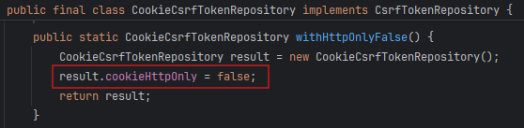

- Above config should be good to generate the CSRF token value.
- But whenever we’re getting CsrfToken value using CookieCsrfTokenRepository class, behind the scene the token is going to be generated Lazily i.e., until unless someone is trying to read the token value manually, the token is never going to be generated & the cookie will also be not generated.
- This has been done intentionally by Spring Security framework to achieve some performance as not all the requests need the CSRF token & cookies. For e.g., GET APIs (unnecessarily loading & reading CSRF token is going to attract some performance issues)
- Since the token is getting generated lazily, the CSRF cookie we’re expecting from the backend to UI will never be generated automatically. We need to write a piece of logic to read the token manually. Once the token is read manually, behind the scenes, Spring Security will take care of generating the token value, generating the cookie, & sending the same to the UI framework.
- In order to read the token value manually, we have to define a filter:

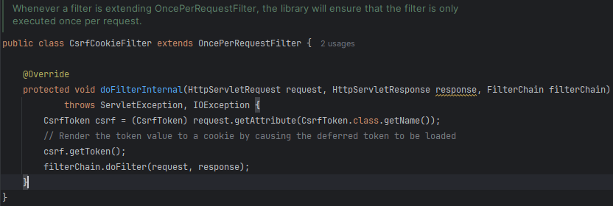

- We also need to pass CsrfTokenRequestHandler to the security configuration so that csrf token from the Request Header/Body can be extracted. We can debug & see CsrfTokenRequestAttributeHandler, CsrfFilter class – doFilterInternal () method.

- From now onwards, we’re going to use a separate UI application (separate login page) to login the user & the credential will be sent to the backend server in the HttpBasic format.
- In above scenarios, Spring Security by default is not going to generate the JSESSION ID. We need to explicitly tell the Spring Security framework to generate the JSESSION ID so that all the subsequent request can be invoked without passing the credentials.
- We can configure above using sessionManagement method & passing sessionConfig.sessionCreationPolicy():
- SessionCreationPolicy.ALWAYS – Always create an HttpSession so that it can be reused again & again to access the secured APIs.
- SessionCreationPolicy.NEVER – Spring Security will never create an HttpSession but will use the HttpSession if it already exists.
- SessionCreationPolicy.IF_REQUIRED – Spring Security will only create an HttpSession if required
- SessionCreationPolicy.STATELESS – Spring Security will never create an HttpSession & it will never use it to obtain the SecurityContext.

- Whatever JSESSION ID gets generated using the Security config session configurations i.e., using sessionCreationPolicy, will not be automatically stored inside the SecurityContextHolder.
- Either we need to manually store the JSESSION ID inside the SecurityContextHolder or make the configuration so that Spring Security framework can take care for us.
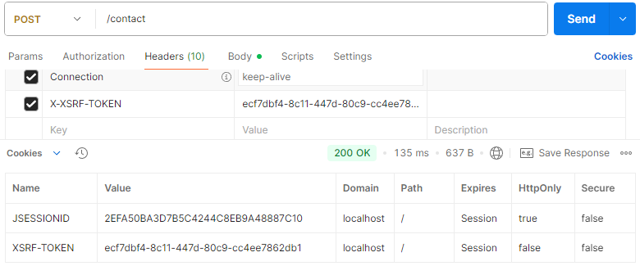
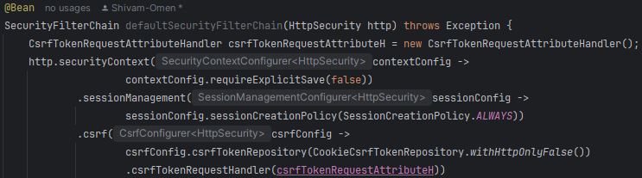

- For public pages, there is no need of CSRF protection as hacker will not be able to get any sensitive data from here. He can only submit new data. Make sure all these public APIs are permitted

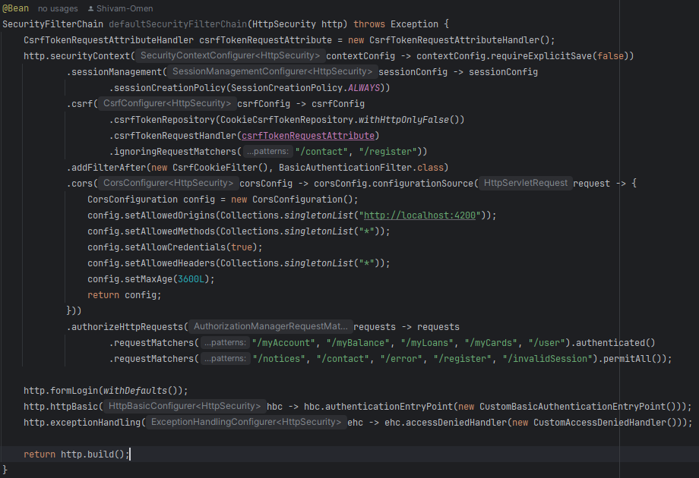

Section 9: Implementing Authorization using Authorities, Roles

Authentication Vs Authorization

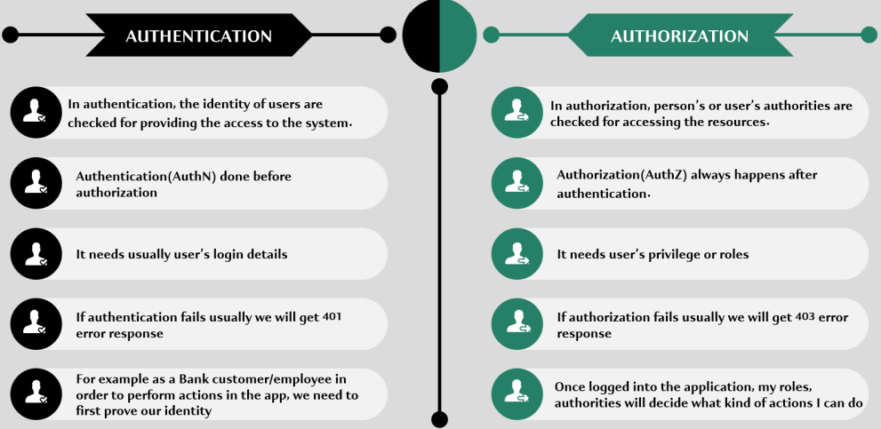

How the Authorities or Roles get stored inside Spring Security
- Authorities/Roles information in Spring Security is stored using GrantedAuthority interface. There is only one method inside this interface that returns the name of the authority or role.
- GrantedAuthority i/f defines the schema that anyone has to follow if they want to store roles or authorities’ information.
- Implementation classes: SimpleGrantedAuthority (most commonly used Impl)
  - SimpleGrantedAuthority stores a string representation of an authority granted to the Authentication object.

Inside Spring Security framework, we represent the user – related data by using 2 different interfaces & its implementation classes
- UserDetails i/f – During the authentication, while loading the UserDetails from the storage system, UserDetails implementation class object will be used to store user details.

- Authentication i/f – Once authentication is successful, the logged-in user details will be stored in Authentication implementation class object.

Note: We can debug the above interfaces & implementation classes to understand how they’re storing the authorities or roles information of an end user.

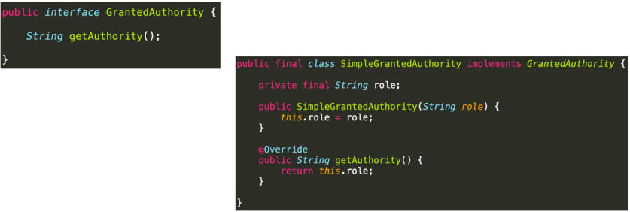

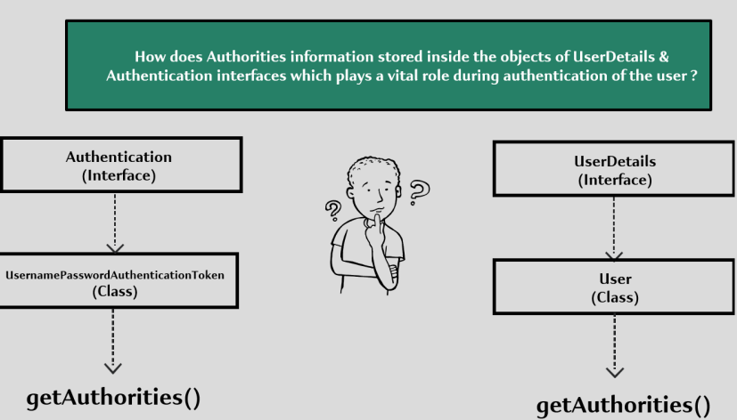

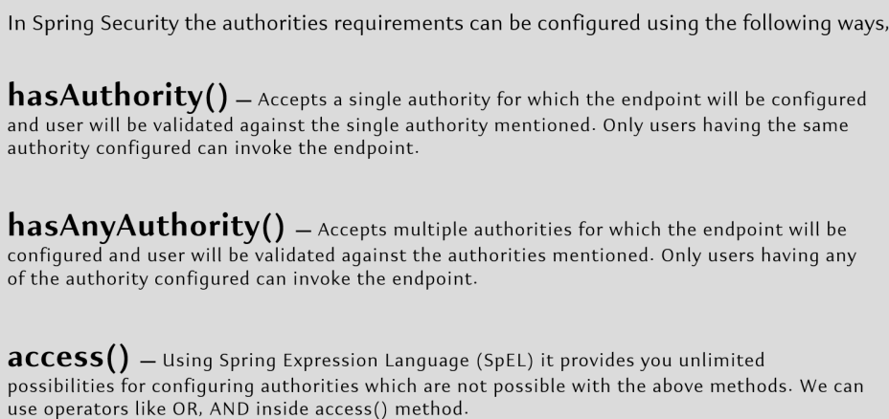

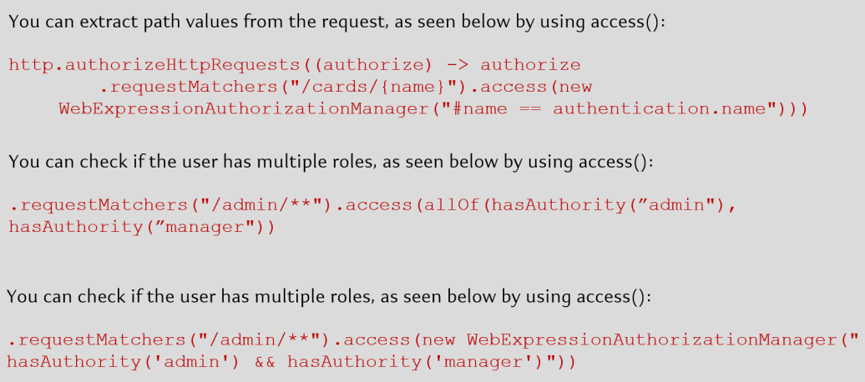

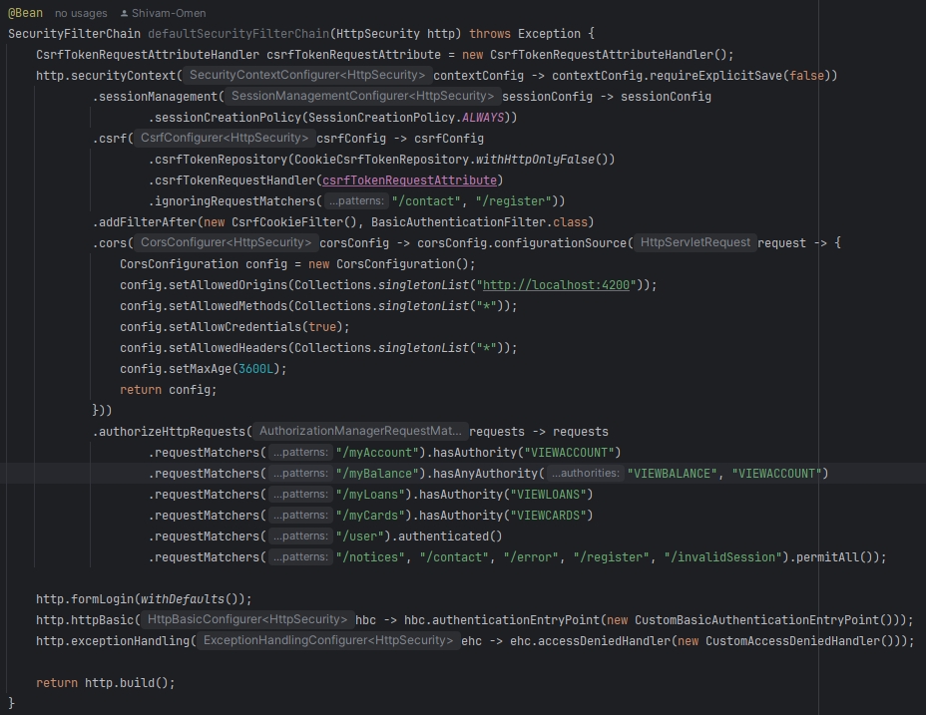

Authority Vs Role in Spring Security

Beside Authorities, Spring Security also allow us to enforce authorization with the help of ROLES concept. There is a very minute difference b/w Authority & Role.

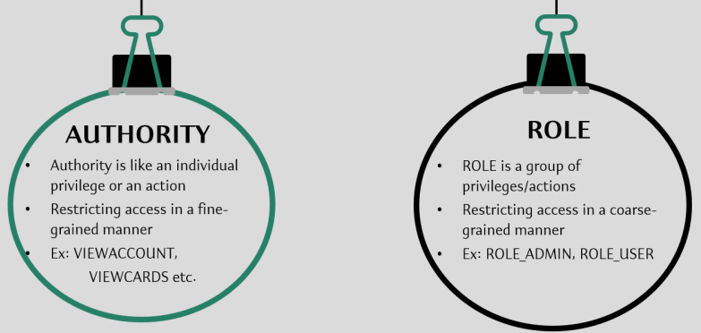

Advantage of using Roles over Authority
- Whenever we’re grouping the authorities using ROLE, the spring security related configuration would be minimal as usually in real project, there’ll be 1000s of actions that an end user can perform inside an app & configuring all the 1000s of authorities using Spring Security config is going to be a tedious process.

Imp Note: While configuring ROLES in Spring Security config & Authorities table, we need to make sure all our roles have a common prefix “ROLE_”. We can customize the prefix by defining a bean.

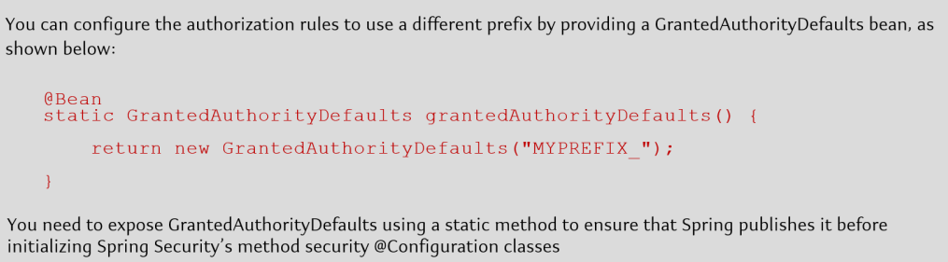

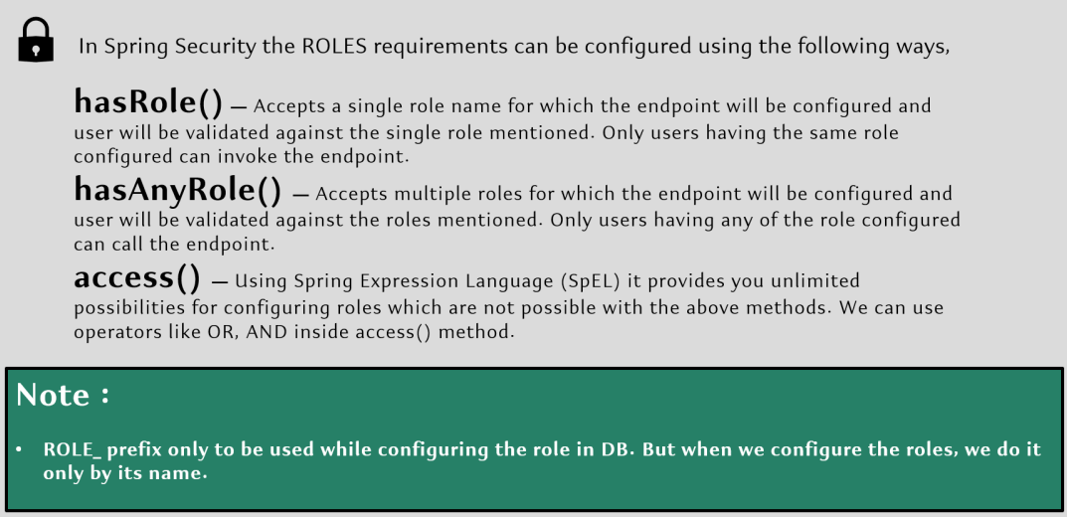

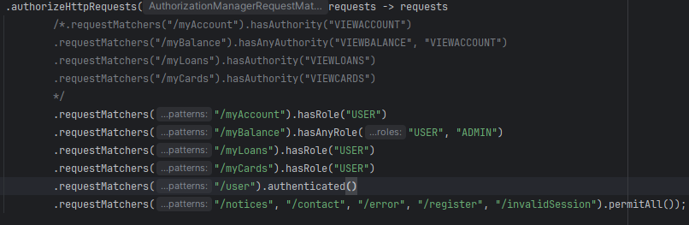

Authorization Event
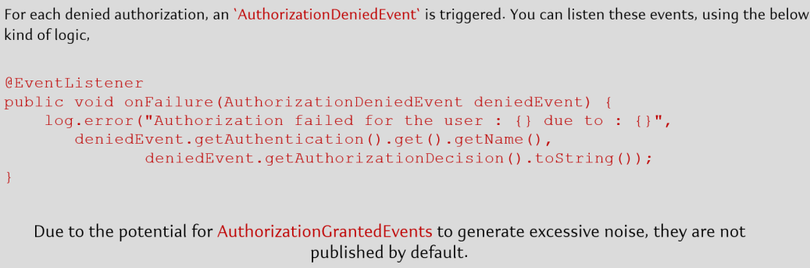

Custom Filters in Spring Security

- Lots of times we will have situations where we need to perform some housekeeping activities during the authentication & authorization flow. Few such examples are:
  - Input Validation
  - Tracing, Auding & reporting
  - Logging of input like IP address etc.
  - Encryption & Decryption.

- All such requirements can be handled using HTTP Filters inside Spring Security. We already saw some inbuilt filters in Spring Security like UsernamePasswordAuthenticationFilter, BasicAuthenticationFilter etc.
- A Filter is a component which receives requests, process its logic & handover to the next filter in the chain.
- Spring Security is based on a chain of servlet filters. Each filter has a specific responsibility & depending on the configuration, filters are added or removed. We can add our custom filters as well based on the need.

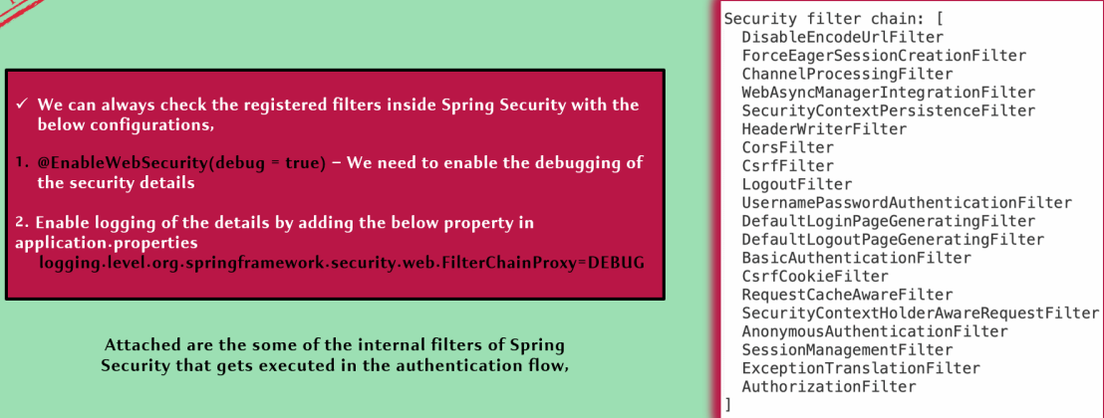

- We can create our own filters by implementing the Filter i/f from jakarta.servlet package. Post that we need to override the doFilter () method to have our own custom logic. For deep analysis, refer FilterChainProxy class & VirtualFilterChain.

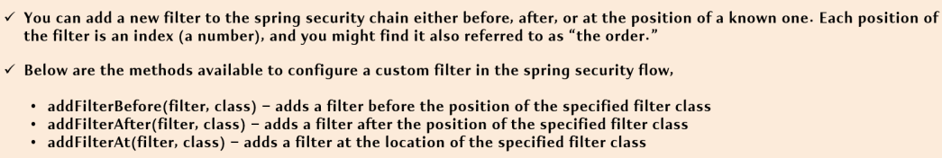



Add Filter Before in Spring Security

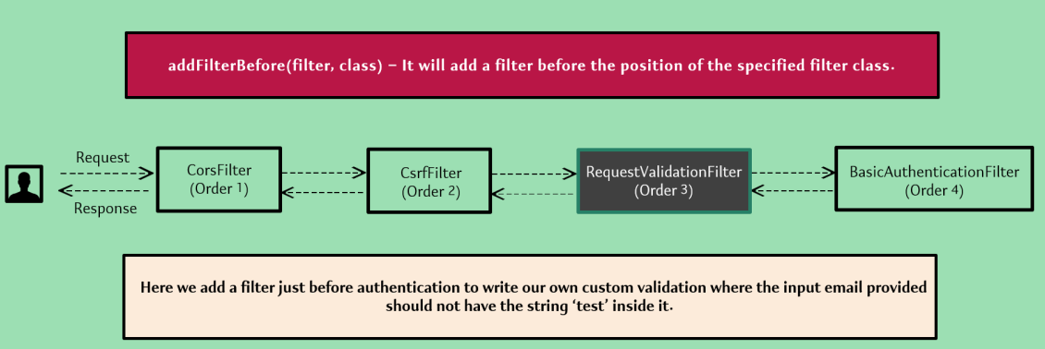

Add Filter After in Spring Security

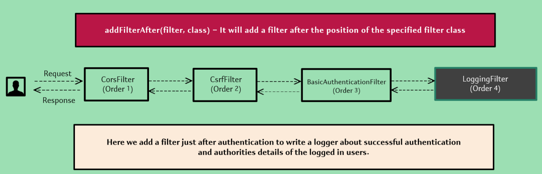

Add Filter At in Spring Security

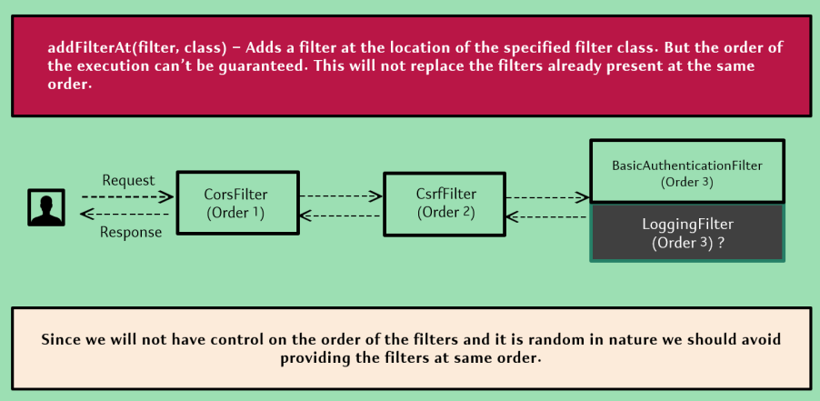

Token Based Authentication using JSON Web Token (JWT)

Opaque Tokens Vs JSON Web Token (JWT)
- In general, there are 2 token formats:
- Opaque Tokens
- JSON Web Tokens (JWT)

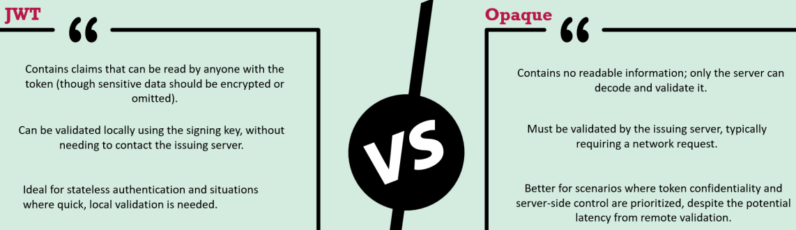

1. Opaque Tokens
- Opaque tokens are typically long, random strings with no inherent meaning or structure that can be decoded. Used to reference authentication information stored on the server side.
- Since they contain no embedded information, they require a call to the Authorization Server or a dedicated introspection endpoint to validate and obtain user information.
- Suitable for scenarios where token validation by a central server is feasible, such as within a secure internal network.

2. JWT Tokens
- A JWT is a JSON string that contains all the claims and information it represents & is certified by a signature from the issuer.
- JWTs are self-contained token in JSON format that consists of 3 parts needed for verification within the token itself: Header, Payload & Signature, encoded in Base64 URL.
- JWT tokens are ideal for stateless, distributed systems where quick token validation is needed without frequent server calls. (can be validated locally by verifying the token’s signature using a public key, without needing a server call)

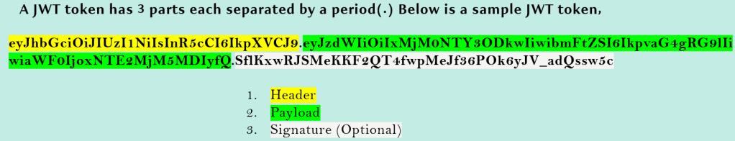

a) JWT Header
- Inside the JWT header, we store metadata/info related to the token. If we chose to sign the token, the header contains the name of the algorithm that generates the signature

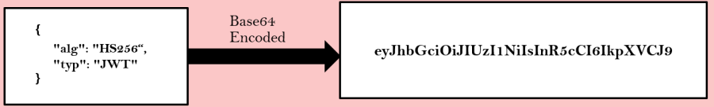

b) JWT Payload/Body
- In the body, we can store details related to user, roles etc, which can be used later for AuthN & AuthZ.
- Though there is no such limitation what we can send & how much we can send in the body, but we should put our best efforts to keep it as light as possible.

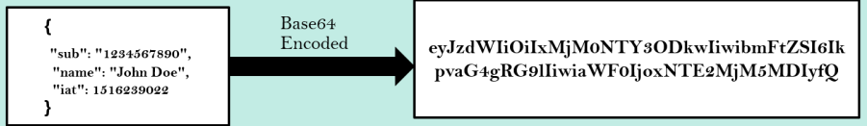

c) JWT Digital Signature
- Digital signature is optional in the token if the party that you want to share JWT token is internal but not open in the web.
- To make sure that no one tampered data on the network, we can send the signature of the content when initially the token is generated.
- To create the signature part, we have to take the encoder header & the encoded payload, a secret, the algorithm specified in the header & sign that.

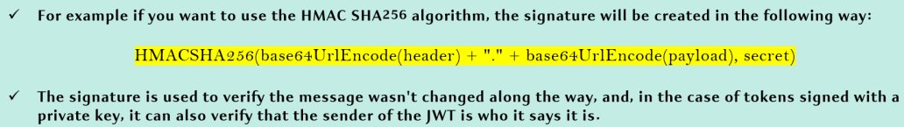

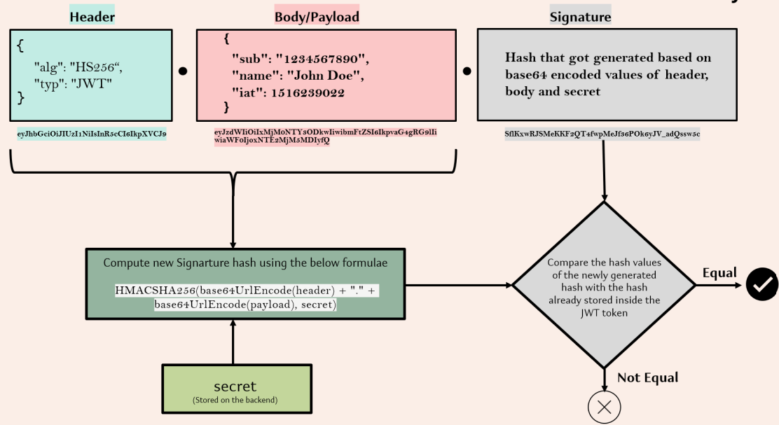

- If we want to play with JWT tokens & put these concepts into practice, we can use https://www.jwt.io/ debugger to decode, verify & generate JWTs.

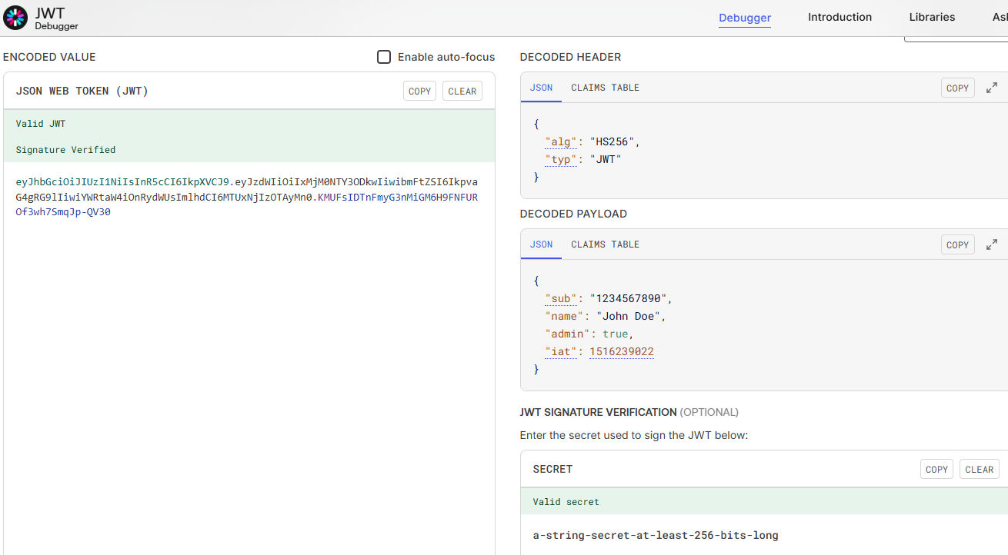

Role of Tokens in AuthN & AuthZ
- A token can be a plain string of UUID format or it can be of type JWT usually that get generated when the user authenticated for the first time during login.
- On every request to a restricted resource, the client sends the access token in the query string or Authorization header. The server then validates the token & if it’s valid, return the secure resource to the client.

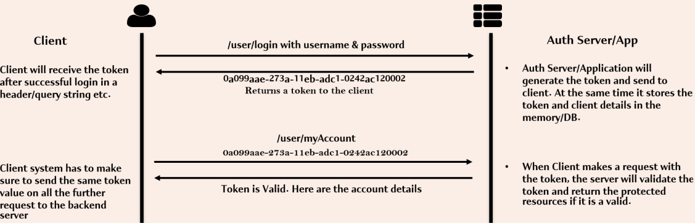

Token Advantages
1. Security
- Limited expose of the user credentials inside the network.
- Tokens can be revoked during any suspicious activities without invalidating the user credentials.

2. Expiration
- Tokens can have specific expiration times set, ensuring tokens are valid only for a predefined duration.

3. Self-contained
- Tokens are self-contained & carry all the necessary information about the suer, roles/authorities etc.

4. Reusability
- Tokens can be used across different domains & services, making them suitable for Single Sign-On (SSO) systems.

5. Cross-Platform Compatibility
- Tokens can be used across various platforms & devices, including web applications, mobile apps, & IOT devices.

6. Statelessness
- The token contains all the information to identify the user, eliminating the need for the session state. If we use a load balancer, we can pass the user to any server, instead of being bound to the same server we logged in on.

Security Configuration to use JWT Tokens

Step 1: We need to add the dependency for the library supporting JWT generation & validation. (Refer GitHub repo section11- pom.xml)

Step 2: As of now, we were telling to the Spring Security framework to generate the JSESSION ID always but now since we want to go with the JWT advanced token format, we need to convey not to generate JSESSION ID. We can achieve this by using STATELESS session creation policy.

By using STATELESS policy, the JWT token will not be stored inside the session. Once the token will be generated, it will be sent back to UI app & UI will send this token for further request.

This makes our application more secure compared to JSESSION ID approach.

Step 3: We will remove the sessionContext related changes as it was required when we generate the JSESSION ID

Step 4: We need to expose the header to the UI application/Client (deployed at different origin) as JWT token will be sent as the Response header to the client.

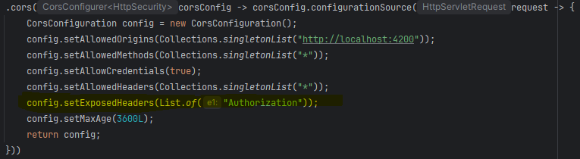

Step 5: How we’re going to generate & validate a JWT token

JWT token Generation Filter
- We would want to generate the JWT token once the initial login is completed. We need to create a new filter extending OncePerRequestFilter.
- In all upcoming request, we don’t want our filter to be invoked, because for all the upcoming requests, we want to validate the token but not generate. We need to override below method to convey Spring Security the same.
- Add the logic for token generation in doFilterInternal method.

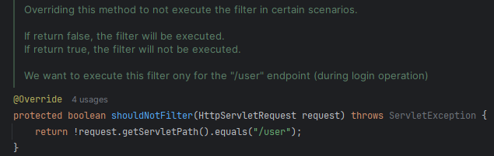

JWT token validation Filter
- We would want to validate the token every time the request comes to the backend. We need to create a new filter extending OncePerRequestFilter.
- In all upcoming request except the during login operation, we want to invoke this filter. We need to add below config:

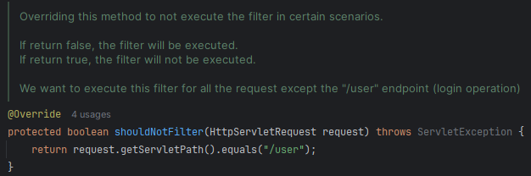

- Add the logic for token validation in doFilterInternal method.

Step 6: Add Token Generation & Validation filter to the Security configuration.
- Add Token Generation Filter after login i.e., BasicAuthenticationFilter
- Add Token Validation Filter before BasicAuthenticationFilter so that we will inform Spring Security framework that authentication is already successful, no need to perform authentication one more time.

JWT Token received as part of Response Header to UI.
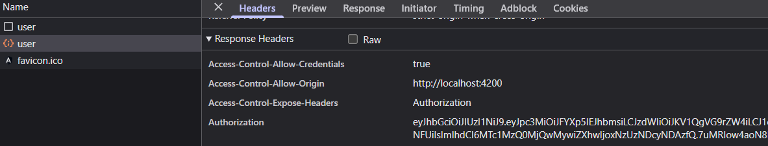

JWT Token sent to BE as part of Request Header.
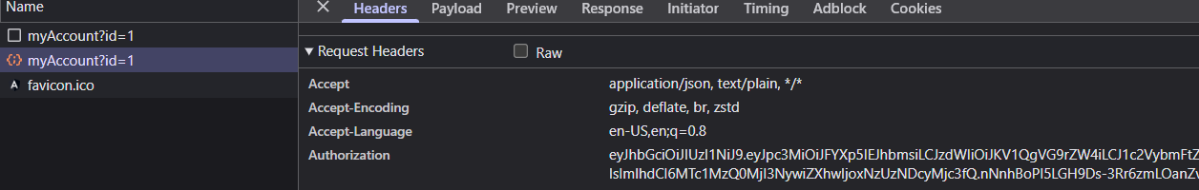
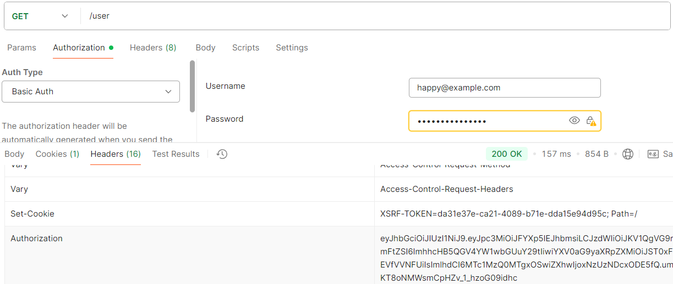

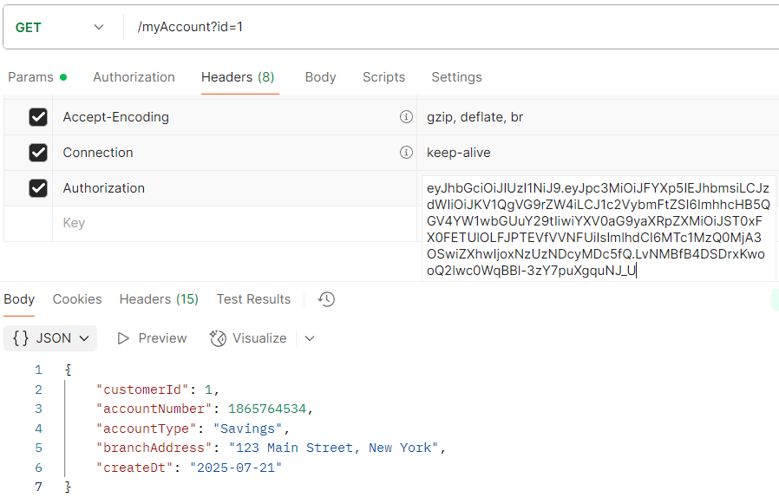

Publish an AuthenticationManager bean for Custom Authentication

- As of now inside our application, we’re supporting the login operation using the HTTP Basic Authentication format & FormLogin.
- Anyone who wants to login to our application, first they need to invoke the /user api & pass basic Authentication credentials & since this is a secure API on backend side, the Spring Security framework will take care of Authenticating the end user with credentials we passed.

- Apart from this FormLogin or Http Basic Authentication, we may get a requirement to accept the credentials inside the request body / header, without following any standards of form login/Http Basic format. In this kind of scenarios whatever Spring Security framework provides is not going to help us.
- We need to build our own REST API operation that accepts the user credentials wherever we want & inside this API we need to invoke the Authentication manually. Once the Authentication is completed, the JWT token or any other token value we want to send inside the Request body.

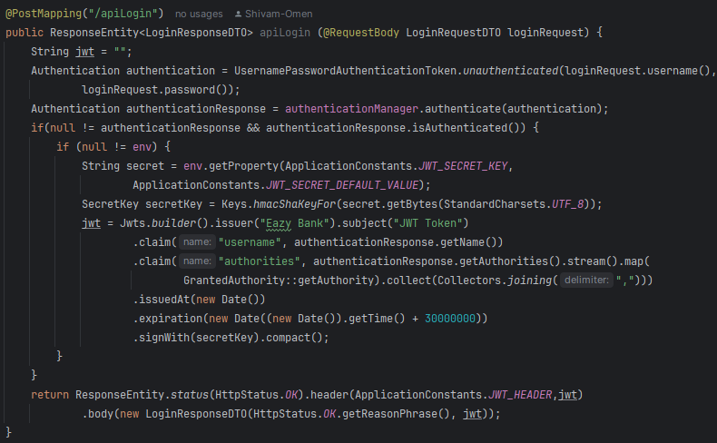

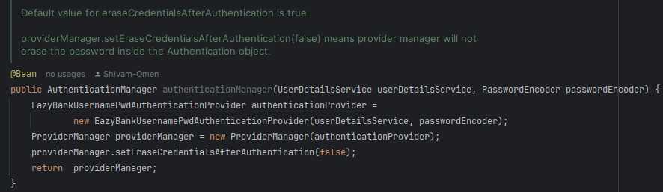

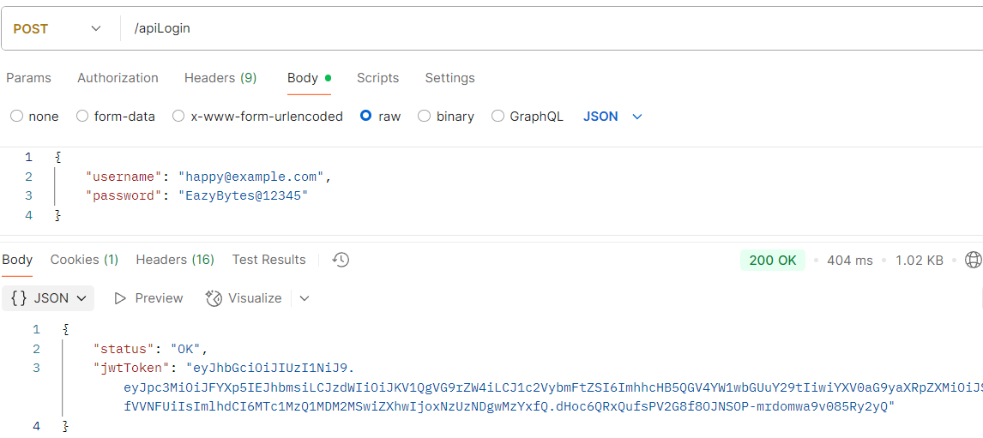

Method Level Security

- As of now we’ve applied authorization rules on the API paths/URLs using Spring Security but Method level security allows to apply the Authorization rules at any layer of an application like in service layer or repository layer etc.
- Method Level Security can be enabled using the annotation @EnableMethodSecurity on the configuration class.
- Method Level Security also helps in applying authorization rules even in the non-web applications like Desktop apps where we will not have any endpoints.

- Method Level Security provides the below approaches to apply the Authorization rules & executing our business logic:

- Invocation Authorization – Validates if someone can invoke a method or not based on their roles/authorities.

- Filtering Authorization – Validates what a method can receive through its parameters & what the invoker can receive back from the method post business logic execution.

- Spring Security will use the aspects from the AOP module & have the interceptors in b/w the method invocation to apply the authorization rules configured.

- Method Level Security offers below 3 different styles for configuring the authorization rules on top of the methods:

- The prePostEnabled property (default value as true) enables Spring Security @PreAuthorize & @PostAuthorize annotations.
- The securedEnabled property enables @Secured annotation
- The jsr250Enabled property enables @RoleAllowed annotation
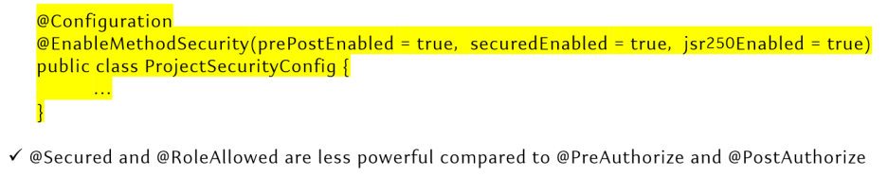

@PreAuthorize

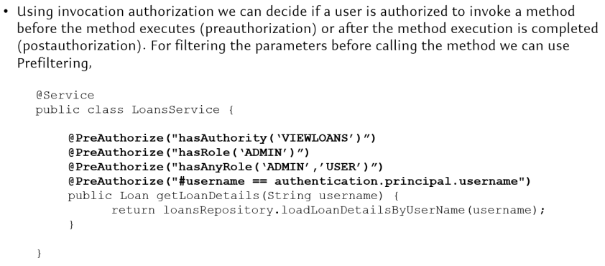
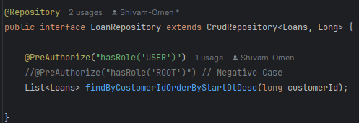

- Referring above code snippet, the method findByCustomer… will be invoked only if the given logged in user has “USER” role.
- In case the Preauthorization failure, 403 error will be thrown by the Spring Security framework while it is trying to invoke the method. So, during the API invocation, there are no issues but while trying to invoke the method, behind the scenes, Spring Security framework will perform the Authorization checks using AOP.

@PostAuthorize

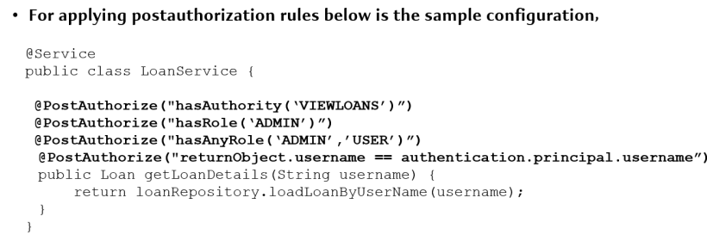
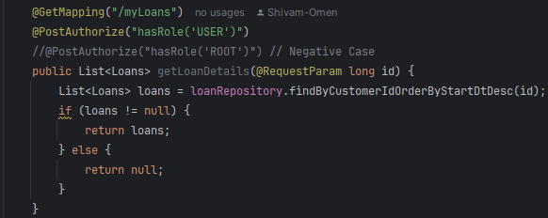

- @PostAuthorize will not stop method execution, instead it will stop sending the response from the annotated method if the authorization check fails.

@PreFilter

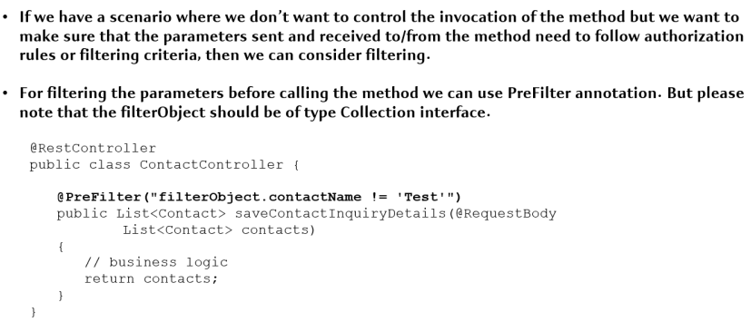

- Refer PreFilterAuthorizationMethodInterceptor & PostFilterAuthorizationMethodInterceptor for in-depth understanding.

@PostFilter

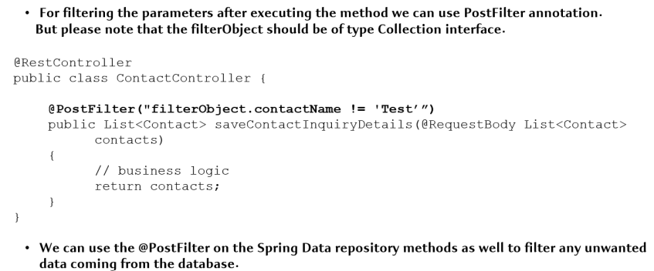

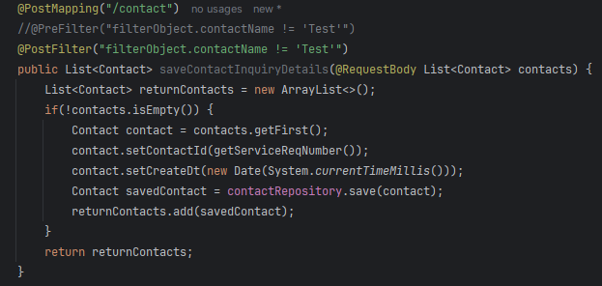

Section 13: OAuth2 & OpenID Connect

Problems the OAuth2 trying to solve:
- If a bank has multiple websites supporting accounts, loans, cards etc. Without OAuth2, the Bank customer has to register & maintain different user profiles in all 3 systems.
- Even the AuthN & AuthZ logic, Security standards will be duplicated in all the 3 websites.
- Any future changes or enhancements around security, authentication etc. need to be done in all the places.

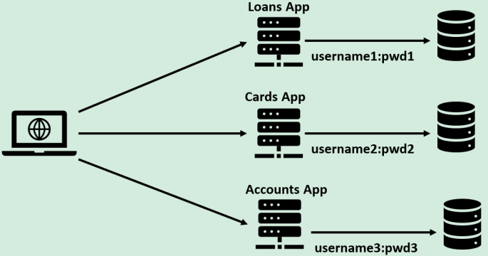

Q. How come, google let us use the same account in all its product? Though they’re different website/apps deployed on different servers
Ans: With the help of OAuth2 implementation. OAuth2 recommend to use a separate Auth server for Authentication & Authorization.

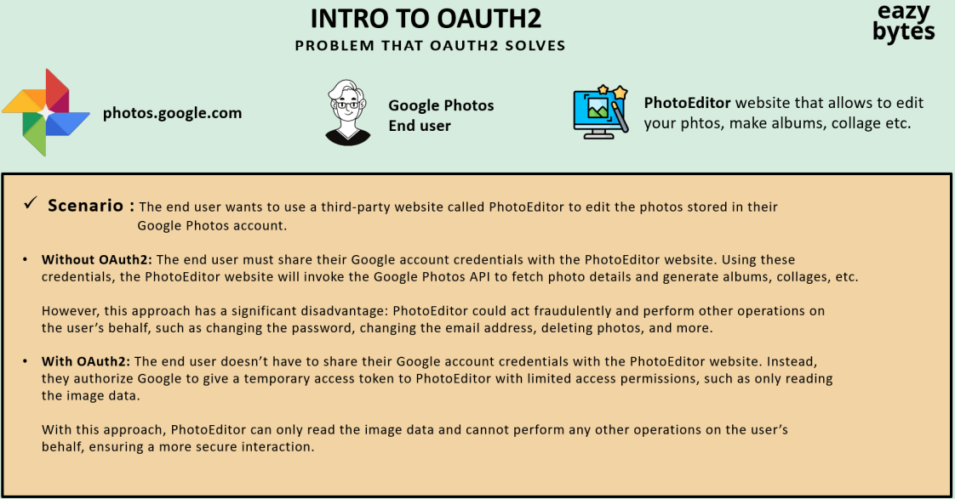

Introduction to OAuth2
- OAuth stands for Open Authorization. It’s a free & open protocol, built on IETF standards & licenses from the Open Web Foundation.
- OAuth 2.0 is a security standard where we give one application permission to access our data in another application. The steps to grant permission or consent are often referred as a Authorization or Delegated Authorization.
- We authorize one application to access our data, or use features in another application on our behalf, without giving them our password.
- In many ways, we can think of the OAuth token as a “access card” at any office/hotel. These tokens provide limited access to someone, without handling over full control in the form of the master key.

- The OAuth framework specifies several Grant Types for different use cases, as well as a framework for creating new Grant Types:
- Authorization Code
- PKCE
- Client Credentials
- Device Code
- Refresh Token
- Implicit Flow (Legacy)
- Resource Owner Credentials / Password Grant (Legacy)

OAuth2 Terminology

Resource Owner (i.e., End User)
- Resource owner is the end user that owns the resources (e.g., photos)
- E.g., In the scenario of Photo Editor application, the end user who want to use the Photo Editor website to edit his photo.

Client
- Client is an application or website that interacts with the Authorization server after taking permission from the Resource owner.
- For e.g., Photo Editor website

Authorization Server
- Authorization server is responsible for the validating the client’s request to access the resource based on the Resource owner consent.
- Resource owner should have an account on this server.
- For e.g., In the scenario of Photo Editor, Google Auth Server acts as the Authorization Server.

Resource Server
- Resource server is the server that hosts the APIs, service or resources that the client wants to consume.
- For e.g., In the scenario of Photo Editor, the Google Photos server (hosts APIs like /getImages etc) acts as the Resource Server.
- In smaller organization, a single server can act as both Resource Server & Auth Server.

Scopes
- Scopes are the granular permissions the client wants, such as access to data or to perform certain actions.
- For e.g., In the scenario of Photo Editor, the Auth Server can issue an access token to Client with the scope of only READ IMAGES.

OAuth2 Sample Flow

Step 1: Client Registration to Authorization Server
- The clients will register themselves with the Authorization server & post registration the Authorization server will issue them the CLIENT ID & CLIENT SECRET which will later use for client identification.

Step 2: Resource Owner/End user Signup/Sign-in to Client Website/Application
- The End user would like to use the Client application to explore client’s application features & the client wants the end user to login-in via Auth Server registered credential.
- For e.g., The end user can login via Signup with Google (Auth Server) that will redirect the user to Google Login Page (Auth Server).



Step 3: Resource Owner Authentication with Auth Server & Resource access specification consent to the Client
- The end user will be authenticated to Auth Server and post authentication; the required access content is given to the Client based on the client’s registration details.



Note: From Step 4, based on the Grant Type, the Flow will vary.

Step 4: Post Client Identification, the Authorization Server will issue tokens to the Client.

Step 5: Client application will send request (along with issued tokens) to Resource Server for the resource access



Step 6: Resource Owner/End user can explore the client’s feature on the received resources & client can according perform operations.



OAuth2 Flow in Grant Type: Authorization Code

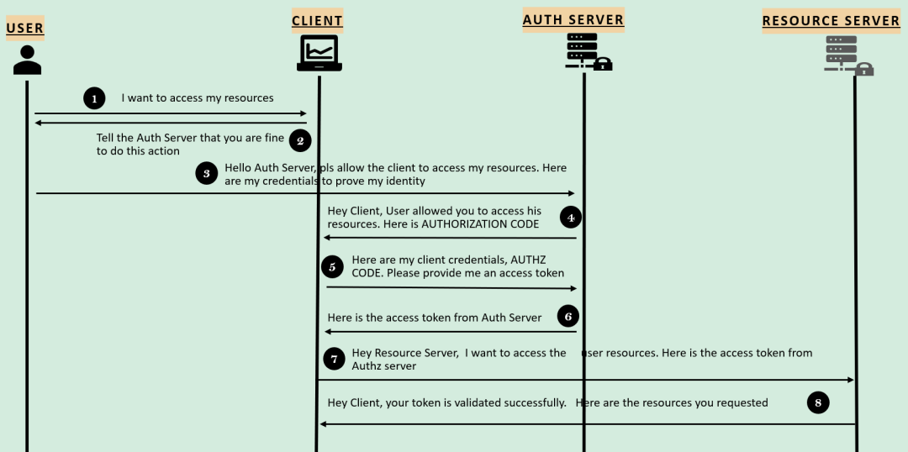

Request 1: Client to Auth Server – Will Receive Authorization Code from Auth Server
- In the step 2 & 3, where client is making a request to the Auth Server endpoint with the below request details:
- CLIENT ID / client_id
- Id which identifies the client application by the Auth Server. This will be granted to client during its registration to Auth Server.
- REDIRECT URI / redirect_uri
- The URI value which the Auth server needs to redirect post successful Authentication.
- If default value is provided during the registration, then this value is optional.
- SCOPE / scope
- Similar to Authorities. Specifies the level of access that client is requesting like READ
- STATE / state
- CSRF token value to protect from CSRF attacks
- RESPONSE TYPE / response_type
- With the value ‘code’ which indicates that we want to follow Authorization Code Grant.

Request 2: Client to Auth Server – Will Receive Access token from Auth Server
- In the step 5, where the client already received an authorization code from Auth Server, will again make a request for the Access token to Auth Server with below request values:
- CODE / code
- The Authorization code received in the above steps.
- CLIENT ID / client_id & CLIENT SECRET / client_secret
- The client credentials which are registered with the Auth Server. Please note that these are not user credentials.
- GRANT TYPE / grant_type
- With the value ‘authorization_code’ which identifies the kind of grant type is used.
- REDIRECT URI / redirect_uri

Q. Why in the Authorization Code Grant Type, Client is making request 2 times to Authorization Server for Authorization Code & Access Token?
- In the 1st call, Authorization server will make sure that End user / Resource Owner directly interacted with it along with the credentials. If the details are correct, Auth server will send the Authorization code to Client.
- In the 2nd call, once Client receives the Authorization code, the Client has to prove its identity along with the Authorization code & Client Credentials to get the Access Token.

Q. Why can’t Auth Server directly club both the calls together & provide the token in a single step?
- There used to have another Grant Type called ‘Implicit Grant Type’ with the same feature but it’s not recommended to use as its less secure.

OAuth2 Legacy Flow in Grant Type: Implicit Flow – Not Recommended

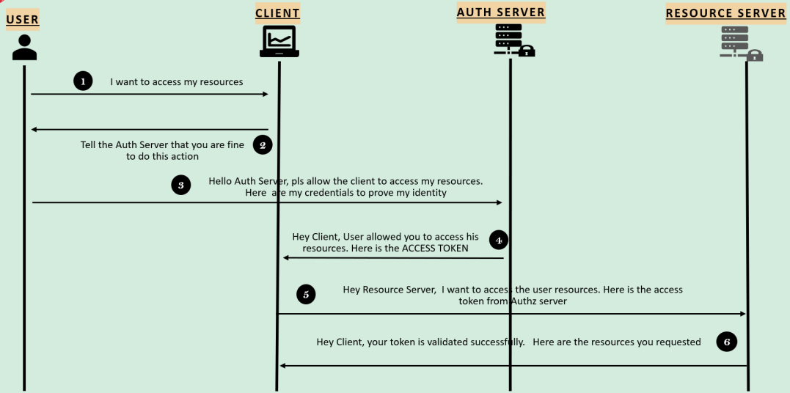

Request 1: Client to Auth Server – Will Receive Access token from Auth Server
- In the step 3, where Client is making a request to Auth Server endpoint with below request details:

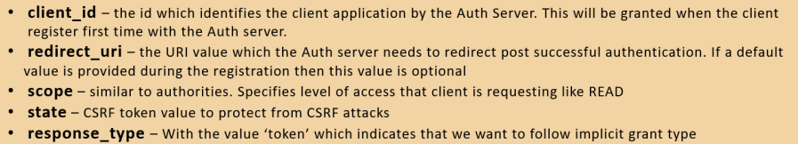

- If the user approves the request, the Auth server will redirect the browser back to the redirect_uri specified by the application, adding a token & state to the fragment part of the URL.

Note: Implicit Grant Flow is deprecated & is not recommended to use in production applications. Always use the Authorization code Grant Flow instead of Implicit Grant Flow.

OAuth2 Flow Grant Type: Authorization Code with Proof Key for Code Exchange (PKCE)

- When public clients (e.g., Native and Single – Page Applications) request Access Token, some additional security concerns are posed that are not mitigated by the Authorization Code Flow alone. This is becoz public clients can’t securely store a Client Secret.
- Given these situations, OAuth 2.0 provides a version of the Authorization Code Flow for public client applications which makes use of a Proof Key for Code Exchange (PKCE)

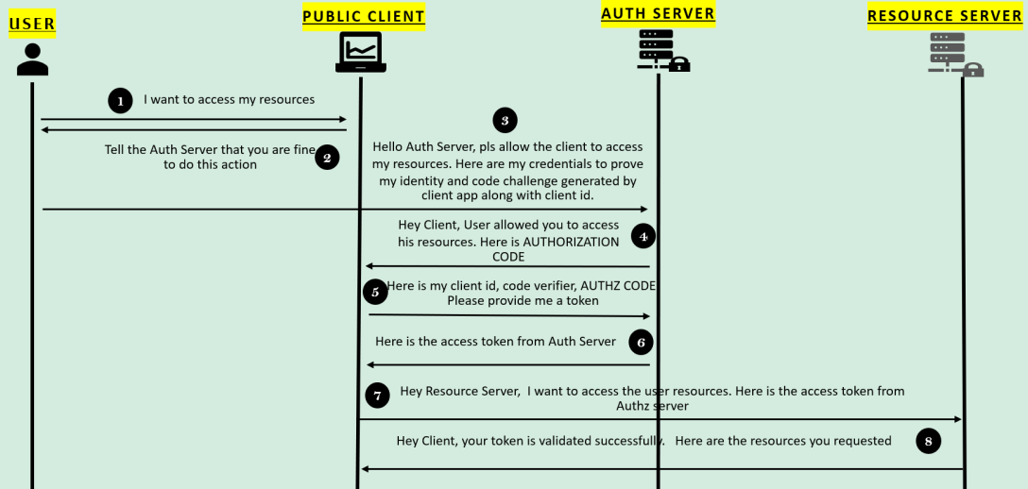

- In the step 2 & 3, where client is making a request to Auth Server endpoint with below request details:

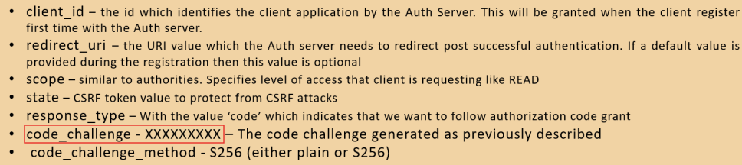

- In the step 5, where client after received an authorization code from Auth Server, it will again make a request to Auth Server for a token with the below values:

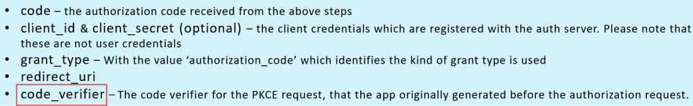

- The PKCE – Enhanced Authorization Code Flow follows below steps:

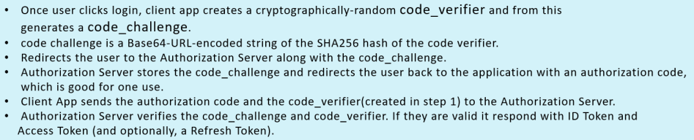

OAuth2 Flow Legacy Grant Type: Password Grant/Resource Owner Credentials Grant Type

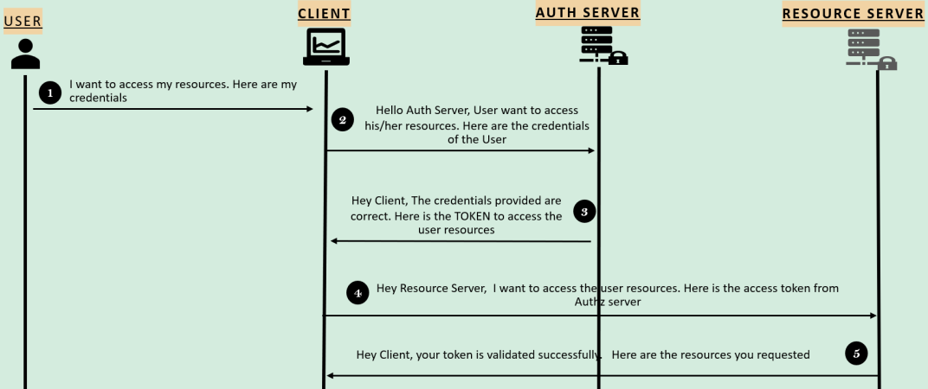

- In the step 2, where Client is making a request to Auth Server endpoint have below request details:

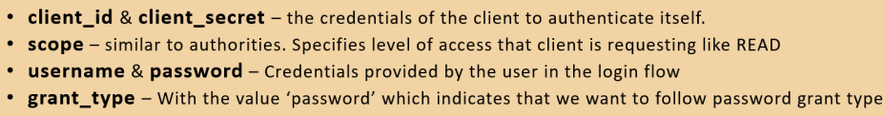

- We use this Authentication flow only if the Client, Authorization Server & Resource Servers are maintained by the same organization.

- This flow will be used followed by the Enterprise applications who want to separate the Auth Flow & Business Flow. Once the Auth Flow is separated different applications in the same organization can leverage it.

OAuth2 Flow Grant Type: Client Credentials

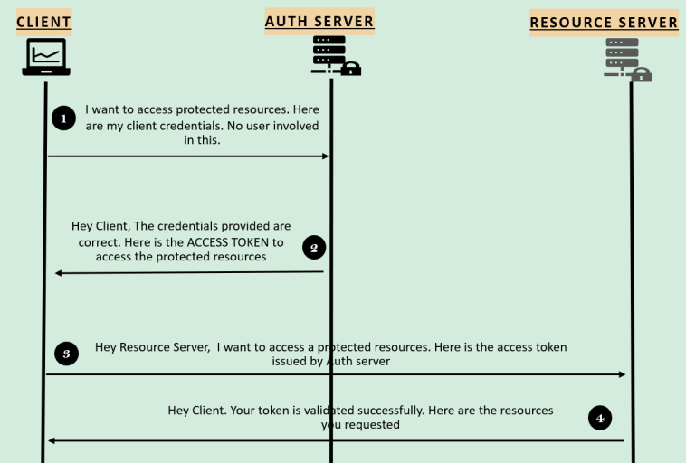

- In the step 1, where Client is making a request to Auth Server endpoint, have below request details:

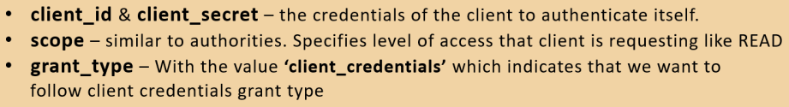

- This is the simplest grant type flow in OAuth2.

- We use this Authentication flow only if there is no user & UI involved. Like in the scenarios where 2 different applications want to share data b/w them using backend APIs

OAuth2 Flow Grant Type: Refresh Token

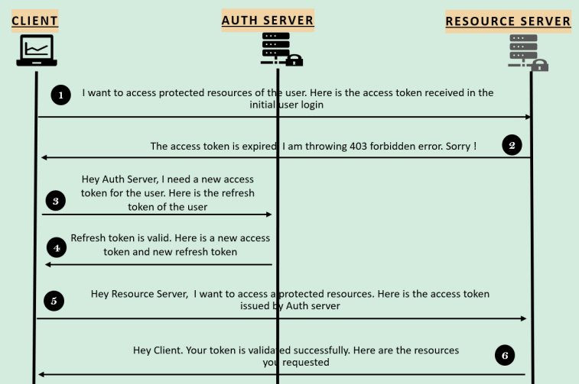

- In the step 3, where Client is making a request to Auth Server endpoint with below request details:

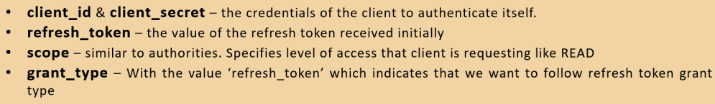

- This flow will be used in the scenarios where the Access Token of the user is expired. Instead of asking the user to login again & again, we can use the Refresh Token which originally provided by the AuthZ server to reauthenticate the user.

- Though we can make our Refresh tokens to never expire but it’s not recommended considering scenarios where the tokens can be stolen if we always use the same token.

- offline_access scope is used to get a Refresh Token that never expires.

Note: We can use https://oauth.net/2/, https://www.oauth.com/, https://www.oauth.com/playground/ to explore all the in-depth OAuth2 details & grant types.

How Resource Server Validates the Tokens issued by Authorization Server

Validating Access Tokens Remotely

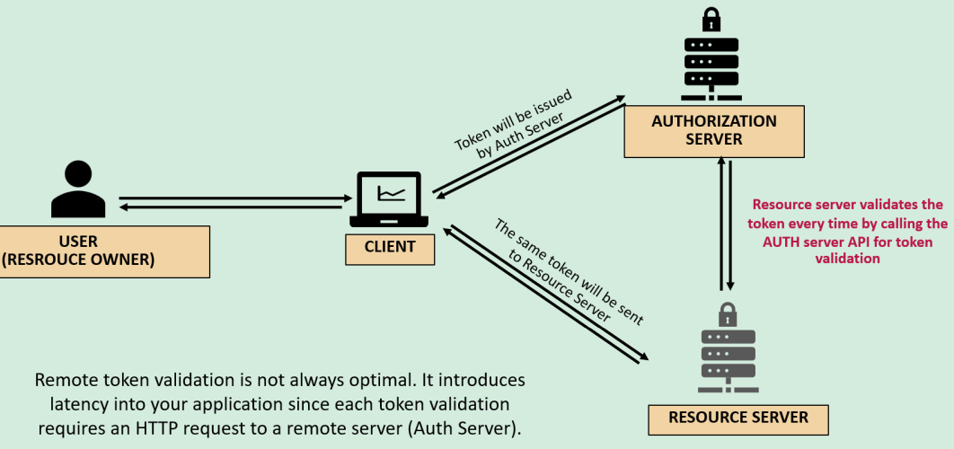

Validating Access Tokens Locally

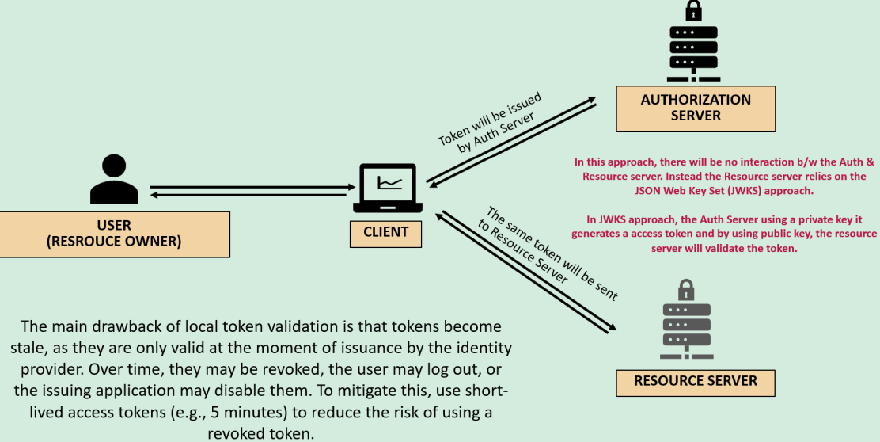

OpenID Connect

- OpenID Connect is a protocol that sits on the top of the OAuth 2.0 framework. While OAuth2 provides Authorization via an access token containing scopes, OpenID Connect provides Authentication by introducing a new ID token which contains a new set of information and claims specifically for Identity.

- With the ID token, OpenID Connect brings standards around sharing identity details among the applications.

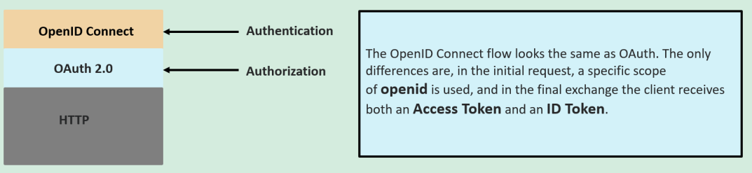

Why is OpenID Connect important?
- Identity is the key to any application. At the core of modern authorization is OAuth 2.0 but OAuth 2.0 lacks an authentication component. Implementing OpenID Connect on the top of OAuth 2.0 completes an IAM (Identity & Access Management) strategy.
- As more & more applications need to connect with each other and more identities are being populated on the internet, the demand to be able to share these identities is also increased.
- With OpenID Connect, applications can share the identities easily and standard way.

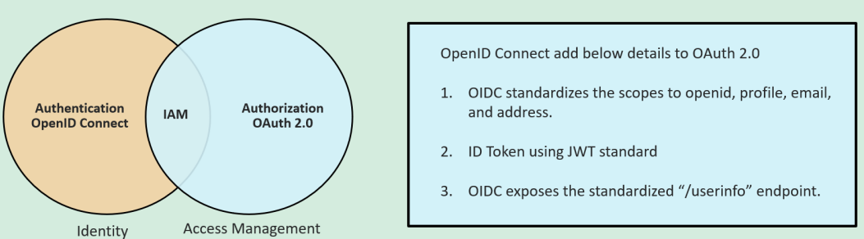

OAuth2 Demo

2 different approaches:

1. Allow the secured APIs access to the end user via the social logins like GitHub, Facebook, Google etc.

2. Allow the secured APIs access via our own Authorization Server

Note: Whenever we enable the OAuth 2.0 login, we need to give clue to our Spring Security framework on which Authorization server we’re trying to use, whether we’re using social logins or our own Auth Server.
- To give this clue, we have to create a bean of type ClientRegistrationRepository & its implementations like InMemoryClientRegistrationRepository and SupplierClientRegistrationRepository.
- Using these repository class, we’re going to store all our Authorization server related details in form of ClientRegistration object.

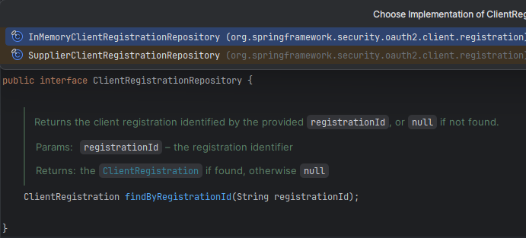

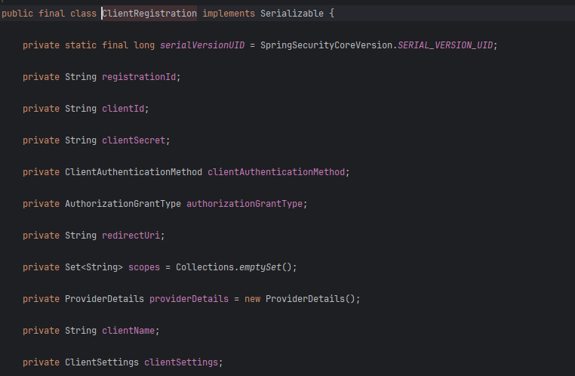

1. Allow the secured APIs access to the end user via the social logins like GitHub, Facebook, Google etc.
- Whenever we want to implement social logins inside our Spring Boot web application, we can leverage one of the enum class available i.e., CommonOAuth2Provider

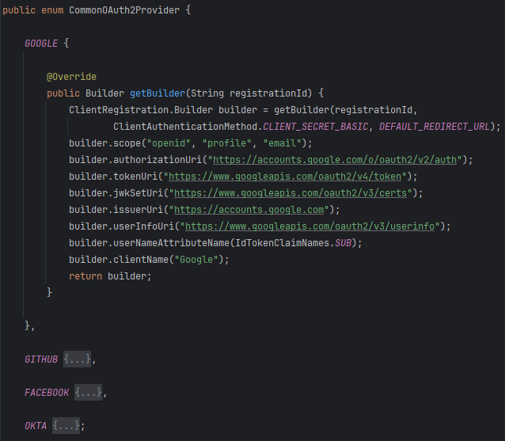

We can configure social login in 2 ways in our spring boot application
- Using defining beans of ClientRegistrationRepository with oauth2Login config
- Using predefined configuration of ClientRegistrationRepository with oauth2Login config

2. Allow the secured APIs access via Authorization Server

- Whatever Auth server that are available with the help of social logins like GitHub, Facebook, LinkedIn etc., all these Auth servers have a very serious drawback/limitation due to which these Auth servers can’t be used inside an Enterprise organization.
- The limitations are:
  - We will not have any control on the social login Auth servers. We can’t create a role or authority based on our business requirements inside these Auth servers.
  - Whatever user related information that we’re getting from the social logins, we just have to accept them & build our business logic using them.
- But in real applications, we can’t live with these kinds of restrictions, we may want to register thousands of end users with respective authorities & roles defined inside the Auth server.
- That’s why the Enterprise applications prefer to build their own Auth server where they have complete control.

a) Resource Server – Our Spring boot application with all the protected APIs & resources
b) Client – Postman, Angular Application
c) Auth Server can be:
- Commercial/Open-Source Product supporting OAuth 2 & Open ID standards like KeyCloak, Okta. All cloud providers like GCP, AWS, Azure have products around the OAuth 2 & Open ID Connect.
- Build Custom Authorization Server from Scratch with help of Spring Auth Server library

Implementing OAuth2 using KeyCloak Auth Server Flow

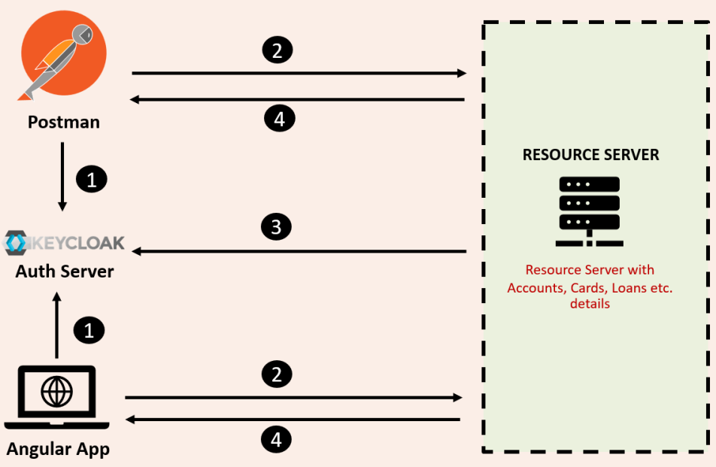

Step 1: Client applications will reach out to the KeyCloak Server to get an access token. When they’re trying to get the access token from the Auth server, they can involve End user if they’re following the Authorization Code or PKSE flow otherwise if they’re following Client Credential grant flow, they don’t have to involve any end user.

Step 2: Once the Access token is received from the Auth Server, these client apps will send the token to the Resource server as part of Request.

Step 3: Once the Access token is received by the Resource Server, depending on the token type (JWT or Opaque), the Resource server will validate the token with Auth server (KeyCloak)

Step 4: If Access token is valid, the Resource server will send the secure resources as response to the client applications.

Intro to KeyCloak Auth Server

- As discussed earlier, OAuth2 & Open ID are just standard or specifications. They are not actual product which can be leveraged by any organization. That’s why they are simply guidelines/standards/specifications.
- Based on these OAuth2 standards, bigger organizations like Facebook, GitHub, LinkedIn etc. they started building their own Auth server for their own internal purpose but this may not be possible for all the organizations to build their Auth server, that’s where Organizations can use already built Auth Server Products based on this specification like KeyCloak (Open Source), Okta (Commercial), AuthO, Amazon Cognito.

- KeyCloak is an open-source product built & maintained by Cloud Native Computing Foundation. We can setup this Auth Server inside our local/dev/production system regardless of the complexity of the application.
- Refer https://www.keycloak.org/ for details on KeyCloak.
- User Federation means we can store all the user credentials inside storage systems like Relational DB, LDAP, Active Directory & we can point our Auth Server to these storage systems for Authentication & Authorization.

- If needed, we can also customize the login page of the Auth Server based upon our own organization look & feel requirement.

Setting KeyCloak in our local system

We can refer https://www.keycloak.org/guides for setting up Keycloak. We as Developer are not responsible to set up the Keycloak server, either Devops team or Platform team or Deployment team will setup in various environment & will provide the URLs to the developers.

Step 1: Docker image
- docker run -p 8180:8080 -d -e KEYCLOAK_ADMIN=admin -e KEYCLOAK_ADMIN_PASSWORD=admin quay.io/keycloak/keycloak start-dev

- start-dev: We’re telling to the key cloak to start using a development profile/mode i.e., embedded H2 database or in-memory database will be used to store all the end user details & all other configurations.

Step 2: KeyCloak Admin Console Access link: http://localhost:8180/ with Credential as admin, admin

Step 3: Set up own Realm
- A Realm is a space that is used to manage a set of users, credentials, roles & groups in a specific environment.
- There is a very good chance we’re not going to maintain the same users, credentials etc across multiple environments, to support these kinds of scenarios, Every Auth server built on the top of OAuth2 will have a concept called Realm.

Step 4: Registering Client details inside the KeyCloak Auth Server
- The Client details will vary based on OAuth2 grant types set up.

a) Client Credential Grant type flow – No End user involved (Backend app to Resource server communication)
- Refer above slides for this grant type flow.
- During the client registration to Auth Server, Auth server will give Client Id & Client Secret which can be leveraged by the 3rd Party app/client to get an access token later.
- Same Access token will be sent to Resource server & post validation; the protected resources will be sent back to client.

Create your own client in the newly created realm by providing client Id

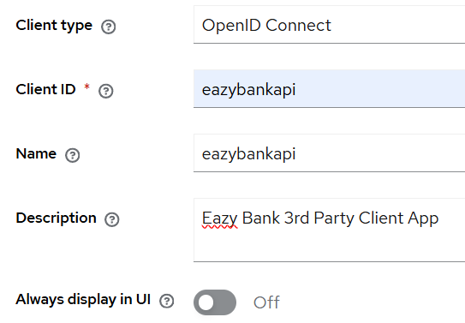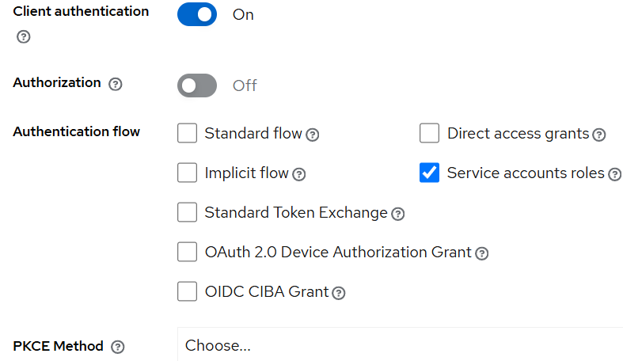
-----------------------------------------------------------------------------------------------------------------------------------------------------

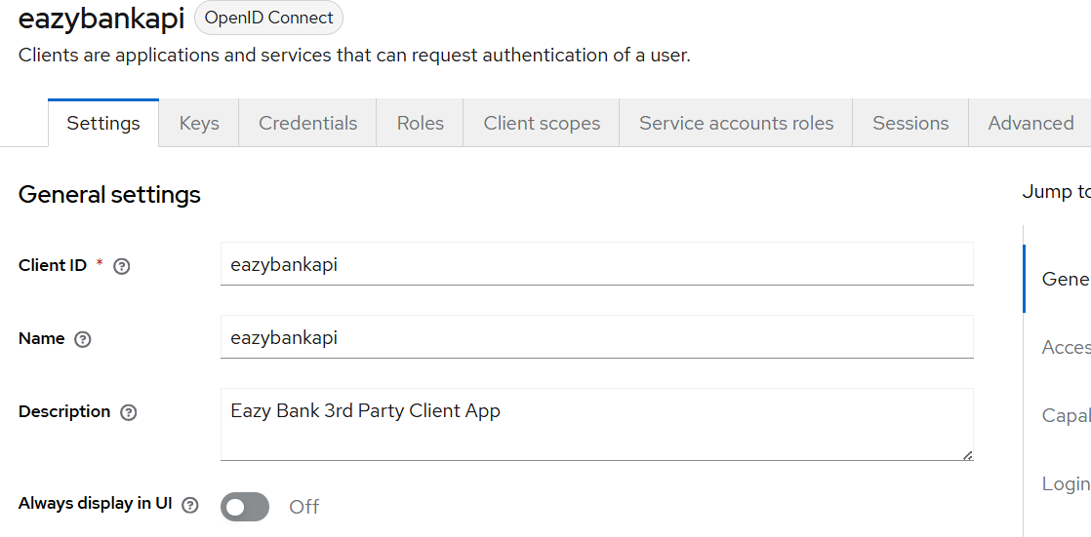
-----------------------------------------------------------------------------------------------------------------------------------------------------
Client Id is eazybankapi

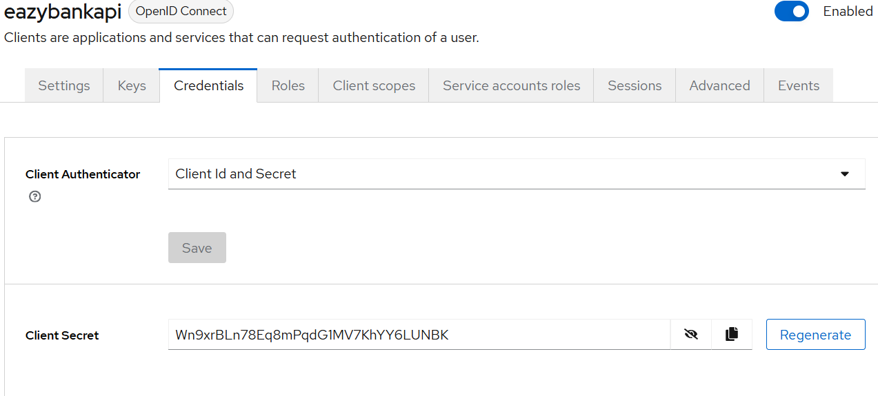

We can create roles using Realm roles & then assign the role using service-account-roles in client

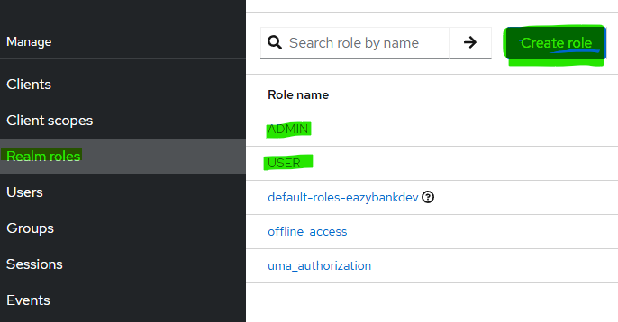
--------------------------------------------------------------------------------------------------------------------------------------------------------
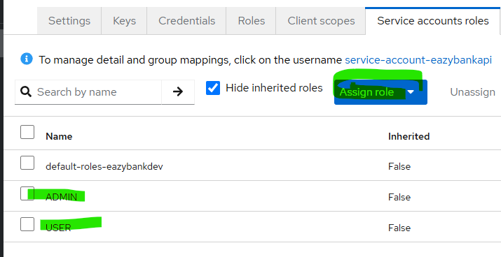

We can access the below endpoint to know all the URLs

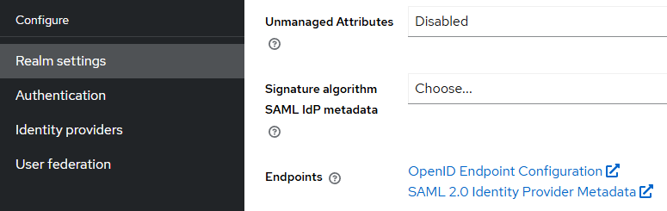

Open ID Configuration: http://localhost:8180/realms/eazybankdev/.well-known/openid-configuration
This is a very famous endpoint & the standard followed by all the Auth servers in the industry
For e.g., https://accounts.google.com/.well-known/openid-configuration
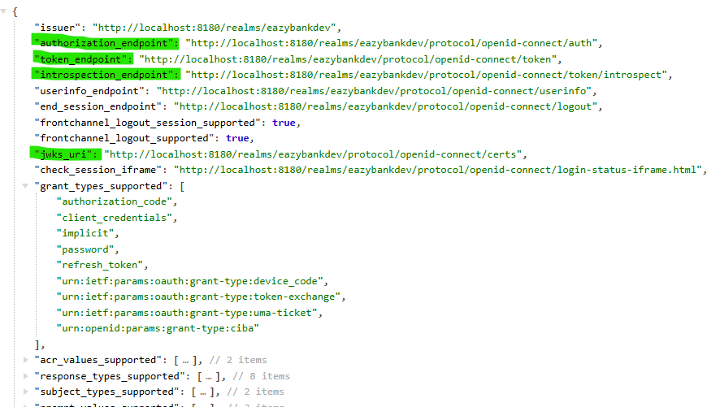
----------------------------------------------------------------------------------------------------------------------------------------------------------

Public Keys to validate the Access Token locally using jwks_uri (Fetched from Auth Server)

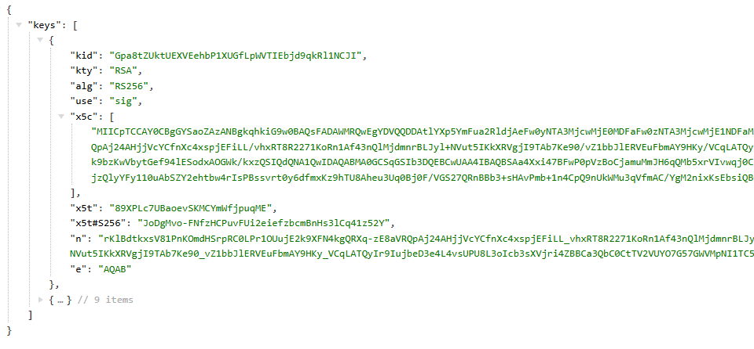

We can use https://jwt.io site to view the token & its embedded information.

Note: We can configure Opaque Token as well instead of JWT but we can’t change the format of access token from JWT to Opaque as Keycloak doesn’t support issuing the tokens in the opaque format.

For opaque token, each request to the Resource Server will be validated with Auth Server.

Creating Client & User details inside KeyCloak for Auth Code Grant Flow

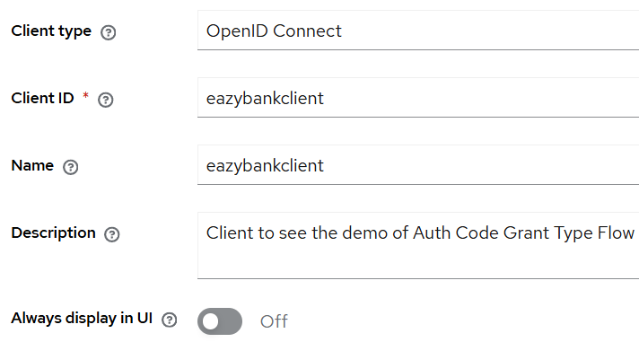
--------------------------------------------------------------------------------------------------------------------------------------------------------

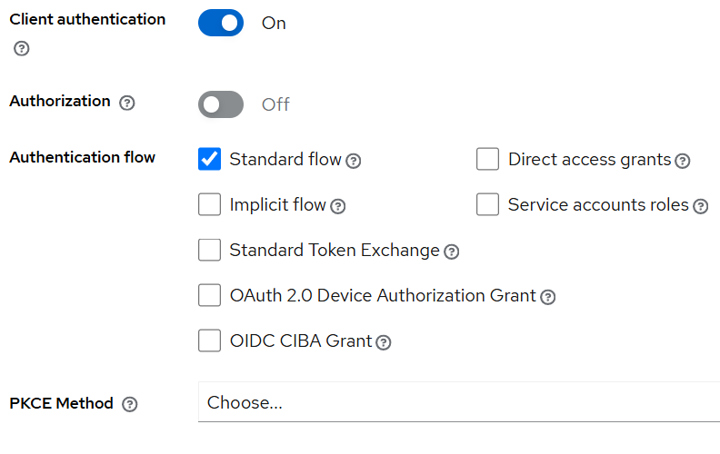
--------------------------------------------------------------------------------------------------------------------------------------------------------

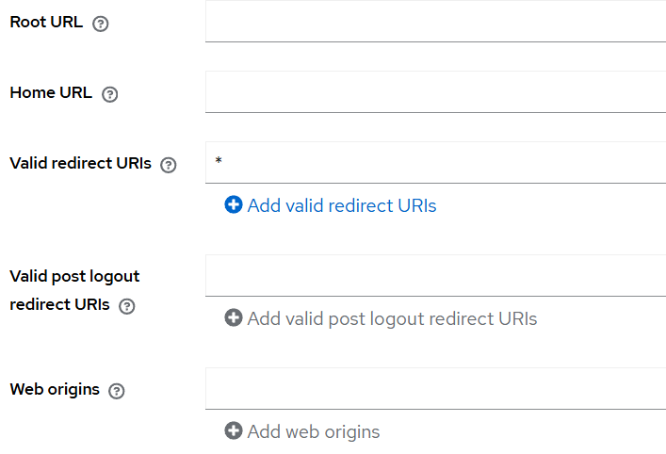

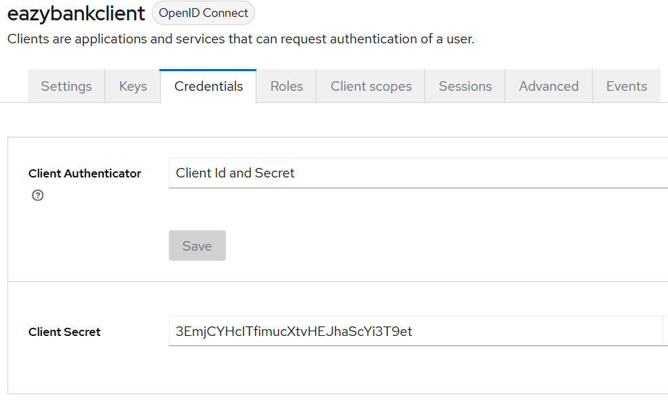

Refer https://www.keycloak.org/documentation https://www.keycloak.org/docs-api/latest/rest-api/index.html for more details on how to configure users through APIs.

